Fiber optic sensors enhanced by diamond structures
for biomedical and environmental sensing

M. Kosowska¹
¹ Faculty of Telecommunications, Computer Science and Electrical Engineering, Bydgoszcz University of Science and Technology, Bydgoszcz, Poland
e-mail: monika.kosowska@pbs.edu.pl

Sensors have become an integral part of today’s world due to their ability to deliver precise data on variety of parameters, either on-demand or in real-time. Current research trends focus on the development of advanced materials, AI-driven analysis, multimodality, and miniaturization [1,2]. As a result, there is a growing interest in fiber optic sensors, which offer high sensitivity, compact size, resistance to electromagnetic interferences, non-invasive and contactless operation mode. Additionally, the ability to functionalize the fiber surface enables a selective detection of specific biomarkers [3]. Therefore, enhancing and tailoring fiber optic sensors can lead to their broad application in biomedical measurements or environmental monitoring.

In this study, fiber optic sensors integrated with diamond structures (boron-doped diamond film, nitrogen-doped diamond film, nanocrystalline diamond sheet) are presented. Diamond structures offer mechanical robustness, chemical stability, biocompatibility, and possibility of tuning their properties towards specific applications [4]. They are also known for their exceptional hardness, which improves durability of the sensors components.

The design and development of interferometric optical fiber sensors are presented. Several configurations and example applications of the optical sensors are discussed, eg. sensor of hemoglobin level [5], setup for monitoring of electrochemical processes [6], sensor for bisphenol A investigation [7]. The system is based on a superluminescence diode, an optical spectrum analyzer, 2x1 fiber coupler, micromechanical setup, and a PC.

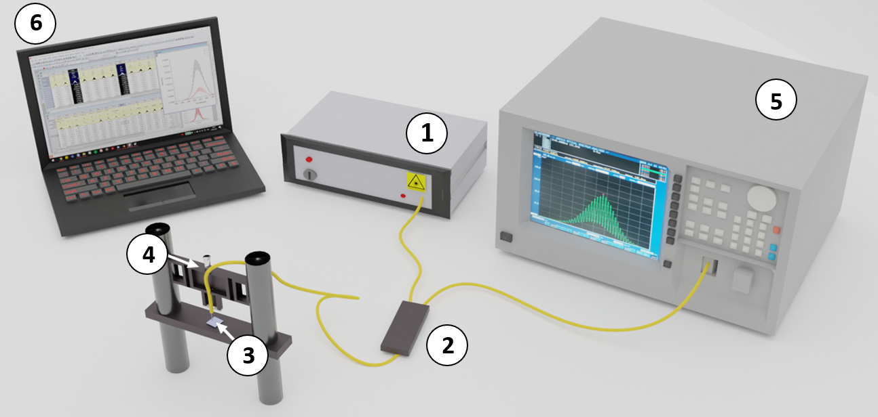
Figure 1. Laboratory measurement setup for the experiments: 1 – light source, 2 – coupler, 3 – measurement head, 4 – micromechanical setup, 5 – optical spectrum analyzer, 6 - PC
REFERENCES
1. A. Venketeswaran, N. Lalam, J. Wuenschell, et al., Adv. Intell. Syst. 4(1), 2100067 (2022).
2. M. Szczerska, K. Cierpiak, M. Kosowska, et al., Sens. Actuators Rep. 10, 100346 (2025).
3. P. Wityk, M. Kosowska, J. Kwon, et al. Opt. Quant. Electron. 56(8), 1303 (2024).
4. M. Kosowska, S. Pawłowska, K. J. Sankaran, et al. Diam. Relat. Mater. 111, 108221 (2021).
5. D. Majchrowicz, M. Kosowska, K. J. Sankaran, et al. Materials 11(1), 109 (2018).
6. M. Kosowska, P. Jakóbczyk, M. Rycewicz, et al. Sci. Rep. 11(1), 12600 (2021).
7. M. Szczerska, M. Kosowska, P. Listewnik, et al. Measurement 189, 110495 (2022).

