Reconfigurable all-optical sigmoid-like activator based on a Fabry-Pérot laser diode with multi-wavelength output capacity

J. Crnjanski, A. Dakić, P. Atanasijević, M. Banović, M. Krstić and D. Gvozdić
School of Electrical Engineering, University of Belgrade, Serbia
e-mail: jasna.crnjanski@etf.bg.ac.rs

Reconfigurable photonic activation functions (AFs) play a key role in advancing neuromorphic computing by enabling ultra-fast and energy-efficient information processing in optical neural networks [1, 2].
In this study, we build upon the foundations of all-optical AFs in Fabry-Pérot laser diodes (FP-LDs) under optical injection shown in [3], achieving AF wavelength conversion and multiple simultaneous sigmoid-like AFs at different wavelengths. To achieve the multi-output operation of our nonlinear element (NLE), we use the dual optical injection (DOI) paradigm, where two input signals are simultaneously coupled into different longitudinal side modes of the FP-LD. Unlike the DOI shown in [3], both optical inputs are pulsed. The DOI pulse trains are Gaussian-shaped, at a repetition rate of 0.5 Gb/s with a FWHM of ~400 ps. The first input operates at a wavelength λ_{c}, frequency detuned by −15 GHz (red shifted) with respect to the m = +5 longitudinal side mode of the FP-LD (blue shifted with respect to the central FP-LD mode), delivering a continuous train of fixed-peak-power pulses. The second input at λ_{p}, used to insert the data, is injected near the m = +3 FP-LD side mode, with a variable detuning in the −15 to −21 GHz range (Fig. 1(a)). The data patterns comprise both linearly increasing and randomized sequences of peaks modulated in power, allowing for a realistic investigation of the system’s nonlinear behavior. The AFs can be extracted either at λ_{c} or λ_{p}, by adjusting the tunable bandpass filter (BPF) providing the NLE with two concurrent, apparently distinct, outputs, as shown in Fig. 1(b). While the AF at λ_{p} follows a previously demonstrated trend [2,3], the wavelength converted AF at λ_{c} exhibits a more pronounced saturation, with a lower ON-OFF power level ratio.
We further extend the known detuning reconfigurability of λ_{p} AFs [3], exploiting the observed interplay between the signals at λ_{c} and λ_{p} within the FP-LD, and demonstrate the 0.55 to 0.75 mW λ_{c} AF threshold shift by varying the λ_{p} detuning in the −15 to −21 GHz range. This adaptivity, shown in Fig. 1(c), enables dynamic shaping and real-time reconfiguration of the wavelength-shifted nonlinear response, creating a programmable NLE suitable for all-optical activation in multiwavelength photonic neural networks, enhancing the parallelism and scalability for future demonstrations.
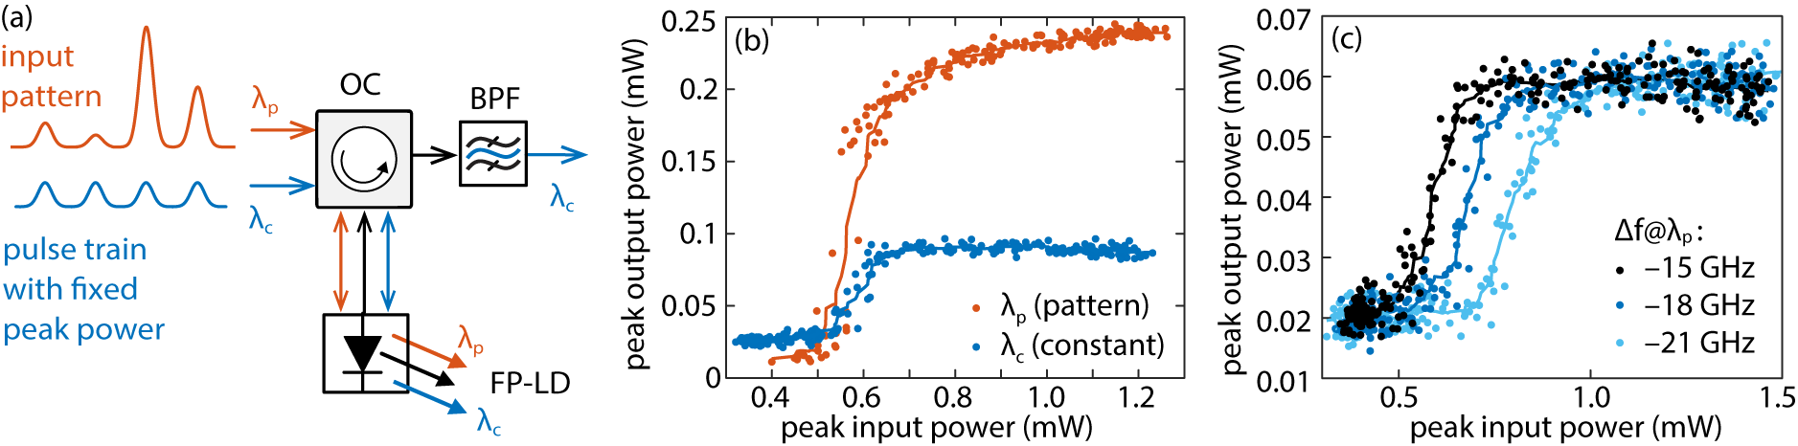
Figure 1. (a) The schematic of the experimental setup. (b) Comparison of nonlinear responses at both outputs. (c) Detuning-dependent nonlinear response at λ_{c}.
Acknowledgment. The research was supported by Science Fund of the Republic of Serbia (#7750121, ORCA-LAB), and by Serbian Ministry of Science, Technology and Innovation (451-03-65/2024-03/200103). The research was partially conducted in the premises of the Palace of Science, Miodrag Kostić Endowment.
REFERENCES
[1] A. Tsakyridis et al, APL Photonics 9, 011102 (2024).
[2] J. Crnjanski et al., Optics Letters 49, 1153 (2024).
[3] M. Banović et al., arXiv:2503.21603, (2025).

