Twisted Light in Scattering Medium: From Optical Angular Momentum to Biomedical Diagnostics

I. Meglinski¹
¹Aston Institute of Photonic Technologies, College of Engineering & Physical Sciences, Aston University,
Birmingham, UK
e-mail: i.meglinski@aston.ac.uk
Structured light carrying orbital angular momentum (OAM), also known as twisted light, offers new capabilities for probing biological tissues with enhanced phase sensitivity and spatial resolution [1]. When propagating through tissue-like scattering media, OAM beams preserve their helical phase structure despite multiple scattering events [1,2]. This phenomenon, known as phase memory, enables retrieval of subtle refractive index variations that are typically lost in conventional optical-based imaging modalities.
In this lecture, we explore the propagation of structured light carrying OAM through complex scattering media such as biological tissues. We begin by introducing the fundamental concepts of spin and orbital angular momentum of light, discussing their physical origins, conservation laws, and interaction with matter. Emphasis is placed on how OAM modes, such as Laguerre–Gaussian beams, retain phase information even after passing through highly turbid, tissue-like environments.
Building on this theoretical foundation, we are going to discuss a Mach–Zehnder-based interferometric system developed for generating and probing OAM beams and show how OAM phase memory can be harnessed for non-invasive sensing of microstructural tissue changes (Fig.1). Our experimental studies, supported by custom Monte Carlo simulations, reveal that the twist of light is up to three orders of magnitude more sensitive to refractive index variations than conventional phase measurements, offering a powerful new avenue for early-stage diagnostics of cancer, diabetes-induced tissue changes, and retinal degeneration.
The talk will conclude with a discussion on the translational potential of OAM-based optical technologies in histology and clinical imaging [3], and how they may be further enhanced through AI-powered reconstruction and quantum photonics integration. A tutorial-style introduction at the beginning of the talk will provide essential background for early-stage researchers in photonics, optics, and biomedical imaging.
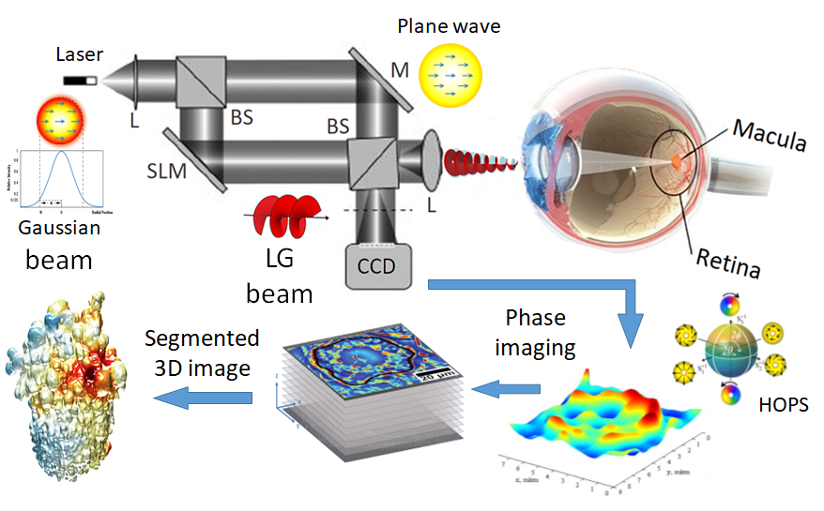
Figure 1. Schematic of a Mach–Zehnder interferometer illustrating how twisted light carrying OAM can be exploited for AI-driven non-invasive optical diagnostics of early tissue abnormalities.
REFERENCES
[1] I. Meglinski, et al., Light Sci. Appl. 13, 214 (2024).
[2] F. Khanom, et al., Sci. Rep. 14, 20662 (2024).
[3] I. Meglinski, et al., Optics and Photonics News, 35(12), 43 (2024).

