Design and Fabrication of Thin Film for All Solid-State
Lithium-Ion Batteries

N. Karadeniz^{1,2}, N. Esen¹, S. Karpuz¹, U. Unal³, A. Cantas⁴, L. Ozyuzer^{1,2}, M. Ozdemir², K. Kosiel⁵, A. Szerling⁵, R. Socha⁶, G. Aygun¹
¹ Department of Physics, Izmir Institute of Technology, Izmir, Türkiye
²Teknoma Technological Material Inc., Iztech Campus, Izmir, Türkiye
³Department of Chemistry, Koc University, Istanbul, Türkiye
⁴Department of Electric and Energy, Pamukkale University, Denizli, Türkiye
⁵Łukasiewicz Research Network-Institute of Microelectronics and Photonics, Warsaw, Poland
⁶CBRTP S.A., 36 Czarnowiejska St. 30-054 Cracov, Poland
e-mail: nurcinkaradeniz@iyte.edu.tr

Organic liquid electrolytes, commonly used in commercial Lithium-ion batteries, are susceptible to fire due to their low flash point, particularly at high voltages. This flammability raises safety concerns in practical applications [1]. Thus, current concerns over lithium-ion battery safety are leading to exciting developments in all solid-state lithium-ion batteries (ASSLIBs), fueled by the promise of unparalleled safety and boosted energy density. ASSLIBs eliminate the risks like leakage and combustibility associated with liquid electrolytes. Performance parameters of ASSLIBs such as cycle life, stability and capacity can be improved by both increasing the ionic conductivity of the electrolyte layer and improving the electrode/electrolyte interface [2]. A previous study in our group investigated the influence of substrate temperature on the surface, structural, and chemical properties of RF magnetron sputtered LiCoO₂ (LCO) thin films for ASSLIB cathodes [3]. Another study focused on the preparation of crystalline Li_{0.5}La_{0.5}Ti_{1−x}Al_{x}O₃ (LLTAlO) targets using conventional solid-state reactions. The effect of Al substitution on the lithium-ion conductivity of LLTO was investigated [4].
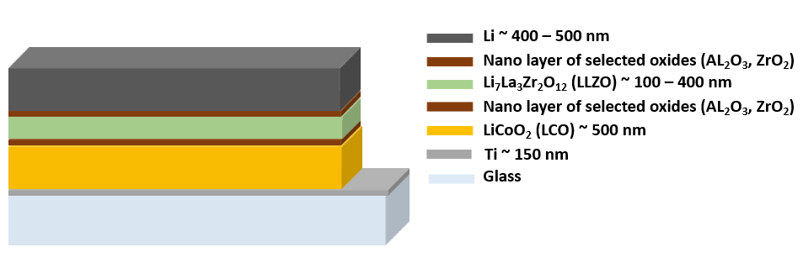
Figure 1. The schematic diagram of all solid-state thin film battery designed on a glass substrate.

This work focuses on the fabrication of thin film components for ASSLIBs that were prepared using RF magnetron sputtering for LCO and Li₇La₃Zr₂O₁₂ (LLZO), along with thermal evaporation for lithium metal. In our structure Titanium is used as a current collector, LCO is the cathode, LLZO is the electrolyte, and Li is the anode layer. Due to undesirable phases that may occur on both the cathode and anode of the electrolyte layer, the nanolayer of selected oxides will act as buffer layers (Fig.1). The cathode–electrolyte interface was carefully investigated using 2.85 nm Al₂O₃, ZrO₂, and Al₂O₃–ZrO₂ buffer layers deposited by atomic layer deposition (ALD) to improve contact and stability. The characterization of samples with SEM, XRD, Raman, XPS and electrochemical tests will be discussed and the design of efficient all solid-state batteries will be presented.
This research was supported by TUBITAK with project number 122N516 under MERANET program. The authors would like to acknowledge the facilities of Research and Application Center for Quantum Technologies (RACQUT) of IZTECH.

REFERENCES
[1] S. Liu, L. Zhou, J. Han, et al. Adv. Energy Mater. 12, 2200660 (2022).
[2] C. Wang, J. Liang, J. T. Kim, X. Sun, Sci. Adv. 8, eadc9516 (2022).
[3] P. Ozcan, N. Esen, A. Cantas, L. Ozyuzer, M. Ozdemir, K. Kosiel, A. Szerling, G. Aygun, Vacuum, 239, 114439 (2025).
[4] S. Ulusoy, S. Gulen, G. Aygun, L. Ozyuzer, M. Ozdemir, Solid State Ion. 324, 226-232 (2018).

