Single-Frequency DFB Laser based on High-Yb-doped photosensitive fiber
A. Shigapov, E. Seregin, M.Likhachev and Yu.Gromova
GREITLEX PHOTONICS DOO, Belgrade, Serbia
e-mail: mike@greitlex-photonics.com

Single-frequency fiber lasers are one of the important tools in number of applications (first of all - lidars). Laser based on distributed feedback (DFB) resonators are most suitable for mass production due to reduction of fabrication steps (only single π-shifted fiber bragg grating should be fabricated) and guarantee of operation in single-frequency regime. To date lack of such lasers was coursed by absence of highly Yb-doped photosensitive fibers. Recent progress in development of highly Yb-doped silica-based fibers [1, 2] open new possibilities in development of DFB Yb-doped fiber lasers. Home-made highly-Yb-doped photosensitive fiber with ability to maintain polarization was used in the current work. A record-short (10 mm in length) DFB laser operated near 1064 nm was fabricated by direct whitening of fiber Bragg grating in the active fiber. Scheme of the laser is shown in Fig.1 (upper insert). Single-mode pump diode (Pump), was coupled to DFB resonator based on active fiber using polarization maintaining single-mode pump and signal combiner (WDM). Output signal was passed through WDM. Full power generated by DFB laser (see Fig.1) and polarization extinction ratio of more than 23 dB were measure just after WDM. To measure output spectra (see bottom insert to Fig.1) we added polarization-maintaining Isolator. Linewidth was found to be smaller than resolution of optical spectrum analyzer (0.02 nm), which confirm the operation of the laser in single-frequency regime (according our estimations distance between own modes of the resonator, i.e. between polarization modes was of about 0.2 nm).

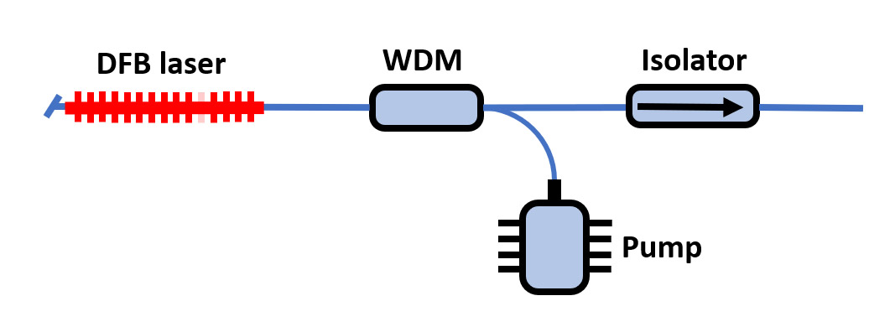
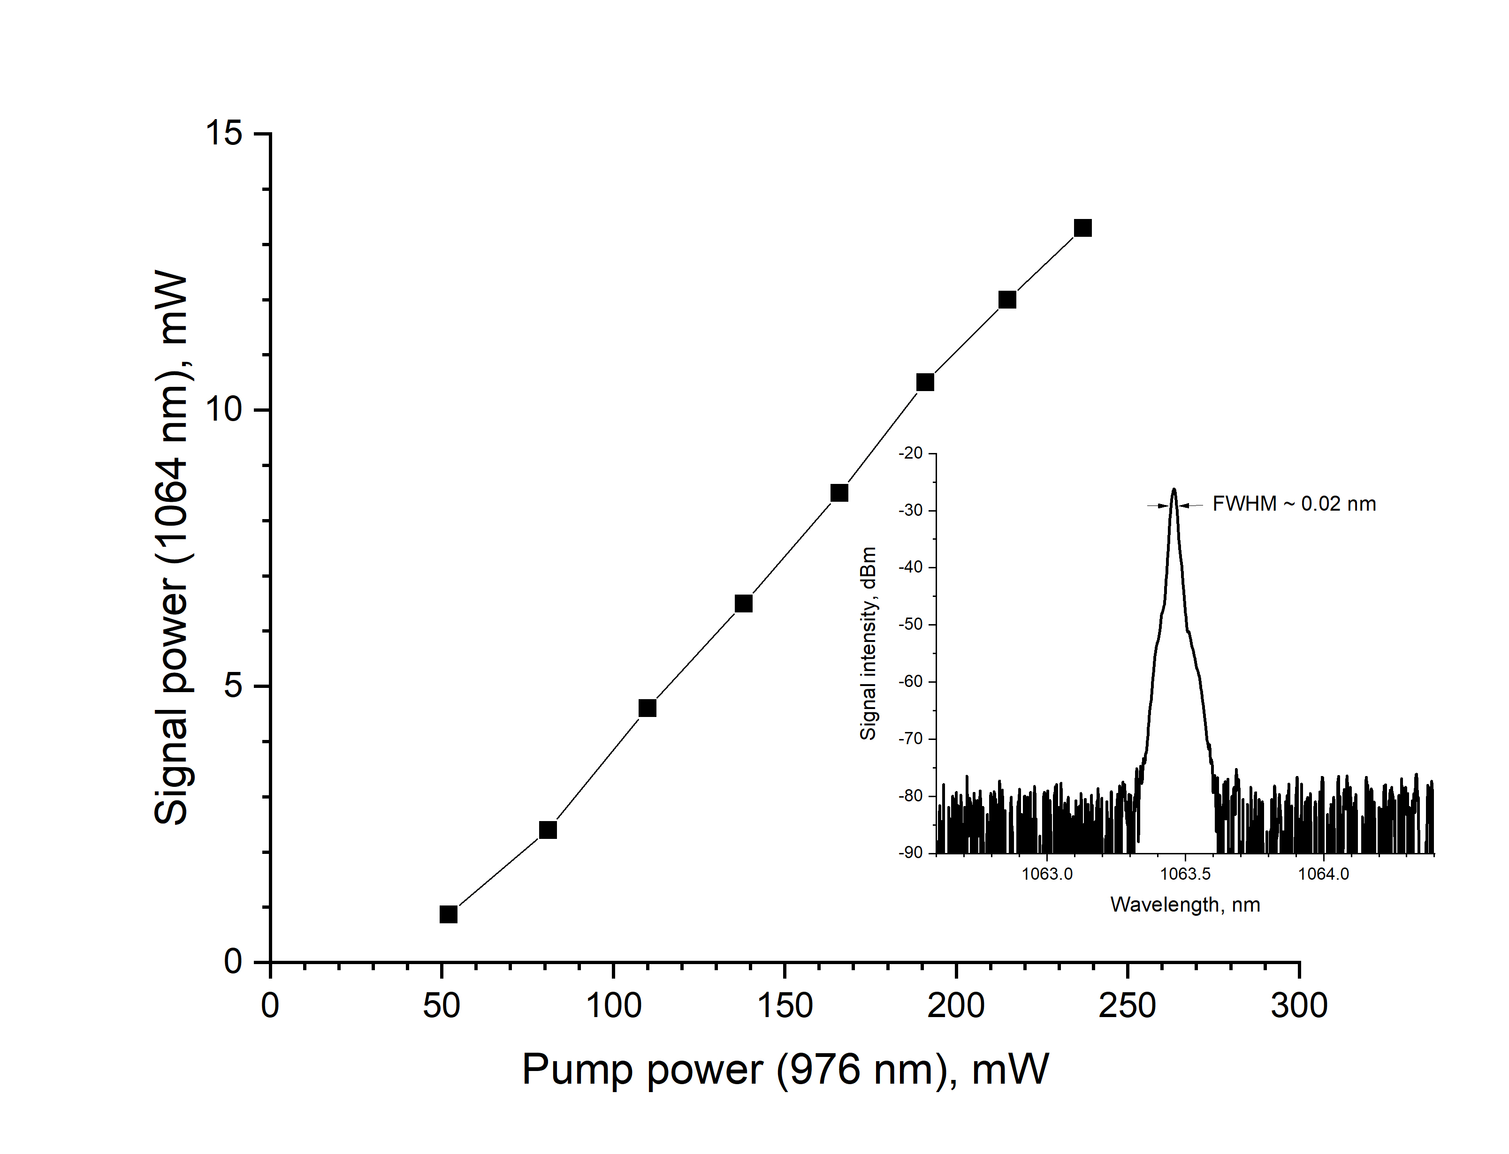
Figure 1. Dependence of output single-frequency signal power on pump power. Upper insert: scheme of DFB fiber laser; bottom insert: output spectrum of the DFM fiber laser.

REFERENCES
[1] K.K.Bobkov, E.K. Mikhailov, T.S. Zaushitsyna, A.A. Rybaltovsky, S.S. Aleshkina, M.A. Melkumov, M.M. Bubnov, D.S. Lipatov, M.V. Yashkov, A.N. Abramov, A.A. Umnikov, A.N. Guryanov, M.E. Likhachev, "Properties of silica based optical fibers doped with an ultra-high ytterbium concentration", J. of Lightwave Technology, 40(18), 6230-6239 (2022).
[2] Y.Li, X.Deng, S.Fu, Q.Sheng, C.Shi, J.Zhang, L.Zhang, W.Shi, and J. Yao, "High-power, high-efficiency single-frequency DBR fiber laser at 1064 nm based on Yb3+-doped silica fiber," Opt. Lett. 48, 598-601 (2023).

