Optimized AR Facet Coatings for 4.6 µm QCLs in Directed Infrared Countermeasures

M. Ozdemir¹, K. Aras², S. Eroğlu², M. Ekmekcioglu^{1,2}, and L. Ozyuzer¹
¹ Teknoma Technological Material Inc. IZTECH Campus, Urla, 35430, İzmir, Türkiye
² Department of Physics, Izmir Institute of Technology, Urla, 35430, İzmir, Türkiye
e-mail: mehtapozdemir@teknoma.net

Mid-wave infrared (MWIR) Quantum Cascade Lasers (QCLs) are useful for applications such as remote spectral sensing, chemical spectroscopy, breath analysis, free space communications, and infrared countermeasure [1]. Directed Infrared Countermeasure (DIRCM) is especially important in military application. It is possible to confuse heat-seeking missiles guidance systems by mid-infrared source in order to protect aircrafts. Most of these application needs high output power and high-efficiency lasers. There are several ways to increase the output power. One of them is increase the number of active region stages. While this method results in higher peak power in pulsed mode, it leads to increase of temperature in the active region. Unlike other approaches, increasing the cavity length does not cause additional heating in the active region or degrade the beam quality [2]. Therefore, controlling the facet reflectivity emerges as a crucial design consideration for optimization. Two main methods are used to reduce laser facet reflectivity: angled-facet waveguides, which are effective but add optical complexity, and dielectric anti-reflection (AR) coatings, which are simpler and widely adopted. Applying these optical coatings to the front facets of QCLs reduces internal reflections and enhances the emitted optical power [3]. In this study, AR coatings were designed for the front facet of the laser as shown in Figure 1.a to enhance the optical efficiency and output power of QCLs, particularly for DIRCM applications at 4.6 µm, where aircraft strongly emit CO₂ radiation and heat-seeking missiles have high sensitivity. The AR coating was optimized to reduce reflectance to below 10% at this wavelength. Multilayer thin-film structures of AlN and Al₂O₃ on a GaAs substrate were modeled and simulated using OpenFilters programme. The optimal simulation was achieved with an AlN (200 nm) / Al₂O₃ (190 nm) / GaAs (2.0 mm) configuration, resulting in ~7% reflectance at 4.6 µm, as shown in Figure 1.b. After the modeling study, the Al₂O₃ and AlN layers were deposited on GaAs respectively using magnetron sputtering without breaking vacuum, yielding a total thickness of 410 nm. Reflectance measurements with a Bruker Vertex V80 FTIR spectrometer showed ~15% reflectance at 4.6 µm. The details of the fabrication of AR coatings and comparison of results with simulations will be discussed.
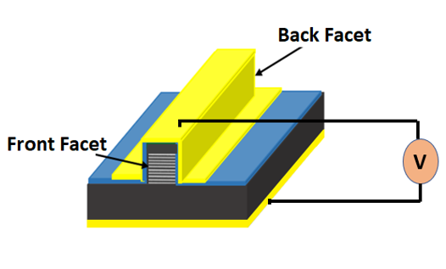.
a)
b)
Figure 1. a) Front facet of the QCL b) Simulation results of the AR coatings

This work was partially supported by TUBITAK project number 22AG072. The authors would like to acknowledge the facilities of Research and Application Center for Quantum Technologies (RACQUT) of IZTECH.

REFERENCES
[1] D. Niewczas, D. Pierscinska, G. Sobczak, P. Kozlowski, A. Krząstek, T. Stefaniuk, K. Pierscinski, Appl. Phys. B 130, 192 (2024).
[2] R. Maulini, A. Lyakh, A. Tsekoun, R. Go, C. Pfluegl, L. Diehl, F. Capasso and C. Patel, Appl. Phys. Lett. 95, 151112 (2009).
[3] Y. Matsuoka, M.P. Semtsiv, S. Peters, W.T. Masselink, Opt. Lett. 43, 4723 (2018).

