3D Printing at the nanoscale using MultiPhoton Lithography

Maria Farsari¹
¹FORTH/IESL, Heraklion, Greece
e-mail: mfarsari@iesl.forth.gr

Multiphoton Lithography (MPL) is an advanced laser-based additive manufacturing technique that enables the fabrication of highly complex three-dimensional micro- and nano-structures with resolutions down to just a few tens of nanometers¹. By employing nonlinear multiphoton absorption, MPL offers unique capabilities that remain unmatched by any other 3D printing method currently available.
This exceptional resolution and design freedom make MPL a powerful tool for directly transforming computer-designed models into fully functional 3D devices with sub-micrometric precision. Over the past years, MPL has been applied to a wide range of materials, enabling the realization of micro-optical elements, electromagnetic and mechanical metamaterials, biomedical scaffolds, photocatalytic systems, and more.
In this tutorial, we will provide a comprehensive introduction to the principles and practical applications of Multiphoton Lithography, with a focus on practical examples that illustrate its unique potential. The session will begin with an overview of the nonlinear absorption mechanism that underpins MPL, the process parameters that determine resolution and fabrication speed, the workflow from computer-aided design (CAD) to printed structures. Special focus will be given to the materials used.
The tutorial will then explore in detail three case studies that showcase the versatility of MPL:
- Micro-optical elements, such as free-form lenses, diffractive optical elements, and waveguides for advanced photonic applications.
- Electromagnetic and mechanical metamaterials, demonstrating how MPL enables the creation of architected structures with tailored electromagnetic responses or unusual mechanical behaviours, such as electromagnetically induced transparency or auxeticity.
- Scaffolds for tissue engineering, highlighting how MPL can fabricate precisely controlled 3D architectures that support cell growth and guide tissue regeneration at the microscale.

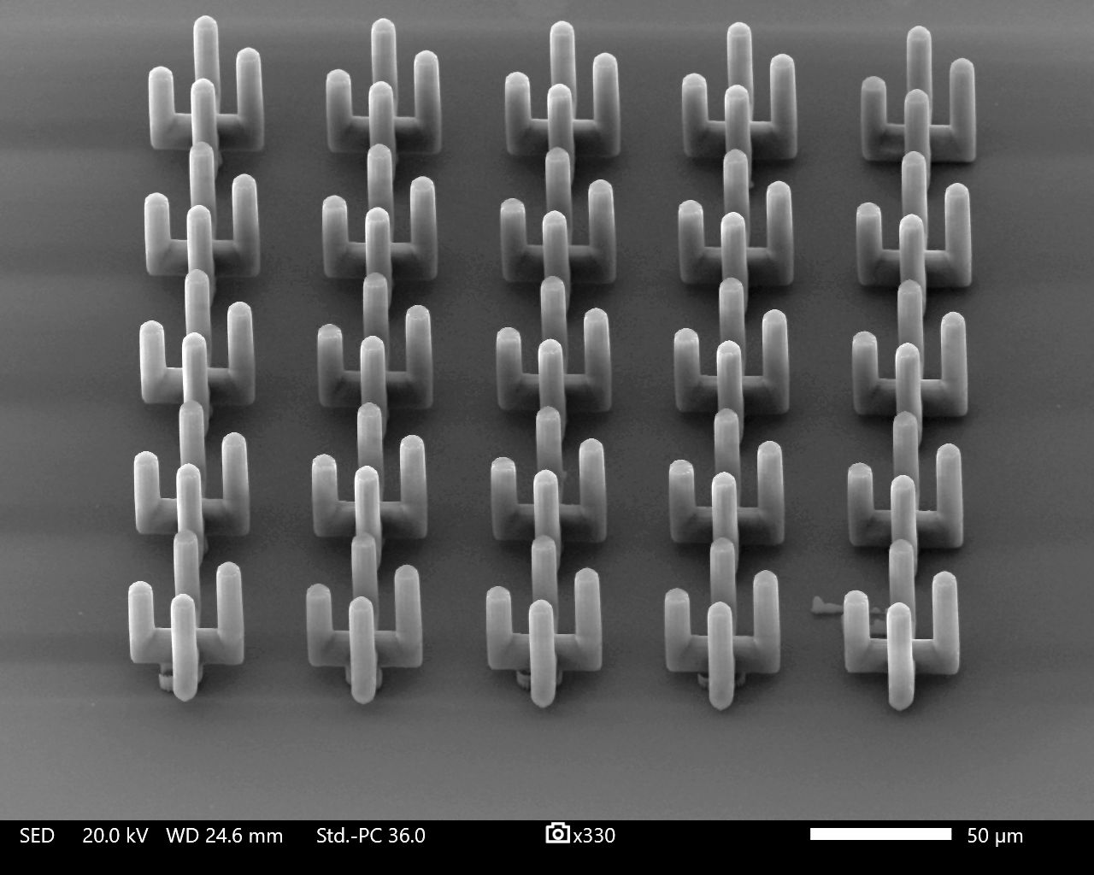 | 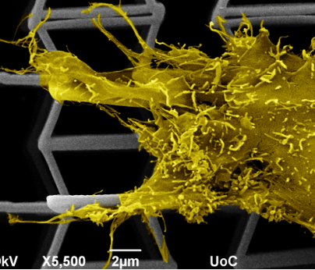
(a) | (b)

Figure 1. (a) A THz metamaterial (b) SEM image of cells growing on an auxetic material

REFERENCES

[1] Zyla, G. & Farsari, M. Laser & Photonics Reviews 18, 2301312, (2024).

