Electronic transport in semiconductors:
from textbook knowledge to modern problems

N. Vukmirović¹
¹Institute of Physics Belgrade, University of Belgrade, Belgrade, Serbia
e-mail: nenad.vukmirovic@ipb.ac.rs

In this talk, I will start by giving a brief review of textbook knowledge on electronic transport in semiconductors, gained in the course of Solid State Physical Electronics by late Prof. Vitomir Milanović. Then, I will present the results of my first paper, resulting from diploma thesis work under Prof. Milanović. In that work [1], we analyzed the optical gain of a GaN quantum well as a potential active medium for an optically pumped terahertz laser. We showed that a three level design can yield significant population inversion between the upper and lower laser level.

I will then drift into modern problems on electronic transport in semiconductors and our recent results in this field. I will first talk about pieces of physics behind electron mobility in semiconducting materials [2]. The methodology for obtaining the electronic states, the phonon modes and the electron-phonon coupling constants within density functional theory will be reviewed. Particular focus will be given on physical considerations necessary to perform accurate interpolation of electron-phonon coupling constants to a dense momentum grid in the first Brillouin zone. The results for temperature dependence of mobility in II-VI semiconductors will be shown (see Fig. 1) and compared to experimental results from the literature.
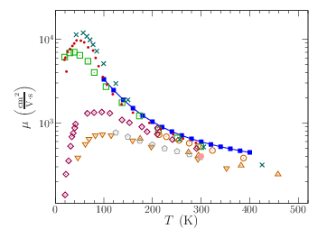
Figure 1. Temperature dependence of electronic mobility in ZnSe. Full line denotes the simulation results while other symbols denote various experimental results from the literature.
I will talk next about the methodology that we introduced to efficiently calculate electronic relaxation times and mobility in semiconducting materials [3]. The methodology will be illustrated by applying it in two cases: the Fröhlich model where analytic solutions exist and hence a comparison can be made, and the real semiconducting material ZnTe. The presentation will be concluded by showing the cases where the conventional Bloch-Boltzmann picture of electronic transport in semiconductors fails calling for novel approaches.
This research was supported by the Science Fund of the Republic of Serbia, Grant No. 5468, Polaron Mobility in Model Systems and Real Materials–PolMoReMa.

REFERENCES
[1] N. Vukmirović, V. D. Jovanović, D. Indjin, Z. Ikonić, P. Harrison, V. Milanović, J. Appl. Phys. 97, 103106 (2005).
[2] N. Vukmirović, Phys. Rev. B 104, 085203 (2021).
[3] N. Vukmirović, Comput. Phys. Commun. 312, 109583 (2025).

