Cross waveguide design for color-centers in diamond

A. Miranda^{1,2}, R. Ishihara^{1,2} and S. Nur¹
¹Department of Quantum Computer Engineering, Faculty of Electrical Engineering Mathematics and Computer Science, Delft University of Technology, Delft, The Netherlands
² QuTech, Delft University of Technology, Delft, The Netherlands
e-mail: a.m.d.miranda@tudelft.nl

Color centers in diamond for quantum networking and computing are experiencing a growing interest because of their peculiar optical and spin properties [1]. Nevertheless technological and cost issues hinder the use of diamond for a complete quantum circuit. To cope with these limitations it is convenient to fabricate a diamond chiplet containing the color center(s) which is then heterogeneously integrated to a receptor fabricated on other platforms (e.g. by pick and place technology, P&P) [1,2,3]. The chiplet consists of a diamond multimode interferometric cross waveguide embedding the color center as well as port waveguides (WGs) for collecting excitation and emission (with eventual tapers and gratings for loss and crosstalk suppression), and tethers to connect it to a frame; the receptor, consists of adiabatic couplers, WGs, and other photonic components. In addition to P&P, this design can find application in any integration scheme such as transfer printing or DOI monolithic.

In order for the system to function properly each component must be designed in order to maximize the excitation to emission conversion and transmission efficiency, working bandwidth, fabrication feasibility and tolerance. Here we propose a methodology to perform this optimization for each component of the chiplet, of the receptor and of their combination: after a comparison of various alternatives presented in the literature, we show a complete study for the chosen solution. Apart from the proposed application, this methodology is of interest for a wider audience because it offers a strategy of optimization for components commonly used in other areas of photonics.

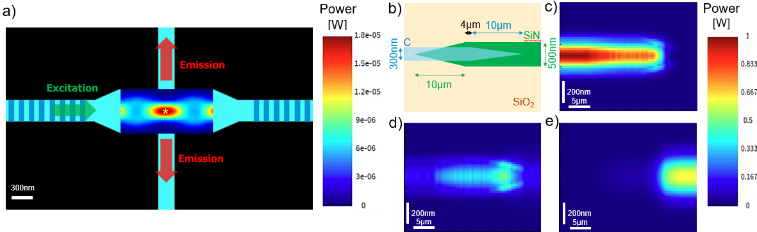

Figure 1. a) structure and power distribution of an adiabatically tapered MMI (1.6µm x 600nm) with Bragg reflectors at the horizontal diamond WGs (300nm x 250nm). b) structure of overlapping diamond and SiN adiabatic couplers (10µm long with 100nm ending and overlap of 4 µm) and corresponding power distribution in c) diamond coupler, d) interface between the couplers, e) the SiN coupler to SiN WG (500nmx250nm).
We gratefully acknowledge support from the joint research program “Modular quantum computers” by Fujitsu Limited and Delft University of Technology, co-funded by the Netherlands Enterprise Agency under project number PPS2007.

REFERENCES
[1] M. Ruf, N. H. Wan, H. Choi, D. Englund, R. Hanson, J. Appl. Phys. 130, 070901 (2021).
[2] N. H. Wan, Ts.-J. Lu, K. C. Chen, M. P. Walsh, M. E. Trusheim, L. De Santis, E. A. Bersin, I. B. Harris, S. L. Mouradian, I. R. Christen, E. S. Bielejec, D. Englund, Nature 583, 226 (2020).
[3] R. Ishihara, J. Hermias, S. Neji, K. Y. Yu, M. van der Maas, S. Nur, T. Iwai, T. Miyatake, S. Miyahara, K. Kawaguchi, 2023 IEEE International Interconnect Technology Conference (IITC) and IEEE Materials for Advanced Metallization Conference (MAM), 1 (2023).

