Multiphoton Live-Cell Metabolic Imaging and Femtosecond Laser Nanosurgery of Filamentous Fungi

T. Pajic¹, N. V. Todorovic², K. Stevanovic¹, M. D. Rabasovic³, M. Živic¹ and A. J. Krmpot³
¹Faculty of Biology, University of Belgrade, Serbia
²Institute for Biological Research “Siniša Stanković”- National Institute of the Republic of Serbia, University of Belgrade, Serbia
³Institute of Physics - National Institute of the Republic of Serbia, University of Belgrade, Serbia
e-mail: tpajic@bio.bg.ac.rs

Filamentous fungi are of enormous ecological, medical and biotechnological importance. Studying their physiology and dynamics in vivo is crucial for understanding their interaction with the environment as well as for developing new therapeutic strategies for disease-causing pathogens. Nonlinear laser microscopy modalities, two-photon excitation fluorescence (TPEF) and third harmonic generation (THG) microscopy, were applied to image structural and functional changes in the cellular (lipid and energy) metabolism of model filamentous fungus Phycomyces blakesleeanus, at the single-cell level. Label-free THG method was used for the first time to image lipid droplets (LDs) in live filamentous fungi that predominantly have LDs smaller than 1 µm [1]. Under various environmental conditions, THG was able to detect changes in size, number and location of the LDs in tiny fungal cells. On the other hand, TPEF enabled the monitoring of morphological changes of mitochondria in real time under the same conditions as THG imaging.
To study fungal physiology, the first femtosecond IR laser nanosurgery was performed on the cell wall of filamentous fungi, enabling electrophysiological measurements on the protoplasts released from the hyphae [2]. The high precision of fs laser ablation allowed us to cut a small portion of the cell wall without damaging the cell membrane only a few micrometers away. A reproducible and highly precise (diffraction-limited, submicron resolution) method for obtaining viable protoplasts was developed. Protoplast release from the nanosurgery-generated incisions in the cell wall was achieved from different regions of the hyphae. The introduction of this method opened the way to investigate the physiology of ion channels directly on the cell membrane of filamentous fungi, which is otherwise inaccessible due to the presence of a rigid chitinous cell wall.

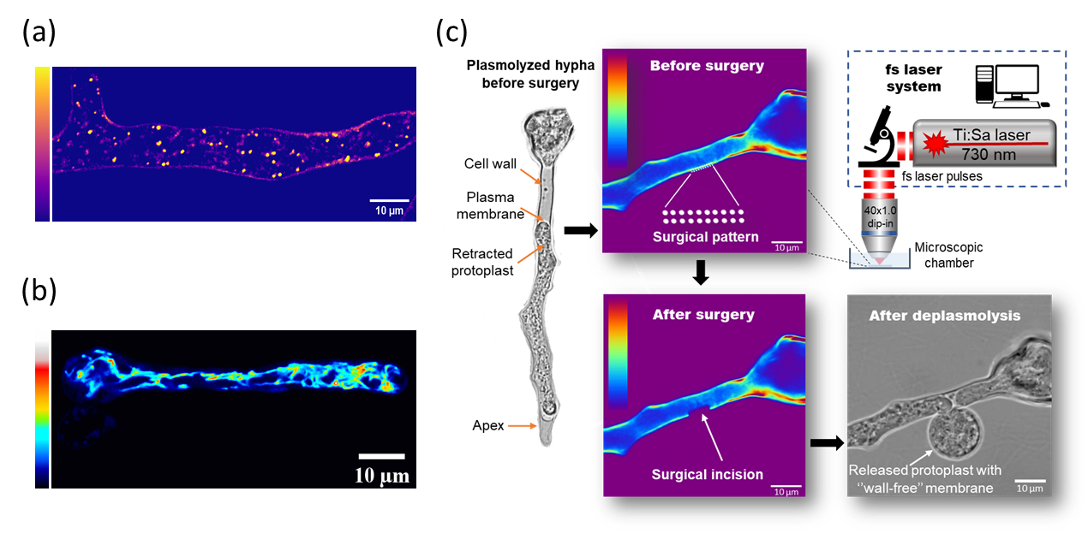
Figure 1. (a) Label-free THG image of lipid droplets in live P. blakesleeanus hypha (b) TPEF image of tubular mitochondria stained with 5 µM Rhodamine123 in live P. blakesleeanus hypha (c) In vivo femtosecond laser nanosurgery of chitinous cell wall of filamentous fungus P. blakesleeanus.
REFERENCES
[1] T. Pajić, N.V. Todorović, M. Živić et al., Sci Rep 12, 18760 (2022).
[2] T. Pajić, K. Stevanović, N.V. Todorović et al., Microsyst Nanoeng 10, 47 (2024).

