Exploring the Phase Diagram of Quantum Many-Body Scars with Programmable Rydberg Atom Arrays

A. Hudomal¹
¹Institute of Physics, Belgrade, Serbia
e-mail: ana.hudomal@ipb.ac.rs

Quantum many-body scarring is a form of weak ergodicity breaking, where specific initial states exhibit non-thermalizing dynamics despite the system's overall chaotic behavior [1]. We use programmable Rydberg atom arrays to explore the interplay between scarring and quantum criticality. Contrary to expectations [2], our previous numerical study revealed the persistence of quantum many-body scarring across the Ising critical point in the effective PXP model [3]. A detailed dynamical phase diagram of the one-dimensional PXP model with a varying chemical potential was mapped out using extensive numerical simulations. Notably, a continuous family of scarred states was identified, spanning both sides of the phase transition. We now experimentally verify this phase diagram using QuEra's Aquila device [4]. We also investigate the role of the Kibble-Zurek mechanism and defect formation during the preparation of the initial state, as well as the effects of defect density and type on the scarred dynamics. Finally, we discuss how our work can be extended to two spatial dimensions and various lattice geometries, where potentially richer phase diagrams and previously unseen families of scarred states may be discovered.

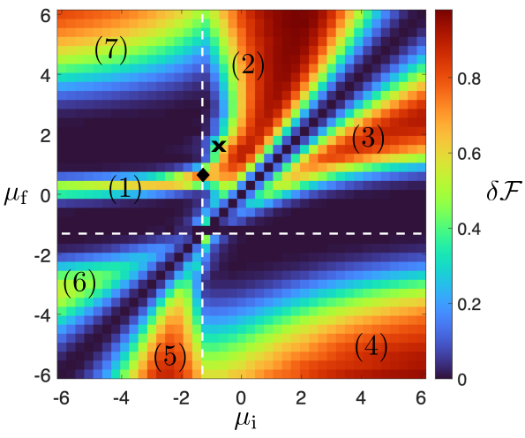

Figure 1. Dynamical phase diagram of the PXP model with chemical potential [3].

REFERENCES
[1] M. Serbyn, D. A. Abanin, and Z. Papić, Nat. Phys. 17, 675 (2021).
[2] Z. Yao, L. Pan, S. Liu, and H. Zhai, Phys. Rev. B 105, 125123 (2022).
[3] A. Daniel et al., Phys. Rev. B 107, 235108 (2023).
[4] J. Wurtz, et al., arXiv:2306.11727 (2023).

