Electron-plasmon Scattering in Doped Graphene

Josip Jakovac
¹Institut za fiziku, Zagreb, Croatia’
e-mail: jjakovac@ifs.

Decay mechanisms and plasmon satellites formed in the spectrum of a photo-excited
hole in doped graphene is a phenomenon that has been investigated for a long time using Angle
Resolved Photo-Emission Spectroscopy (ARPES) measurements [1–3]. The results I will present are produced by the ab-initio simulation of photo-emission spectra in electrostatically and
chemically (KC₈ ) doped graphene, in the framework of our recently developed many-body RPA-
G₀W₀ approximation. The decay width along the graphene π⁺/π⁻ bands at the Fermi level features
the exponential law Γ ∼|E_{σ,πK} -E_{Fermi} |^{α} (Fig. 1a), which perfectly fits the previous experimental
results [1, 4], deviating from the standard Fermi liquid behavior α = 2. At lower energies, the width
of the π⁺/π⁻ bands exhibits a peak due to the Dirac plasmon emission decay, also experimentally
measured [1]. On the other hand, the plasmonic satellites appearing in the spectrum (Fig. 1b) feature
much lower intensities than experimentally obtained [2, 3], except in the E_{Dirac} < ω < E_{Fermi}
frequency range. Also, due to the Fermi liquid theory, we obtained a kink at the Fermi level in
highly doped graphene (Fig. 1b).

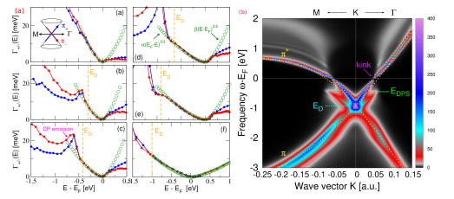

Figure 1. a) The imaginary part of self-energy along π⁺ /π⁻ bands in electrostatically doped [witt concentrations increasing (a)→(e)] and chemically (f) doped KC₈ graphene. b) The simulation of spectral intensity along the high symmetry path (M←K→ Γ) in electrostatically highly doped graphene (10 ¹⁴ cm⁻² ).

REFERENCES
[1] A. Bostwick, T. Ohta, T. Seyller, K. Horn and E. Rotenberg, Nature Phys. 3, 36 (2007).
[2] H. Zhang, S. Wang, E. Wang, et al, npj Quantum Mater. 6, 83 (2021).
[3] A. Bostwick, F. Speck, T. Seyller et al, Science 328, 999 (2010).
[4] J. Jakovac and V. Despoja, Phys. Rev. B 110, 195425 (2024).

