Blue and red diode pumped low-cost ultrafast lasers
for biomedical applications

Bojan Resan
School of Engineering, University of Applied Sciences and Arts Northwestern Switzerland
Windisch, Switzerland
e-mail: bojan.resan@fhnw.ch

Last years, we witnessed a huge progress in high power laser diodes and modules in visible wavelength range. The GaN material improvements for blue laser diodes were driven by the high demand for Blue-Ray technology and display industry. kW – class blue diode modules with fiber delivery, are demonstrated for materials processing. Red fiber delivered diode modules generating 100s of W are also reported. Those advances in high power blue and red diodes are enabling direct diode pumping of the mature laser materials with superb output performance, including titanium doped sapphire and alexandrite. Absorption peak of titanium doped sapphire is in green and therefore the common pump laser is a complex frequency doubled solid-state laser. The high cost, large footprint, and low reliability of such pump lasers prevented industrial applications of titanium doped sapphire laser. On the other hand, alexandrite lasers are used in medical applications, but are currently pumped with red flash lamps.
We will present our results of the blue laser diode pumped SESAM modelocked femtosecond laser generating 400 mW average power and 70 fs pulse duration [1]. We used such laser for non-linear microscopy and obtained two-photon fluorescence and second-harmonic generation images. We generated up to 70 nm bandwidth from such blue diode pumped titanium-sapphire oscillator, which is a very promising light source for high resolution optical coherence tomography. With a blue diode fiberized module, we obtained >30% small-signal gain in a single pass through the amplifier crystal [2]. We designed a room temperature blue diode pumped titanium-sapphire regenerative amplifier system.
On the other hand, we achieved 1 W in CW mode from the red diode pumped alexandrite laser. This is very promising for modelocking, which was not obtained so far with red diode pumping.

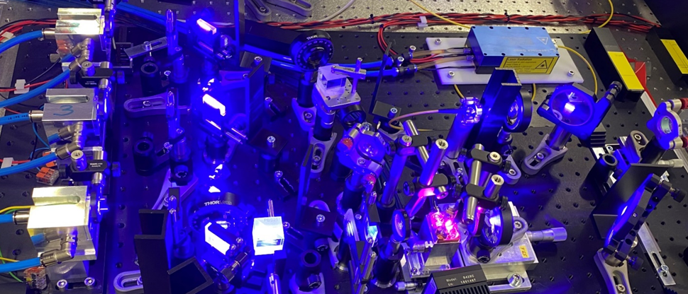
Figure 1. Blue diode pumped Ti:sapphire amplifier.

REFERENCES
[1] A. Rohrbacher, O. E. Olarte, V. Villamaina, P. Loza-Alvarez, and B. Resan, “Multiphoton imaging with blue-diode-pumped SESAM-modelocked Ti:sapphire oscillator generating 5 nJ 82 fs pulses,” Optics Express 25(9), 10677-106784, May 2017.
[2] D. Hug, A. Dax, R. Carreto, T. Südmeyer, A. Trisorio and B. Resan, “Progress in Blue Diode-Pumped Titanium:Sapphire Regenerative Amplifier at Room Temperature,” CLEO EU, Munich, June 2023.

