Photo-electronic security device based on photonics integrated circuits

Christofer Cid-Lara^{1,2,3} and Rodrigo A. Vicencio^{1,2}
¹Departamento de Física, Facultad de Ciencias Físicas y Matemáticas, Universidad de Chile, Chile
²Millenium Institute for Research in Optics – MIRO, Chile
¹Departamento de Ingeniería Eléctrica, Facultad de Ciencias Físicas y Matemáticas, Universidad de Chile, Chile
e-mail:c.cid.l@outlook.com

Photonics chips or Photonic integrated circuits (PIC) are mainly based on waveguide lattices phenomena and have been widely studied on several fields such as computing [1], neural networks training and inference [2], analogies of physical systems [3], and microfluidics [4]. But real applications face substantial limitations due to the utilization of expensive equipment such as lasers, cameras and optics in a controllable environment.

We propose and test a photonic chip having an array-like pattern to encode binary information (users definition) that can be reconstructed through automatic image processing on free space after illumination. This detection can produce a triggering signal of opening/closing into a given actuator. We created a low-budget device capable of detecting binary patterns of femtosecond-written waveguide lattices in borosilicate. Our system only requires a LED, a lens, a microcontroller, and a cheap CCD camera. We also propose scalability to more complex systems, having improved security protocols, like encrypting information in the form of flat bands states [5].

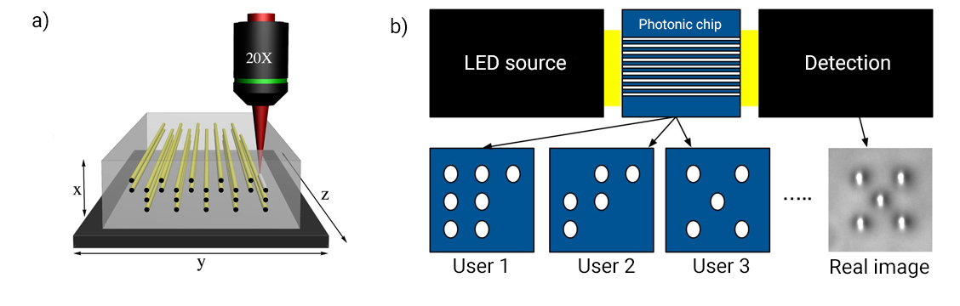
Figure 1. (a) Femtosecond laser writing technique. (b) Diagram of the photo-electric system
As shown in Fig. 1 (b) we encode users as a binary matrix (in this figure 3x3) inside the photonic chip, so it can be detected through a CCD camera once it is illuminated with a LED. The detection is made through image processing in a Raspberry Pi Zero W and OpenCV python library in real time with high specificity.

REFERENCES
[1] Nakajima, M., Tanaka, K. and Hashimoto, T. Scalable reservoir computing on coherent linear photonic processor. Commun Phys 4, 20 (2021).
[2] Ashtiani, F., Geers, A.J. and Aflatouni, F. An on-chip photonic deep neural network for image classification. Nature 606, 501–506 (2022).
[3] Román-Cortés, D., Fadic, G., Cid-Lara, C. et al. Strain induced localization to delocalization transition on a Lieb photonic ribbon lattice. Sci Rep 11, 21411 (2021).
[4] Rodríguez-Ruiz I, Ackermann TN, Muñoz-Berbel X, Llobera A. Photonic Lab-on-a-Chip: Integration of Optical Spectroscopy in Microfluidic Systems. Anal Chem. 2016 Jul 5;88(13):6630-7.
[5] Vicencio, R.A., Mejía-Cortés, C., Morales-Inostroza, L., Cantillano, C., and Real, B., “Control system and procedure for controlled access by means of an optical device based on flat bands'' US20180210150A1.

