Quantized vortices in dipolar BECs when crossing the
superfluid-supersolid phase transition

M. Sindik^{1,2}, A. Recati^{1,3}, S. M. Roccuzzo⁴, L. Santos⁵, and S. Stringari^{1,3}
¹Pitaevskii BEC Center and Department of Physics, University of Trento, Italy
²Institute of Physics Belgrade, University of Belgrade, Serbia
³Trento Institute for Fundamental Physics and Applications, INFN, Italy
⁴Kirchhoff-Institute for Physics, Ruprecht-Karl University of Heidelberg, Germany
⁵Institute for Theoretical Physics, Leibniz Universität Hannover, Germany
e-mail: marija.sindik@unitn.it

We study quantized vortices in dipolar Bose-Einstein condensates at the transition between the superfluid and the supersolid phase [1]. Recently, ultracold atomic gases have revealed unique features of supersolidity, an intriguing state of matter which presents simultaneously crystalline order and superfluidity [2]. However, the experimental observation of quantized vortices in these systems remains an open issue, since their observability in dipolar supersolids is largely prevented by the strong density depletion caused by the formation of droplets [3].

We propose a novel approach to the nucleation of vortices and their observation, based on the quenching of the s-wave scattering length across the phase transition. Starting from a slowly rotating, vortex-free configuration in the superfluid phase, quenching into the supersolid phase drives the vortex nucleation, due to the strong reduction of the critical angular velocity in the supersolid, as illustrated in Fig. 1. Once a vortex is created, it is robustly preserved when the condensate is brought back to the superfluid phase, where it may be readily observed. These results may have a significant impact on ongoing experiments, given that the observation of quantized vortices would constitute a key probe of the superfluid character of dipolar supersolids.

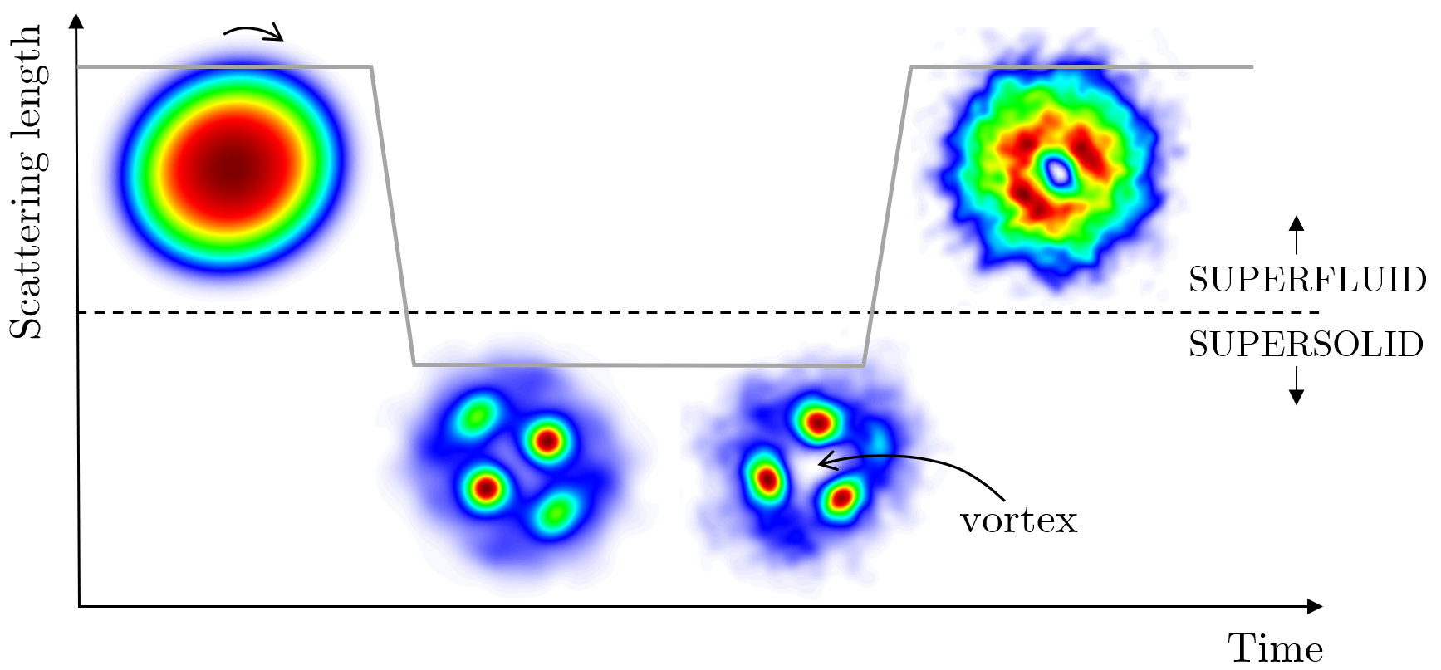

Figure 1. Step-by-step illustration of the protocol process

REFERENCES
[1] M. Sindik, A. Recati, S. M. Roccuzzo, L. Santos, S. Stringari, Phys. Rev. A 106, L061303 (2022).
[2] L. Tanzi et al., PRL 122, 130405 (2019).
F.Bottcher et al., Phys. Rev. X 9, 011051 (2019).
L. Chomaz et al., Phys. Rev. X 9, 021012 (2019).
[3] A. Gallemi, S. M. Roccuzzo, S. Stringari, and A. Recati, Phys. Rev. A 102, 023322 (2020).

