W**ave-packets induced by the radiation of an atom coupled to the continuum in photonic lattices**

B. Real1,2, D. Guzmán-Silva1,2 and R. A. Vicencio1,2

1 *Departamento de Física, Facultad de Ciencias Físicas y Matemáticas, Universidad de Chile, Chile*

2*Millennium Institute for Research in Optics - MIRO, Chile*

bastianreal71@gmail.com

The generation of an input wave-packet with well-defined momentum and energy is an experimental challenge when exciting photonic lattices. So far, most of the experimental techniques lie in externally modulating a beam via, for instance, spatial light modulators [1]. Despite these progresses, an optically integrated control of wave-packets is needed to excite desired eigenstates, which could facilitate concatenate photonic operations.

In this work, we exploit the analogy of an atom decaying into a continuum using waveguide arrays [2, 3], to generate wave-packets with precise momenta. A metastable atom and the continuum are simulated respectively by a single waveguide and a 1D tight-biding lattice [2], which are weakly coupled, as schematized in Fig. 1(a). The temporal decay and radiation are mapped into the spatial propagation along the waveguides facilitating the detection at given “times”. Experimentally, we fabricate a waveguide weakly coupled to a 1D photonic lattice using the femtosecond laser writing technique [4]. We excite the waveguide atom and, after 3 cm of propagation, we detect the radiation in the 1D lattice has a specific momentum [see Fig. 1(b)-(c)]. When placing an adjacent SSH lattice in the nontrivial topological phase, the wave-packet with wave-vector center in $π/2$ (and thus zero energy) excites precisely one of its edge state, exhibiting light intensity only on A sites, as shown in Fig. 1(d).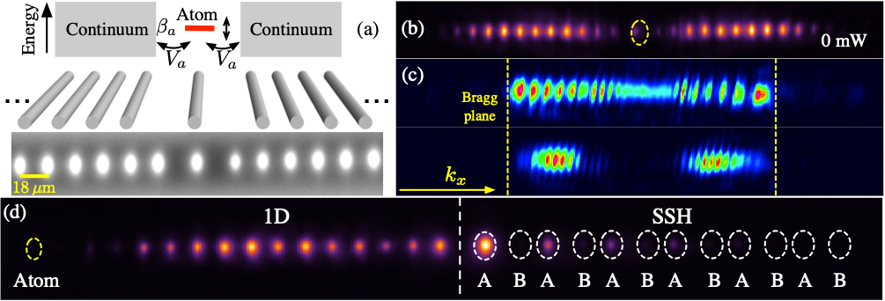

Figure 1. (a) Photonic analog of an atom coupled to a tight-binding continuum. Top panel schematizes the energy of the atom (red line) and the continuum. Middle, sketch of the photonic implementation. Bottom, output facet of the glass wafer after white illumination. (b) Output intensity profile when the atom is excited (yellow ellipse). (c) Fourier plane of both a discrete diffraction (top) and intensity pattern shown in (b) (bottom). (d) Excitation of a SSH edge state using the wave-packet. Yellow circle denotes the atom, and white ellipses indicate the SSH lattice sites (A and B) with alternating distances among them.

REFERENCES

[1] C. Cantillano, L. Morales-Inostroza, B. Real, S. Rojas-Rojas, A. Delgado, A. Szameit, R. A. Vicencio, Science Bulletin 62 (5), 339-344 (2017).

[2] S. Longhi, Phys. Rev. Lett. 97, 110402 (2006).

[3] F. Dreisow, A. Szameit, M. Heinrich, T. Pertsch, S. Nolte, A. Tünermann, S. Longhi Phys. Rev. Lett. 101, 143602 (2008).

[4] A. Szameit, D. Blo ̈mer, J. Burghoff, T. Schreiber, T. Pertsch, S. Nolte, A. Tu ̈nnermann, and F. Lederer, “Discrete nonlinear localization in femtosecond laser written waveguides in fused silica”, Opt. Express 13, 10552 (2005).