**Electric-field induced SHG (EFISHG) in graphene?**

J. Woeste1,2, N. Stojanovic2, M. Gensch2,1

1. *Technische Universität Berlin, Berlin, Germany.*
2. *Institut für Optische Sensorsysteme, DLR, Berlin, Germany*

**Contact:** M. Gensch ( [michael.gensch@dlr.de](mailto:michael.gensch@dlr.de) )

**Abstract**

High harmonics generation (HHG) is a process which gives a direct insight into nonlinear properties of matter. Modern quantum materials like graphene or topological insulators attract considerable interest from scientific communities interested in the fundamental understanding of the often-exotic light-matter interactions as well as in the search for new technological applications. We mastered to study the nonlinear THz properties of such materials by means of THz emission spectroscopy e.g. single layer graphene [1]. The developed experimental set-ups allow one to determine the incident and re-emitted THz fields quantitatively with unique sensitivity levels. The results obtained for monolayer graphene can be explained by a simple thermodynamic model [1, 2] and open up the technological possibility for purely electronic THz frequency synthesis within the present generation of graphene transistors operating at fundamental frequencies of a few hundred gigahertz. Recently our collaboration successfully showed that (i) the nonlinearity of graphene can be controlled over two orders of magnitude by applying moderate gate voltages in the sub-Volt regime [3] and (ii) that a specifically designed grating-graphene meta-material enables further increase in the THz nonlinearity via plasmonic field enhancement [4]. In these previous works, we have focused on studying nonlinearities of odd-order, since monolayer graphene is a centrosymmetric material, where even-order susceptibilities cancel out. As a next step we plan to investigate if an effective 2nd order nonlinearity (2) can be efficiently generated by applying appropriate in-plane DC electric fields, thus breaking the inversion symmetry, such as what has recently been demonstrated and observed in GaAs [5]. Preparations for this experiment and its feasibility are discussed.

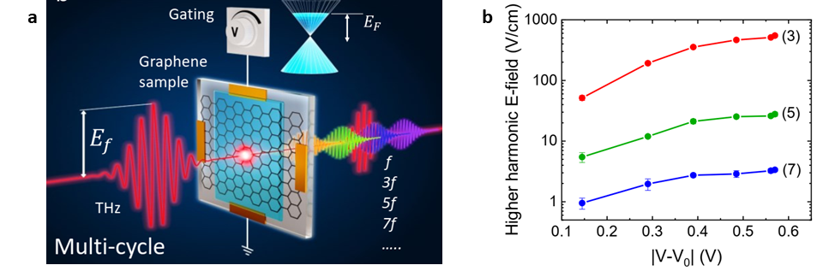

Figure 1. a Schematics of the recent THz HHG experiment on the gated graphene sample. b the peak electric field of the generated 3rd, 5th and 7th harmonics as a function of the gating voltage [3].

REFERENCES:

[1] H.A. Hafez et al, Nature **561**, 07 (2018).

[2] Z. Mics et al, Nat. Comm. **6**, 7655 (2015).

[3] S. Kovalev et al, Science Adv. **7**, eabf9809 (2021).

[4] J.-C. Deinert et al, ACS Nano **15**, 1145 (2021)

[5] K. Lee et al, Adv. Opt. Mat. **8**, 2000359 (2020).