Femtosecond laser spectroscopy for Exploration of Space

^{1,2}Y. Ha, ³O. Gueckstock, ⁴G. Kourfakas, ⁵J. Petrovic, ⁶M. Rabasovic, ⁶A. Krmpot, ^{3,7}T. Seifert, ⁸R. Pan, ³A. Denker, ^{3,7}T. Kampfrath, ¹N. Stojanovic, ^{1,2}M. Gensch
¹German Aerospace Center (DLR), Institute of Optical Sensor Systems, Rutherfordstr. 2, 12489 Berlin, Germany
²Technische Universität Berlin, Strasse des 17. Juni 135, 10623 Berlin, Germany.
³Department of Physics, Freie Universität Berlin, Arnimallee 14, 14195 Berlin, Germany
⁴Helmholtz-Zentrum Berlin, Hahn-Meitner Platz 1, 14109 Berlin, Germany
⁵Vinča Nuclear Research Institute, Mike Petrovića Alasa 12-14, 11351, Beograd, Serbia
⁶Institute of Physics Belgrade, Pregrevica 118, 11080 Belgrade, Serbia
⁷TeraSpinTec GmbH, Lüneburger Str. 26, 10557 Berlin, Germany
⁸DESY, Notkestraße 85, 22607 Hamburg, Germany
e-mail: nikola.stojanovic@dlr.de

Space agencies around the world have the exploration of solar system bodies in the focus of their activities for decades already. The search for traces of life and to a better understanding of the geology of planets, moons and asteroids motivates these explorations. Our (DLR institute for Optical Sensor Systems (DLR-OS)) contribution to this topic is the development of spectroscopic sensors for material identification. DLR-OS is developing a wide range of spectroscopic sensors that reach from passive infrared spectrometers for remote sensing employed on orbiters to active laser spectroscopies such as NIR spectroscopy, Raman spectroscopy or Laser-Induced Breakdown Spectroscopy that are employed on robotic lander missions. Space, weight and power restrictions as well as robustness against harsh environmental conditions are inherent prerequisites for space missions and lead to specific design solutions for these instruments. Driven by emerging technology of space ready short-pulsed (femtosecond) lasers [1,2], we are introducing the new topic of time domain spectroscopies to space exploration. In this work, we present our first results on coherent phonon and THz time domain spectroscopies on space relevant minerals.

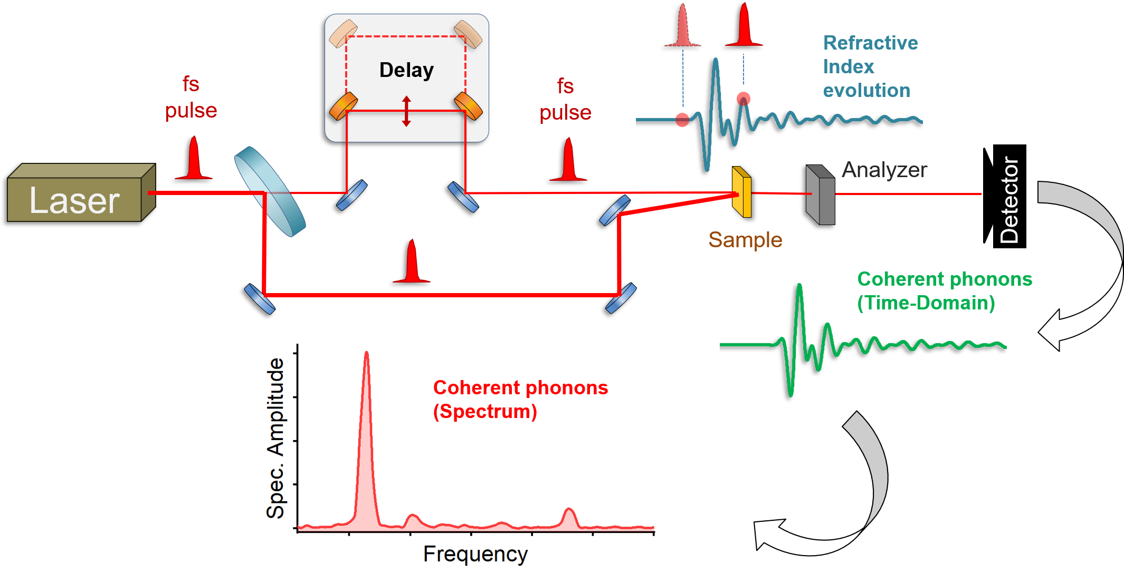
Figure 1. Scheme of Time-Domain Coherent Phonon Spectroscopy setup.

REFERENCES
[1] J. Lee, et al., Scientific Reports 4, 5134 (2014).
[2] M. Lezius et al., Optica 3, 1381 (2016).

