Rogue wave clusters of the nonlinear Schrödinger equation composed of Akhmediev breathers and Kuznetsov-Ma solitons

Stanko N. Nikolić^{1,2} Sarah Alwashahi³, Najdan B. Aleksić², Milivoj R. Belić²
¹Institute of Physics Belgrade, University of Belgrade, Pregrevica 118, 11080 Belgrade, Serbia
²Division of Arts and Sciences, Texas A&M University at Qatar, P.O. Box 23874, Doha, Qatar
³Faculty of Physics, University of Belgrade, Studentski trg 12, 11001 Belgrade, Serbia

e-mail: stankon@ipb.ac.rs

We analyze the various spatiotemporal patterns of rogue waves (RW) which may have the form of multi-elliptic clusters composed of Akhmediev breathers (AB) obtained on uniform background using the Darboux transformation (DT) scheme (Fig. 1). We solve the eigenvalue problem of the Lax pair of order n in which the first m evolution shifts are equal, nonzero, and eigenvalue dependent, while all eigenvalues' imaginary parts are close to one. We show that AB of order n − 2m appears at the origin and can be considered as central rogue wave. We show that the high-intensity narrow peak, with the complex intensity distribution in its vicinity, is enclosed by m ellipses consisting of the first-order ABs. The number of maxima on each ellipse is determined by its index and solution order [1].

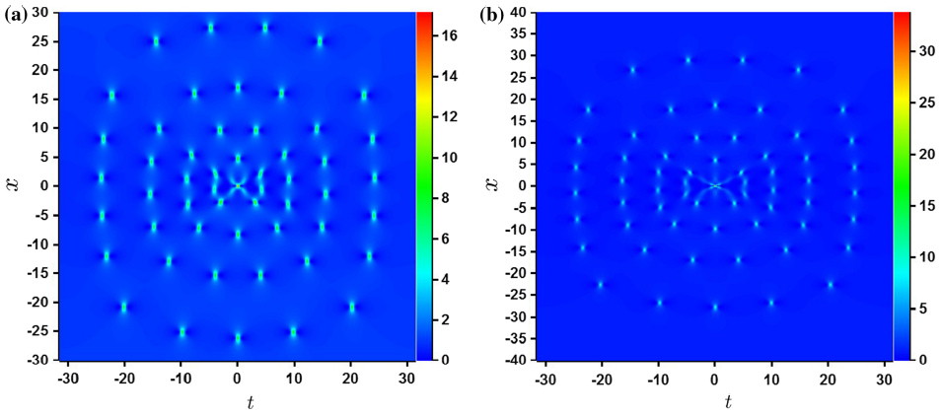
Figure 1. 2D color plots of rogue wave clusters on the uniform background having four ellipses (m = 4) around n − 2m order rogue wave, formed at the origin of the (x,t) plane. The orders of DT and the Akhmediev breather representing the central peak are: (a) n = 10 with the second-order RW, and (b) n = 11 with the third-order RW.

We next show RW clusters composed of Kuznetsov-Ma solitons (KMS), characterized by strong intensity narrow peaks, which are periodic along the evolution axis [2]. These structures are calculated in DT scheme with commensurate frequencies when eigenvalues are greater than one (Fig. 2a). The second solution class exhibits a form of elliptical rogue wave clusters (MERWC). Similarly to AB case, the first solution class is obtained when the first m evolution shifts in the n^{th} order DT scheme are nonzero and equal. Here the high intensity peaks built on KMS of order n-2m periodically appear along the evolution axis. The central rogue waves are enclosed by m ellipses consisting of a certain number of the first-order KMS (Fig. 2b).
(a)
(b)
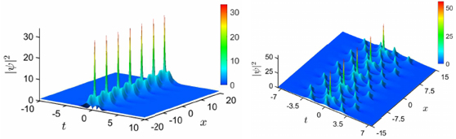
Figure 2. (a) The second-order KMS on a uniform background built from DT components with commensurate frequencies. (b) 3D intensity color plots of MERWC on the uniform background, having two ellipses (m=2) around the second-order central rogue waves (n=6).

REFERENCES
[1] S. N. Nikolić et al., Nonlinear Dyn. 108, 479 (2022).
[1] S. Alwashahi et al., Nonlinear Dyn (2023). https://doi.org/10.1007/s11071-023-08480-0.

