Large Thermally Irreversible Photoinduced Shift of Selective Light Reflection in Hydrazone-Containing Cholesteric Polymer Systems

M. Cigl¹, A. Boychuk², V. Shibaev², V. Hamplová¹, V. Novotná¹ and A. Bobrovsky²
¹Institute of Physics of the Czech Academy of Sciences
Prague, Czech Republic
²Department of Chemistry, Lomonosov Moscow State University
Moscow, Russia
e-mail:cigl@fzu.cz

Stimuli responsive self-organized polymers are peculiar class of so-called “smart” materials demonstrating various types of mesomorphic structures easily controlled by external electric field, light or physical stimuli. In the present work we synthesized and studied a comb-shaped hydrazone-containing copolyacrylate exhibited cholesteric liquid crystalline properties with the pitch length of the helix being tuned under irradiation with light. In the cholesteric phase selective light reflection in the near IR spectral range (1650 nm) was measured and a large blue shift of the reflection peak from 1650 nm to 500 nm was found under blue light (428 or 457 nm) irradiation. This shift is related to the Z-E isomerization of photochromic hydrazone-containing groups and it is photochemically reversible. The improved and faster photo-optical response was found after copolymer doping with 10 wt % of low-molar-mass liquid crystal. In contrast to many other photochromic systems based on E-Z isomerization, the E and Z isomers of hydrazone photochromic group are kinetically stable that enable to achieve a pure photoinduced switch without any dark relaxation at any temperatures. The large photoinduced shift of the selective light reflection, together with thermal bistability, makes such systems promising for applications in photonics.
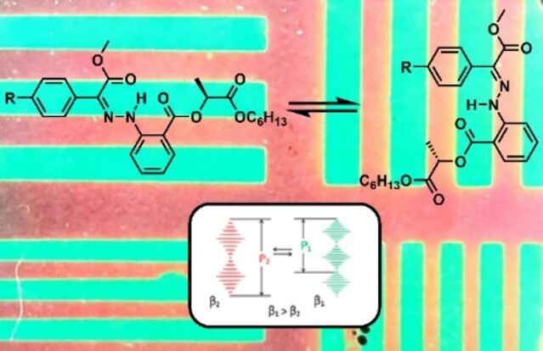

Figure 1. Hydrazone–containing copolyacrylate showing photoreversible large shift of the selective light reflection under blue and UV light irradiation

REFERENCES
[1] A. Bobrovsky, A. Ryabchun, M. Cigl, V. Hamplová, M.Kaspar, F.Hampl, V.Shibaev J. Mater.Chem.C 2, 8622, (2014).
[2] A. Boychuk, V. Shibaev, M. Cigl, V. Hamplová, V. Novotná, A. Bobrovsky ChemPhysChem 24, e202300011, (2023).

