Interaction of ns laser with 316L-NiB stainless steel obtained by powder metallurgy – morphological effects and LIBS analysis

J. Stasic¹, M. Trtica¹, M. Kuzmanovic², J. Savovic¹, J. Ruzic¹, M. Simic¹, X. Chen³, D. Bozic¹
¹Vinca Institute of Nuclear Sciences - National Institute of the Republic of Serbia, University of Belgrade,
Belgrade, Serbia
²University of Belgrade, Faculty of Physical Chemistry, Belgrade, Serbia
³School for Mechanical and Electrical Engineering, Wenzhou University,Wenzhou City, PR China
e-mail: jelsta@vinca.rs

Austenitic stainless steel 316L finds a number of applications including filtration technology, nuclear industry, biomedicine, etc. Powder metallurgy (PM) allows obtaining the desired structure of the material, from full density to highly porous one, and PM technology most often comprises pressing and sintering steps. Gravity sintering, applied in this work, i.e. liquid phase sintering where the pressing step is excluded, is enabled by adding small amount of boron or its compound [1]. The addition of NiB lowers the sintering temperature by formation of eutectics (liquid phase), and also enhances mechanical properties (tensile strength, hardness) and corrosion resistance of 316L steel [2]. The aim of this work was to examine the surface behavior of PM-obtained 316L-NiB exposed to conditions of high heat fluxes by employing nanosecond laser pulses (TEA CO₂ laser emitting at 10.6 μm, fluence ~14 J/cm², intensity ~40 MW/cm²), which is reported scarcely in literature [3]. Simultaneously with irradiation in vacuum, plasma formed by laser irradiation above the sample surface was analyzed using LIBS (Laser Induced Breakdown Spectroscopy). Namely, small amount of boron (1 wt.% of NiB contains 83 wt.% of Ni and 17 wt.% of B) is not easily detected in gravity sintered sample and one of the techniques of choice could be the LIBS. For comparison purposes, 316L sample wihout NiB was also examined. Laser-irradiated surfaces were analyzed using SEM connected to EDX device. The damage was superficial, with intense melting in the central part of the irradiated spot, Fig. 1(a). LIBS analysis, Fig. 1(b), has shown successful in detecting the presence of boron in the 316L-NiB stainless steel, with low estimated limit of detection of 32 ppm.

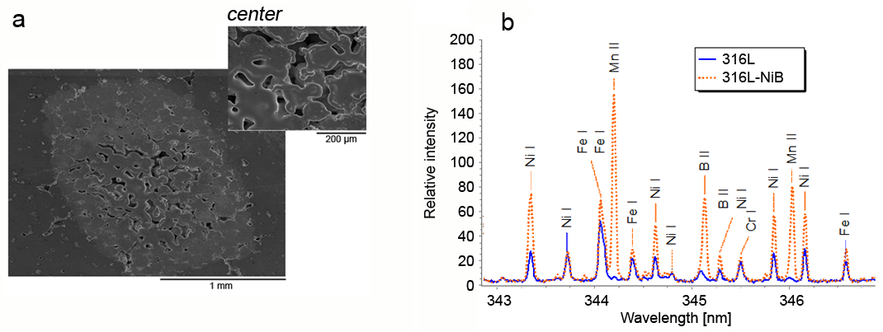

Figure 1. (a) 316L-NiB irradiated by 300 ns pulses (inset - central part); (b) corresponding LIBS spectra.
Acknowledgements:
This research was sponsored by: (i) Ministry of Science, Technological Development and Innovation of the Republic of Serbia through Contract No. 451-03-47/2023-01/200017, (ii) Bilateral project Serbia-China No. 451-02-818/2021-09/17; (iii) IAEA CRP F13020, Contract No. 24076.

REFERENCES
[1] D. Bozic, M. Vilotijevic, J. Ruzic, U. Jovanovic, J. Stasic, Sci. Sint. 48, 293 (2016).
[2] E. Bayraktaroglu, H.O. Gulsoy, N. Gulsoy, O. Er, H. Kilic, BioMed. Mater. Eng. 22, 333 (2012).
[3] N. Farid, S.S. Harilal, O. El-Atwani, H. Ding, A. Hassanein, Nucl. Fusion 54, 012002 (2014).

