ns-Laser – Titanium Interaction: Hydrogen Ambience

M. Trtica¹ and J. Stasic¹
¹VINCA Institute of Nuclear Sciences - National Institute of the Republic of Serbia, University of Belgrade,
Belgrade, Serbia
e-mail: etrtica@vinca.rs

Interaction of a pulsed, ns-laser operating at 10.6 µm with a titanium target in hydrogen ambience was studied. In general, interaction in this type of environment is scarcely studied, however it can be of great importance. Titanium and its alloys show excellent physical and chemical properties and for these reasons they are attractive for aero-space and marine engineering, medicine, nuclear problematics, etc. Some phenomena, especially the action of thermal flux on a material, within fission/fusion reactor for example, can be simulated by ns-laser [1,2]. The Ti-surface variations at high TEA CO₂ laser energy density/fluence of ~20 J/cm² and intensity of ~60 MW/cm² were investigated in this work. Irradiation was carried out at a reduced H₂ atmosphere of ~200 mbar [3]. The energy absorbed from the laser beam is partially converted to thermal energy, which generates a series of effects, such as melting, vaporization of the molten material, shock waves, etc. Also, it should be mentioned that irradiation was accompanied by generation of plasma in front of the target. The following titanium target surface changes and phenomena were observed: (i) the damages were only on a superficial level (Fig. 1B) with depth ≤ 2 µm; (ii) appearance of pores on the grain boundaries in the central irradiated zone (Fig. 1A). The cracking effect is visible as well in this zone. In the main, all changes can be attributed to the extra-fast heating and cooling process; (iii) in the peripheral zones similar features were registered, while the transition between irradiated and non-irradiated region is sharp.
It can be concluded from this study that the reported laser fluence and intensity, in hydrogen ambience, effectively modified the titanium target. The created surface structures generally could be acceptable in cases where high roughness is required, while for some applications in nuclear technologies additional studies should be done (in this context, the presence of H₂ in fusion reactor materials is not desirable [3]).

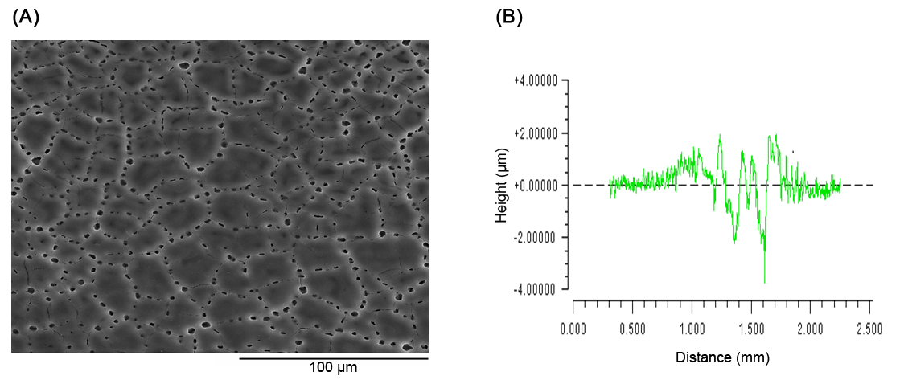
Figure 1. (A) SEM analysis of Ti-target in H₂ ambience; (B) 2D profilometry; (Irradiation after 300 laser pulses).
Acknowledgements:
This research was sponsored by: (i) International Atomic Energy Agency (IAEA) through CRP F13020, Contract No. 24076, “Contemporary and new IF structural-first wall materials: Conditions of high thermal and electromagnetic fluxes“ and, (ii) Ministry of Science, Technological Development and Innovation of the Republic of Serbia through Contract No. 451-03-47/2023-01/200017.

REFERENCES
[1] M. Trtica et al., Appl. Surf. Sci. 258, 2741 (2012).
[2] N. Farid et al., Nucl. Fusion 54, 012002 (2014).
[3] M. Trtica at el., The paper ref. no. 246-22 (title: LIBS Hydrogen Isotopes Detection: Significance in Nuclear/Fusion Technology) - accepted for publication in ZhPS (Russian version), 91, January-February (2024).

