Reverse sigmoid-like nonlinearity in Fabry-Perot injection-locked lasers

P. Atanasijević, M. Banović, J. Crnjanski, M. Krstić, P. Mihailović, S. Petričević and D. Gvozdić
School of Electrical Engineering, University of Belgrade, Serbia

e-mail: petarat@etf.bg.ac.rs

The increasing demand for faster, more efficient computing propelled the field of neuromorphic photonics to unforeseen extents. A variety of approaches to generation of much needed nonlinearities were proposed, while still evolving all-optical solutions remain the most promising way to achieve scalability [1]. Contrary to their monotonically increasing equivalents, the examples of decreasing nonlinearities, such as the reverse sigmoid are rarely encountered in proposed solutions [2].

In this research, we experimentally realize an all-optical nonlinear unit based on an injection-locked Fabry-Perot laser diode, exploiting its dispersive bistability [3]. An input optical pulse train with 5 ns pulse widths, 128 ns periods and increasing amplitudes is injected near the slave laser’s m = +2 side mode (positive side modes correspond to shorter wavelengths), with a controlled frequency detuning of -12.7 GHz (negative value corresponding to red shift). Positive/negative pulses are applied depending on the initial state of the slave laser, free-running or injection-locked (Fig. 1 a) and b), respectively). The central mode of the free-running slave laser’s spectrum is filtered using a bandpass optical filter and monitored as the unit’s output using a photodiode. The nonlinear input-output dependence exhibits a reverse sigmoid-like trend, influenced by injection-locking parameters, as well as slave laser’s operating conditions. Furthermore, different nonlinearities are achieved depending on the slave laser’s initial state, as shown in Fig. 1. Typical 50% sigmoid thresholds are achieved for peak input optical powers of about 100 µW, corresponding to pulse energies of 0.5 pJ. Presented nonlinearity provides a promising alternative route to current trends in neuromorphic photonics.

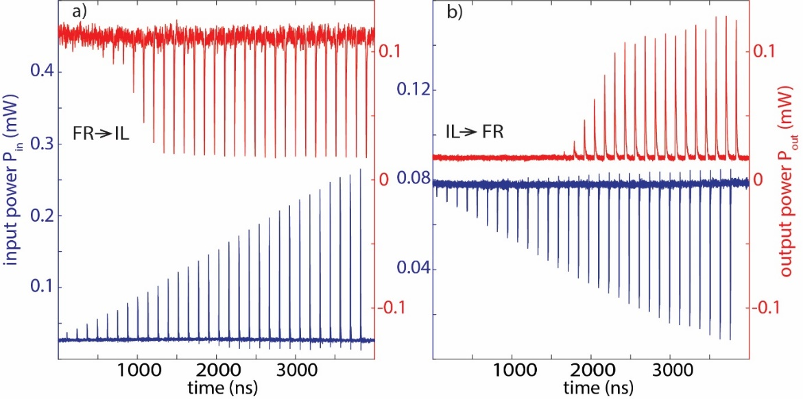
Figure 1: Input (blue) and output (red) pulses of the proposed nonlinear unit, for different initial states of the slave laser: a) free-running (FR), and b) injection-locked state (IL).

REFERENCES
[1] Dabos, G. et al. Neuromorphic photonic technologies and architectures: scaling opportunities and performance frontiers [Invited]. Opt Mater Express 12, (2022).
[2] Tait, A. N. et al. Silicon Photonic Modulator Neuron. Phys Rev Appl 11, (2019).
[3] Crnjanski, J.V, et al. Adaptive sigmoid-like and PReLU activation functions for all-optical perceptron. Opt. Lett. 46, (2021)

This research was supported by Science Fund of the Republic of Serbia, Grant no #7750121, All-optical Reservoir Computer Architecture based on Laser Bistability – ORCA-LAB, and partially by Serbian Ministry of Education, Science and Technological Development.

