**FEM analysis of natural photonic structures of insects in the IR band**

B. Salatic1, D. Pavlovic1 and D. Pantelic2

1*Institute of Physics, Belgrade, Serbia*

2*University of Belgrade, Senzor INFIZ, Institute of Physics, Serbia*

e-mail:banes@ipb.ac.rs

The cuticle plays an important role in regulating the body temperature of insects. A closer look at its structure reveals that it often has patterns on the micro and nano scale. During the interaction of electromagnetic radiation with the cuticle, these photonic structures affect the temperature of the insect depending on their size, shape and spatial arrangement. While in the visible part of the spectrum these structures behave as anti-reflection layers [1] and produce structural coloring, in the IR part of the spectrum their function can be twofold. For some insects, these structures have the role of increasing body temperature by absorbing electromagnetic radiation, while for other insects their purpose is the efficient release of excess heat radiatively into the environment [2].

Here we present a numerical model that describes the scattering of plane waves on the complex photonic structures of *Hoplia argentea* scarab beetle for the infrared spectrum of wavelengths. The FEM model is based on the SEM images of the insect elytron shown in Figure 1. (a). The distance between the filaments on the top layer is 1 µm and it was a fixed value. All other dimensions such as the height and width of the filaments, the dimensions of the layers filled with air and their distance are varied and the final results of the simulation are averaged. Preliminary results indicate that this structure of the insect's elytron plays a significant role in the radiative cooling of the insect.

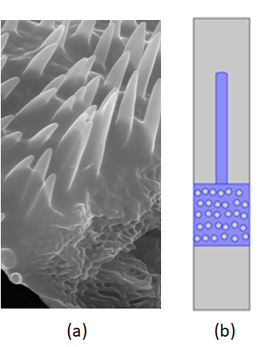

Figure 1. (a) Sem image of *H. argentea* elytron. (b) model used for FEM simulation (chitin is marked in blue, while air is gray)

Acknowledgement: This research was sponsored by the NATO Science for Peace and Security Programme under grant G5618.

REFERENCES

[1] P. Vukusic, J.R Sambles, Nature 424 (6950), 852–855. (2003).

[2] N.N. Shi, C.C. Tsai, F. Camino, G.D. Bernard, N. Yu, R. Wehner, Science (80-. ). 349, 298–301 (2015)