Dynamics of optomechanical array revealed by holography
H. Skenderović, A. M Dezfouli, D. Abramović, M. Rakić, and N. Demoli
Institute of Physics, Zagreb, Croatia
e-mail:hrvoje@ifs.hr

This work examines the possibility of making an imaging device that would use the thermophoretic effect on certain biomimetic microstructures for optical reading [1]. The microstructures are inspired by the wing scales which make butterfly wings, and a proposed imaging device would not be limited to visible light but could be sensitive in other parts of the spectrum (ultraviolet and infrared).

Due to the illumination of a butterfly wing with electromagnetic radiation, the illuminated side is slightly heated. As a result, nearby air molecules on the heated side pick up slightly more energy compared to molecules on the unheated side. This difference in energy leads to deflections which are registered by holographic method. The performance of the wings is tested by interferometric holography (setup shown in Fig. 1) using quasi-Fourier configuration.

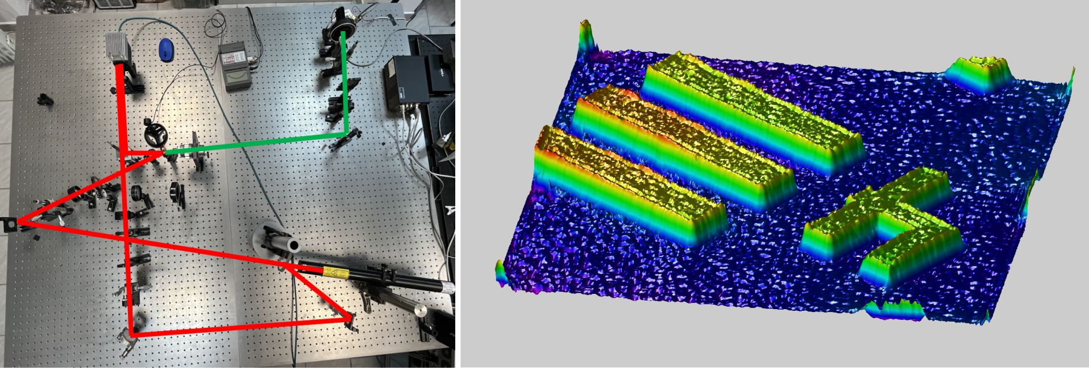

Figure 1. Left pane: holographic setup. Right panel: retrieved phase of the standard USAF target.

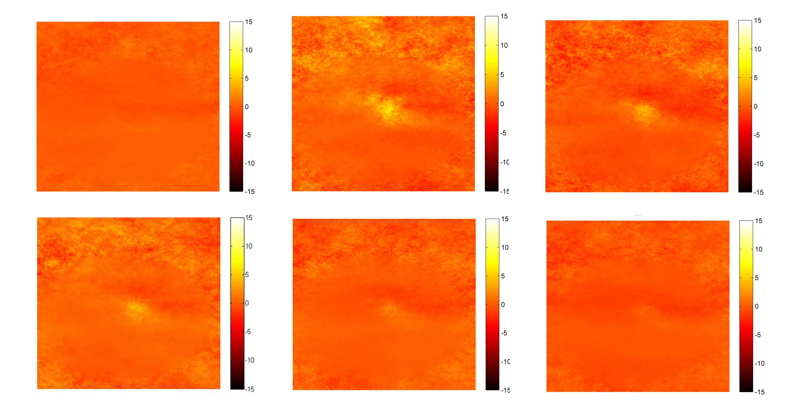
Figure 2.Time development of target upon excitation, phase image..
For probing time response of the butterfly wing, a sequence of holograms [2] was recorded upon excitation by auxiliary laser. The holograms were reconstructed and uwrapped phase image is shown in Fig. 2. Based on similar measurements dynamical and sensitivity characteristics of the wings as optomechanical array are presented.
Acknowledgement: This research was sponsored by the NATO SPS Programme under grant G5618.

REFERENCES
[1] P. Atanasijevic, D. Grujic, F. Krajinic, P. Mihailovic, and D. Pantelic, Opt. Laser Technol. 159,
108919 (2023)
[2] H. Skenderović, Technical Digest Series (Optica Publishing Group, 2022), paper M4A.1.

