A compact, holographic imaging sensor for biophotonic structures

D. Pantelic¹, D. Pavlovic², D. Grujic², B. Salatic², P. Atanasijevic³ and P. Mihailovic³
¹University of Belgrade, Senzor INFIZ, Institute of Physics, Serbia
²Institute of Physics, Belgrade, Serbia
³University of Belgrade, School of Electrical Engineering, Belgrade, Serbia
e-mail: dejanvpantelic@gmail.com

Nature is a rich source of formidable “engineering” achievements acquired through millions of years of evolution. They enable various forms of life to survive by camouflage, thermal regulation, imaging and numerous other mechanisms. Based on that, researches are looking for bioinspired and bioderived techniques, systems and devices.
A highly sensitive detection technique of infrared radiation, based on Morpho butterfly wing, was proposed [1]. A method is based on thermal dilatation of nanostructured wing scales induced by infrared radiation, and subsequent detection of spectral shift of iridescence. The method is suitable only for pointwise detection, making imaging very difficult.
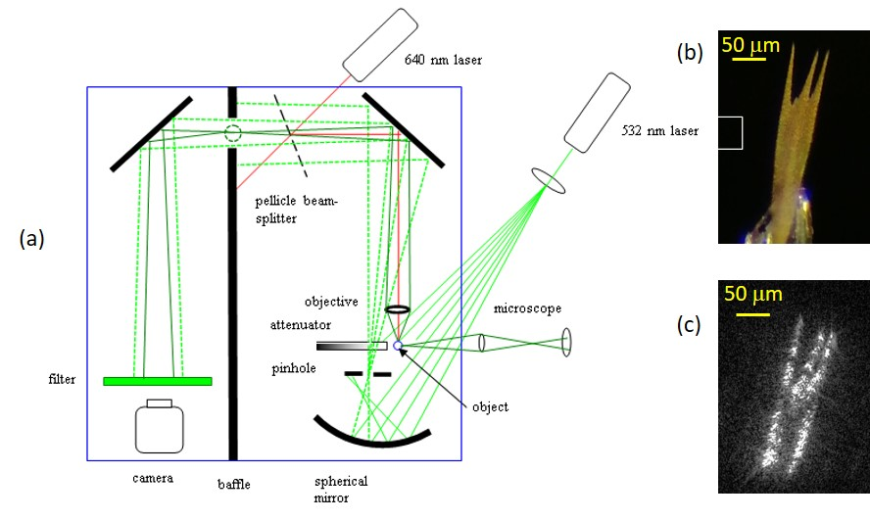

Figure 1. (a) A compact holographic imaging sensor, (b) wing scale and (c) its holographic interferogram.
Here we present further development of a compact, imaging device, based on butterfly wing scales, as an alternative to expensive thermal imaging cameras [2, 3]. A system, depicted in Fig. 1(a), uses 532 nm laser as a light source for holography. A single beam is expanded and directed towards an object (butterfly wing or an individual wing scale) and a concave mirror. Light reflected from a mirror is spatially filtered and interferes with a beam reflected from an object. Interference pattern is directed towards high-speed camera using a pair of beam folding mirrors. Hologram is digitally reconstructed enabling imaging of millimeter to micron sized objects and their response to incoming radiation (Fig. 1(b, c)).
This research was sponsored [in part] by the NATO Science for Peace and Security Programme under grant G5618.

REFERENCES
[1] A. D. Pris, Y. Utturkar, C. Surman, W. G. Morris, A. Vert, S. Zalyubovskiy, T. Deng, H. T. Ghiradella, and R. A. Potyrailo, Nat. Photonics 6, 195–200 (2012).
[2] D. Grujić, D. Vasiljević, D. Pantelić, Lj. Tomić, Z. Stamenković, and B. Jelenković, Opt. Express 26, 14143-14158 (2018).
[3] P. Atanasijevic, D. Grujic, F. Krajinic, P. Mihailovic, D. Pantelic, Optics & Laser Technology 159, 108919, (2023).

