**Unraveling the Phononic Mysteries: BIC Revealed in hBN Resonators through Phonon Polaritons.**

**Harsh Gupta1, 2, James Edgar3, Francesco De Angelis1, Andrea Toma1, Michele Tamagnone**1

1Istituto Italiano di Tecnologia (IIT), via Morego 30, 16163 Genova, Italy.

2Dipartimento di Chimica e Chimica Industriale, Università di Genova, Genova, Italy.

3Department of Chemical Engineering, Kansas State University, Manhattan, U.S.A

**Abstract:** In this study, we present the study of phonon-polariton bound states in the continuum (BIC) modes in an array of elliptical, hexagonal boron nitride (hBN) nanoantennas. Using both theoretical analysis and experimental verification, we demonstrate the existence of a red-shifted quasi-BIC (Q-BIC) mode with a high-quality factor along the x-polarization. Additionally, we uncover a novel concept of a blue-shifted Q-BIC mode with a high-quality factor along the y-polarization, which we also verify theoretically and experimentally.

Bound state in the continuum (BICs) is a fascinating phenomenon in the field of physics that has garnered significant attention from researchers over the years [1]. BICs refer to a special class of localized modes in open systems that exhibits resonance frequencies embedded within the continuous spectrum but do not radiate energy into the surrounding continuum. The use of bound states in the continuum (BIC) is, in particular, a very active research topic in photonics. One promising approach is the use of dielectric metasurfaces for sensing applications. In fact, one of the main challenges is improving the quality factor Q by confining BICs, which is defined as,

Quality Factor (*Q*) =  [1]

We modeled phonon polaritons in hBN through the Lorentz model, including the matrix tensor equations of direction-dependent permittivity, which defined different values in x and z directions because of the uniaxial in-plane isotropic crystal property of hBN (𝜀𝑥𝑥=𝜀𝑦𝑦≠𝜀𝑧𝑧).

The system in our model comprises two elliptical hBN resonators arranged parallel to each other along the y-axis. We started by simulating the system without any rotation of the ellipses to establish the baseline for the Q-BIC properties within a frequency range of 40THz to 45THz. The main resonance of hBN was observed at 43.60THz/1454 cm-1 along x-polarization and 42.3THz/1411 cm-1 along y-polarization, inside the upper reststrahlen band of h11BN (Type II hyperbolic polariton). Although the BIC mode was present at this stage, it was not visible due to its non-radiative nature. To demonstrate the Q-BIC modes, we considered a cell of two ellipses and broke the symmetry, and rotated them in opposite directions by 25 degrees a (Fig.1a). This resulted in a new Q-BIC mode with a redshift in the resonance frequency to 41.95THz/1399.3 cm-1 are shown in Fig. 1c, along with x-polarization as a low-frequency dark mode and an increase in the quality factor of the quasi-BIC mode.. We achieved the enhancement in quality factor from 161.5 (main resonance) to 233.05 (Q-BIC) by nearly 44% calculated from eq. 1 along with x-polarization and a new Q-BIC blue shifted mode occurs along y-axis polarization at 43.95THz/1466cm-1 in our simulations, which can be explained by the band structure folding in the Q-BIC hBN resonators.

We conducted an experimental study to confirm our simulated findings on the BIC and Q-BIC modes in hBN

nano-antennas. To create our sample, we exfoliated natural h11BN onto a CaF2 substrate, chosen for its UV-IR spectrum transparency, and patterned the meta-surfaces of elliptical resonators with e-beam lithography. After fabrication, SEM images were taken and presented in Figure 1b, which shows elliptical hBN nano-antenna resonators with a period size of 1.7µm. We used FTIR spectroscopy to measure the transmission spectrum under the IR-transmission regime of 1300 cm-1 -1350 cm-1 with an aperture size of 20µm. Our results indicate the presence of the Q-BIC mode, which is red-shifted at a frequency of 1383 cm-1 along the x-polarization, as shown by the solid red line in Figure 1d. We used a polarizer to separate out both modes along the x and y polarization, as shown in Figure 1d. Our findings also provide experimental evidence of the presence of band structure folding along y-polarization, as the Q-BIC along y-polarization is blue-shifted to 1437cm-1, as shown by the solid blue line in Figure 1d. Finally, we achieved nearly a 39% enhancement in the red-shifted Q-factor from 143 (main resonance) to 198 (Q-BIC) along the x-polarization. This project has received funding from the European Research Council (ERC) under the European Union’s Horizon 2020 research and innovation program (Grant Agreement No. 948250)

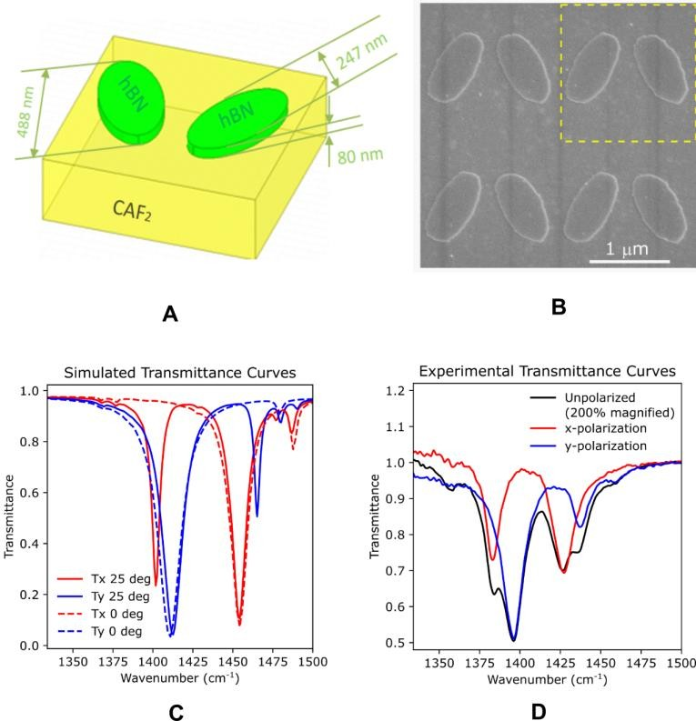

**Figure 1 -** hBN resonators with the major axis of 488nm, minor axis of 247nm, hBN thickness of 80nm over the CAF2 substrate (1a), SEM image of the hBN resonators having a period size of 1.7µm with same measurements of simulated resonators (1b), Simulated transmitted curves shows the main resonances at zero degrees rotation by dotted lines and 25 degrees rotation curves by solid lines, red and blue color shows the x and y polarization respectively (1c), Experimental FTIR curves show by solid lines, black represents to the unpolarized curve (without polarizer), red and blue shows the transmission curves shows the x and y polarization respectively.

**References**

1. Joseph, Shereena, et al. "Bound states in the continuum in resonant nanostructures: an overview of engineered materials for tailored applications." Nanophotonics 10.17 (2021): 4175-4207.