Dependence of Transport Parameters on Interface Composition Diffusion and Doping Segregation in Longitudinal Optical Phonon, Bound to Continuum and Hybrid THz Quantum Cascade Laser Designs

Novak Stanojević^{1, 2}, Aleksandar Demić³, Nikola Vuković¹, Dragan Indjin³ and Jelena Radovanović¹
¹ School of Electrical Engineering, University of Belgrade, Serbia
² Vlatacom Institute of High Technologies, Belgrade, Serbia
³ School of Electronic and Electrical Engineering, University of Leeds, UK
e-mail:novakstanojevic1@gmail.com

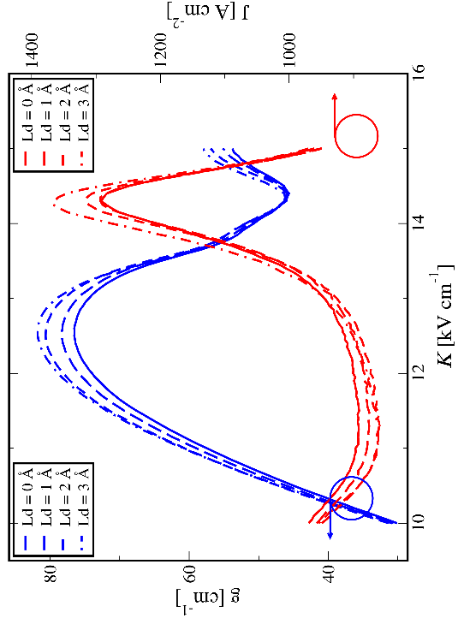
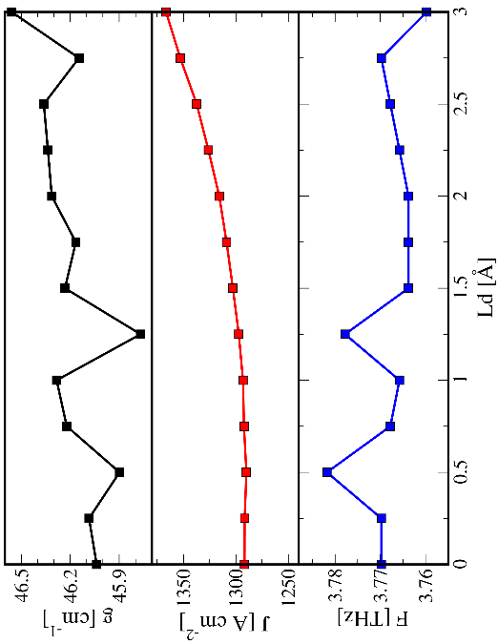
Abstract. Quantum cascade lasers (QCLs) are semiconductor lasers with emission frequencies ranging from the mid-IR to the THz part of the spectrum, that can be designed by varying layer thicknesses and composition [1]. Due to the unique THz light emission of QCLs, many designs have been developed, the most important of which are the Longitudinal Optical Phonon (LO), Bound to Continuum (BTC), and Hybrid designs [2]. These devices are created at high temperatures by molecular beam epitaxy (MBE) making them prone to diffusion of added barrier material that leads to interface composition diffusion which can have a prominent effect on QCL operation [3]. Doping segregation, that is the diffusion of the charged dopants, which affects the doping profile, and Hartree term in the total effective potential energy is also present in real QCLs. In this contribution, we investigate the dependence of transport parameters such as material gain, current density, and emission frequency in the negative differential resistance (NDR) point in the three most common THz QCL designs that are stated above, on interface diffusion and doping segregation. The NDR point defines the maximum current density at which the QCL can operate, while the operation starts at material gain equal to the threshold value. The transport of these devices was modeled using the density matrix formalism which takes into account quantum coherence effects thus adequately describing resonant tunneling through the injection barrier [4]. The finite difference method was then used for the numerical solving of Fick’s law to model both composition diffusion and doping segregation.
Figure 1. Effect of interface diffusion on transport parameters in NDR point (left), and on material gain and current density versus external bias (right) in a LO design quantum cascade laser
REFERENCES
[1] J. Faist, et al., Science 264, 553-556 (1994).
[2] B. S. Williams, Nature photonics, vol. 1, no. 9, p. 517 (2007).
[3] Li Wang, et al., Appl. Phys. Express 16, 032007 (2023).
[4] A. Demić, et al., IEEE Transactions on Terahertz Science and Technology, vol. 7, 368-377 (2017).
ACKNOWLEDGMENT
This work was financially supported by the Vlatacom Institute of High Technologies under project 178, the Ministry of Science, Technological Development and Innovation of the Republic of Serbia under contract number: 451-03-47/2023-01/200103, "Multi-Scale Modeling of Terahertz Quantum Cascade Laser Active Regions", Multilateral scientific and technological cooperation in the Danube region 2020-2021, "DEMETRA: Development of high-performance mid-IR / THz quantum cascade lasers for advanced applications", Science Fund of the Republic of Serbia, Serbian Science and Diaspora Collaboration Programme: Knowledge Exchange Vouchers, and European Cooperation in Science and Technology (COST) Action CA21159 PhoBioS.

