Pushing the Boundaries of Metasurface Engineering: Hierarchical Supercells and Experimental Validation
Tatiana Contino^{1,2}*, Michele Tamagnone¹
¹Fondazione Istituto Italiano di Tecnologia, via Morego 30, 16163 Genova, Italy
²Dipartimento di Chimica e Chimica Industriale, Università di Genova, Genova, Italy
*Corresponding author: tatiana.contino@iit.it

Abstract: In this work, we demonstrate a new concept of metasurfaces based on a generalization of supercells. In general, these supercells consist of a series of unit cells that combine with each other to achieve a specific function. We present hierarchical supercells (supercells of supercells), and we extend supercells to general 2D Bravais Lattice, providing a simple mathematical framework to describe the resulting metagratings.

Metasurfaces are artificial planar materials consisting of arrays of subwavelength-spaces nanostructures at an interface, allowing for unprecedented control over the properties of light like phase, amplitude, and polarization, and have allow multiple and versatile functionalities in a single device [1,2]. In general, metasurfaces are obtained through subwavelength unit cells designed to impart a local phase profile to light propagating through the cell. Multiple functions such as focusing, holograms, polarization functions, and beam shaping can be achieved by this technique. Using supercells (arrangements of multiple cells which can are optimized together in the design), it is possible to achieve multiple functions at same time[3]. When the supercell is repeated periodically, the device behaves as a grating, splitting the light in multiple diffraction orders (metagrating). The size of the supercells determines the number and direction of diffraction orders to be considered while the geometry of the nanostructures present in the unit cell determines the local effect of the metasurface on light.
In this work, we generalize the concept of supercells in two ways: (i) using hierarchies to create supercells of supercells and (ii) by means of general 2D integer Bravais lattices.
Hierarchies of supercells can be defined in the following way: starting from metasurfaces based on a single-unit cell that is repeated periodically on the plane, we define first-order supercells by joining several cells and then breaking the previous translational symmetry by creating differences among the various cells in the supercell. Second order supercells, similarly, are supercells of supercells, and so on for higher orders. Each time the supercell order is increased, new diffraction orders are obtained. By engineering the unit cells it is possible to obtain devices with different functions on each order (Figure 1A-C). The phase and amplitude of each order depend on the particular asymmetry introduced when the supercell is created, specifically the amplitude is proportional to the perturbation parameter in the small-perturbation limit.
In addition to considering supercells that extend horizontally or vertically on the plane, we consider here supercells that extend obliquely. It is possible to identify these supercells by means of an integer 2D Bravais lattice, defined by the points $\left\{n\overline{a}+m\overline{b}\right\}$, where $\overline{a}$ and $\overline{b}$ are 2D integer vectors. We can then define the supercell matrix L as
$$L=\left(\begin{matrix}a_{x} & b_{x} \\ a_{y} & b_{y}\end{matrix}\right)∈Z^{2×2}$$ | (1)
It is straightforward to show that the number of cells in the supercells is $\left|\det\left(L\right)\right|$. In Figure 1D,E we show an example of such a Bravais lattice (with $\left|\det\left(L\right)\right|=4$), and we identify the associated supercell as a “Tetris-like” tile which fills the entire plane. The number of orders is also increased by a factor of $\left|\det\left(L\right)\right|$. Specifically, the diffraction orders for a metagrating with periodicity of P are given by:
$$\sum_{m,n}{δ\left(\overline{k}-\frac{2π}{P}\left[\begin{matrix}m \\ n\end{matrix}\right]\right)}$$ | (2)
while when the supercell is defined, the new diffraction orders (more numerous) are given by
$$\sum_{m,n}{δ\left(\overline{k}-\frac{2π}{P}L^{-1,H}\left[\begin{matrix}m \\ n\end{matrix}\right]\right)}$$ | (3)
In this poster presentation, we will show concrete examples of devices based on these two concepts.

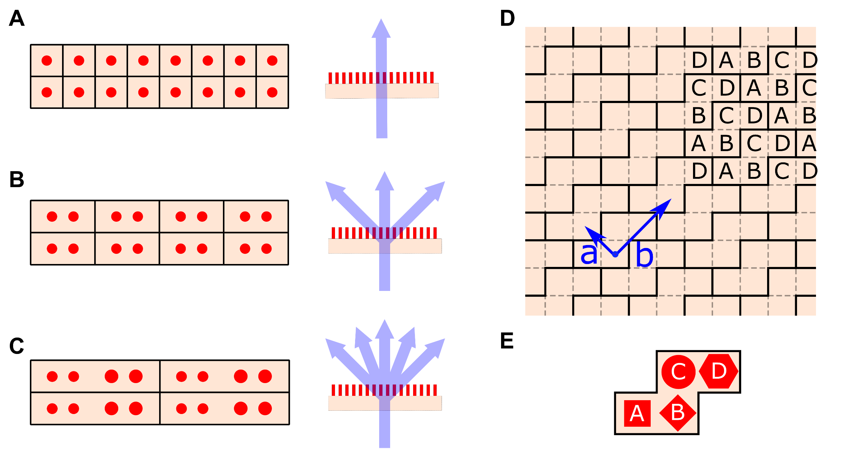

Figure 1: Generalized supercell metasurface concepts. A-C: Metagratings using supercells of increasing hierarchy. 0th order supercells are just the unit cells of the metasurface, 1st order are creating joining 0th cells and so on. Increasing hierarchies generate an increased number of diffraction orders. D: An example of supercells based on a general integer Bravais lattice. E: Example of optical elements in a Bravais supercell.

This project has received funding from the European Research Council (ERC) under the European Union’s Horizon 2020 research and innovation programme (Grant agreement No. 948250).

References
- Khorasaninejad, Mohammadreza, Wei Ting Chen, Robert C. Devlin, Jaewon Oh, Alexander Y. Zhu, and Federico Capasso. "Metalenses at visible wavelengths: Diffraction-limited focusing and subwavelength resolution imaging." Science 352, no. 6290 (2016): 1190-1194.
- Devlin, Robert C., Mohammadreza Khorasaninejad, Wei Ting Chen, Jaewon Oh, and Federico Capasso. "Broadband high-efficiency dielectric metasurfaces for the visible spectrum." Proceedings of the National Academy of Sciences 113, no. 38 (2016): 10473-10478.
- Spägele Christina, Michele Tamagnone, Dmitry Kazakov, Marcus Ossiander, Marco Piccardo, and Federico Capasso. "Multifunctional wide-angle optics and lasing based on supercell metasurfaces." Nature Communications 12, no. 1 (2021): 3787.

