Optimization of UV LED design using evolutionary algorithms
L. Leguay¹, H. Mączko², A. Schliwa¹, S. Birner²
¹Institute of Solid-State Physics, Technical University of Berlin, Hardenbergstr. 36, 10623, Berlin, Germany ²nextnano GmbH, Konrad-Zuse-Platz 8, 81829, Munich, Germany
l.leguay@tu-berlin.de

In this study, we present a computational approach to optimize the design of UV-emitting LED devices based on nitride semiconductors. These devices show potential for various applications including surface sterilization, gas and disease detection, and water purification. But despite recent advances in the field, there remains a lot of room for improvement, particularly in terms of efficiency. We demonstrate that the performance of such UV LED devices can be enhanced using optimization algorithms paired with semiconductor calculation tools.

Specifically, we use the simulation software nextnano++ [1] in combination with an evolutionary algorithm [2] to optimize the design of LED nanostructures based on AlGaN multiple quantum wells. Our findings reveal noteworthy improvements in the carrier current densities of the device with a significant increase of the theoretical internal quantum efficiency (IQE) at the target emission wavelength of 300 nm.

This work underscores the importance of ongoing research to improve the efficiency of UV LED devices and highlights the potential for optimization algorithms and semiconductor calculation tools in the development of high-performance UV LED devices with a range of practical applications.

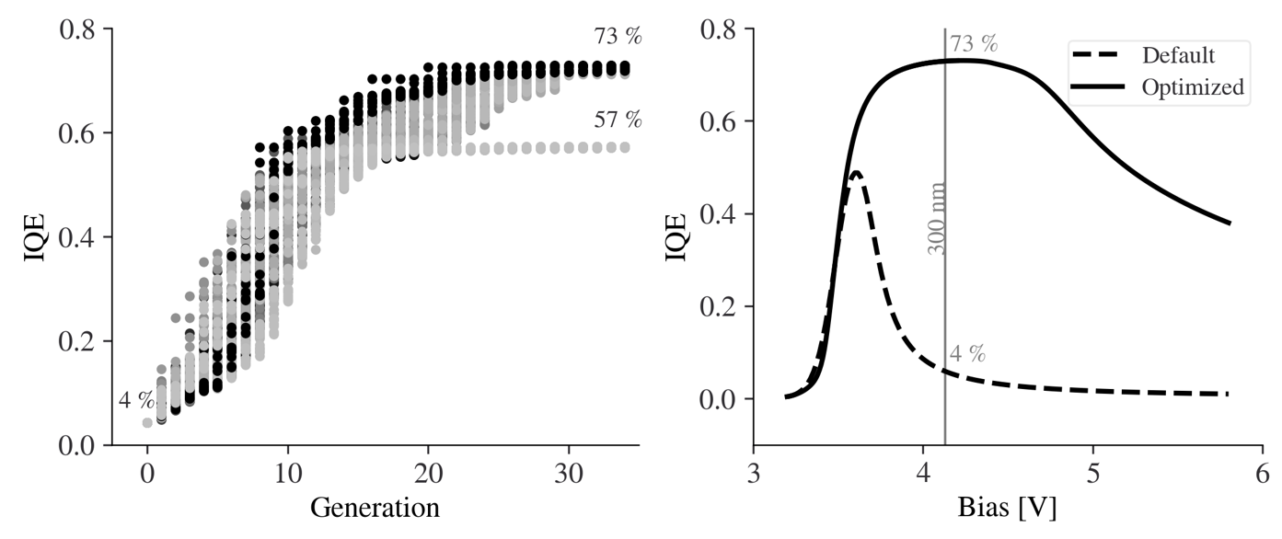

Figure 1. Evolution of the IQE through the multiple runs of the evolutionary algorithm (left) and comparison of the IQE of the default design and the optimized design (right).

REFERENCES
[1] S. Birner et al, IEEE Trans. Electron Dev. 54, 2137, 2007.
[2] H.G. Beyer and H.P. Schwefel, Natural Computing 1: 3–52, 2002.

