**Smart optical assay based on novel bioorthogonal SERS nanoprobes for the ß-amyloid peptide quantification**

C. Dallari1,2, C. Credi1,3 and F. S. Pavone1,2,3

1*European Laboratory for Non-Linear Spectroscopy (LENS), Florence, Italy*

2*Department of Physics, University of Florence, Florence, Italy*

3*National Council of Research (INO-CNR), Sesto Fiorentino, Italy*

e-mail:dallari@lens.unifi.it; caterina.dallari@unifi.it

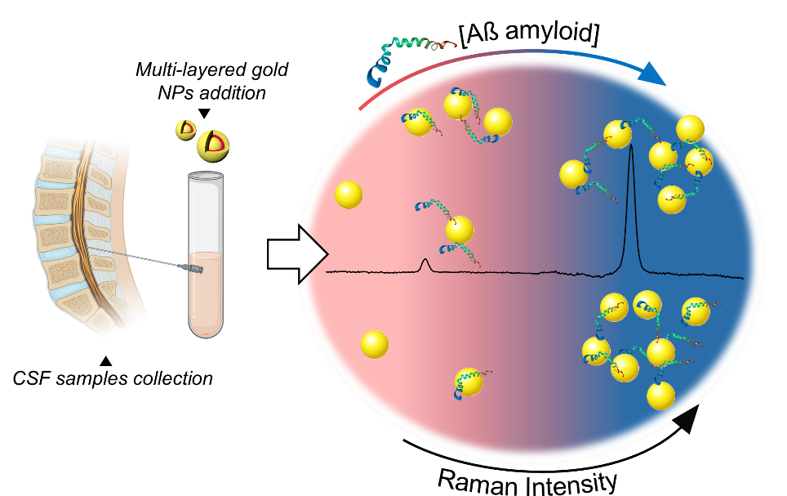To date, the early diagnosis will likely to be the most effective therapy for Alzheimer’s disease (AD) since it can ensure timely pharmacological treatments that can reduce the irreversible impairment while delaying the AD symptoms.[1] Amyloid β-peptides (Aβ) are recognized as key pathological AD biomarkers present in different biological fluids, but their detection still relies on expensive or low-accuracy assays. In this context, optical detection techniques based on surface enhanced Raman spectroscopy (SERS) through advanced nanoconstructs have gained rising attention for the development of alternative methods for the targeting of Aβ peptides in fluids.[2] Here, a multilayered nanoprobe constituted by bioorthogonal Raman Reporters (RRs) embedded within gold nanoparticles (Au@RRs@AuNPs) has been developed and successfully validated for specific detection of ß- amyloid peptide (Aß) in the human cerebrospinal fluid (CSF) with accuracy in the clinical range of interest, high selectivity and sensitivity down to pg/ml. These are guaranteed by the intrinsic properties of the bioorthogonal RRs working in the Raman background-free spectral region and remaining stable within the two layers of gold, a key point for quantitative SERS. Then, the selective aggregation behavior in the presence of the targeted analyte is exploited for Aß quantification considering that its concentration is proportionally reflected in Raman intensity changes. Finally, the proposed nanoplatform combines the typical speed of Raman measurements, providing high specificity and sensibility and representing a significant step ahead of the state of the art on SERS for clinical analyses.

Figure 1. Graphical scheme representing the working principle of multilayered RRs@AuNPs for the early-stage detection of Alzheimer’s Disease through the screening of Aβ (1-42) in the cerebrospinal fluid.

REFERENCES

[1] H. Braak and E. Braak, “Demonstration of Amyloid Deposits and Neurofibrillary Changes in Whole Brain Sections,” *Brain Pathol.*, vol. 1, no. 3, pp. 213–216, 1991, doi: 10.1111/j.1750-3639.1991.tb00661.x.

[2] L. Cheng *et al.*, “Ultrasensitive Detection of Serum MicroRNA Using Branched DNA-Based SERS Platform Combining Simultaneous Detection of α-Fetoprotein for Early Diagnosis of Liver Cancer,” *ACS Appl. Mater. Interfaces*, vol. 10, no. 41, pp. 34869–34877, 2018, doi: 10.1021/acsami.8b10252.