Experimental and theoretical study of the phase response of M_{x} magnetometer to modulating transversal magnetic field

M. M. Ćurčić¹, A. Milenković¹ , A. Bunjac¹, T. Scholtes², and Z. Grujić¹
¹Institute of Physics Belgrade,Serbia
¹Leibniz Institute of Photonic Technology, Jena, Germany
e-mail: zoran.grujic@ipb.ac.rs

We will present our results on the study of a scalar optically pumped magnetometer (OPM) [1]. More precisely, we investigate the phase response of a true scalar M_{x} magnetometer to the sudden changes of transversal magnetic field. As a sensing element we employ paraffin coated cell filled with Cs. A single light source is used for both pumping (polarizing) the medium and probing i.e. reading out a variation in the intensity of the resonant light due to the applied magnetic field. Pump light is circularly polarized. The wave vector and RF magnetic field that drives the spin precession are at 45º with the respect to the main static magnetic field B₀ as presented on Fig. 1. Magnetometer operates at room temperature. Set of Helmholtz coils is used for the generation of additional modulating filed. The sensor head is placed inside a three layer mu-metal shielding. Changes of the magnetometer response are detected with a lock-in amplifier, which enables us to obtain in-phase and quadrature components of the transmitted probe signal.
In addition to experimental study, we did both numerical and analytical modeling of a described system. Theoretical study is based on the transient Bloch equation. Analytically, the equation is solved in rotating frame after applying a rotating wave approximation (RWA). In this manner, we were able to obtain set of simple equations describing detected signal, decomposed into in-phase and quadrature components, for comparison with experimental results and tracking of the phase evolution.
The model results show good agreement with the experiment. Being a scalar magnetometer, our sensor should not experience any changes in the measured phase depending on the orientation of the applied modulating field. However, both experimental measurements and model predictions have demonstrated this is not the case. With the main offset field in z-direction, and applied modulation in yz plane, phase of the signal shows an unexpected behavior for a scalar magnetometer. We will present obtained results, and discuss which conditions lead to the before mentioned signal abnormalities.

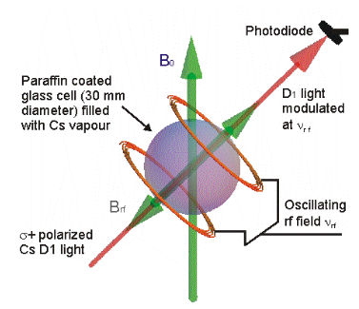

Figure 1. Schematic of the scalar M_{x} optically pumped magnetometer.

REFERENCES
- A. Weis, G. Bison, Z.D. Grujic, High Sensitivity Magnetometers – Magnetic Resonance Based Atomic Magnetometers, Springer, pp 361-424 (2016).

