**Modeling microwave ablation for tumor treatment using open-source software components**

Nikola Boskovic1, Marija Radmilovic-Radjenovic1 and Branislav Radjenovic1

1*Institute of Physics, Belgrade, Serbia*

e-mail:nikolab@ipb.ac.rs

Microwave ablation (MWA) is a minimally invasive medical procedure with a short recovery time for treating various types of cancers. During MWA, a small needle-like probe is inserted inside the tumor. Inside the probe there is a microwave radiator (antenna) that delivers microwave energy, causing tissue heating, and effectively produces necrosis of the tumor tissue. The primary goal of modeling and studying of MWA is to determine ablation zone caused by the particular combination of radiator, input power, time and position of the probe. MWA should cause total necrosis of tumor tissue and minimal damage to surrounding healthy tissue. Simulation of MWA requires calculation of electromagnetic wave propagation, heat transfer, and tissue damage. Physical processes can be described using partial differential equations (PDEs). Multiple effects such as blood flow and change of water content inside the tissue with temperature have a major influence on the MWA.

In our study we have created the complete geometry of MWA including a multi-slot coaxial antenna [1], a real liver tumor taken from the database [2], and the surrounding liver tissue using Gmsh [3]. Geometry is meshed and PDEs are solved using Finite Elements Method (FEM) via GetDP package [4]. The MWA occurs at 2.45 GHz, with an input power of 13 W, during 600 s. The electric field is calculated in frequency domain, while temperature distribution and necrosis are calculated in the time domain using the custom fast fully explicit stable Euler scheme. We have calculated all quantities required in the MWA, including temperature and distribution of tissue necrosis over time, Fig. 1, with results comparable to Comsol [5].

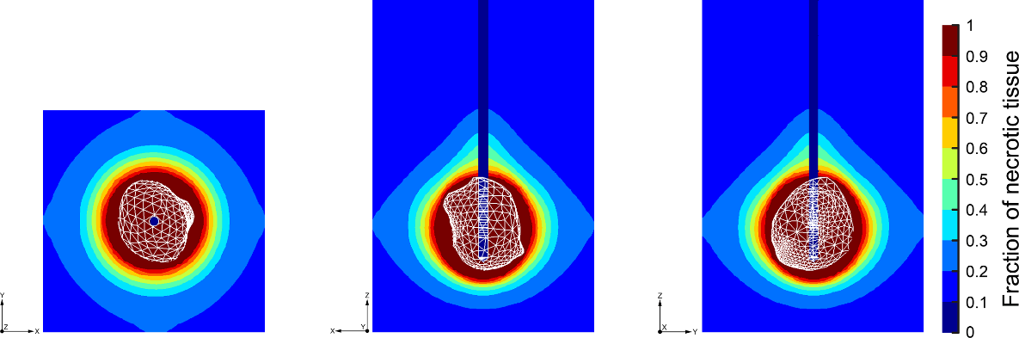

Figure 1. Fraction of necrotic tissue at different cross-sections at 600 s. The shape of the tumor is marked in white and is located in the zone of total tissue damage.

**Acknowledgements.** This research was supported by the Institute of Physics Belgrade, through the grant by the Ministry of Science and Technological Development of the Republic of Serbia and by the Science Fund of the Republic of Serbia, GRANT 7739583, SimSurgery.

REFERENCES

1. Radmilović-Radjenović, M.; Bošković, N.; Radjenović, B. Computational Modeling of Microwave Tumor Ablation. Bioengineering 2022, 9, 656.
2. Radmilović-Radjenović, M.; Bošković, N.; Sabo, M.; Radjenović, B. An Analysis of Microwave Ablation Parameters for Treatment of Liver Tumors from the 3D-IRCADb-01 Database. Biomedicines 2022, 10, 7.
3. Gmsh. Available online: https://gmsh.info
4. GetDP. Available online: https://getdp.info
5. Comsol Multiphysics. Available online: www.comsol.com