Rapid and sensitive cancer detection with fluorescence lifetime imaging microscopy

Wenhua Su, Mingmei Ji, Jiong Ma, Ruiqian Guo and Lan Mi
Department of Optical Science and Engineering, Fudan University, Shanghai, China
e-mail:lanmi@fudan.edu.cn

Fluorescence Lifetime Imaging Microscopy (FLIM) has great potential for cancer detection. In this talk, I will introduce the FLIM method and related techniques for noninvasive cancer screening and diagnosis. First, a pH-sensitive AgInS₂(AIS)/ZnS quantum dots (QDs) with long fluorescence lifetimes are introduced as an intracellular pH sensor. The FLIM technique is used in combination with AIS/ZnS QDs to distinguish cancer cells from normal cells, with promising results for noninvasive cervical cancer screening [1]. I will also talk about an endogenous coenzyme (reduced nicotinamide adenine dinucleotide (phosphate), NAD(P)H) as an indicator of cellular energy metabolism. FLIM is used to detect NAD(P)H in unstained exfoliated cervical cells to evaluate cellular metabolic status. FLIM images are analyzed by unsupervised machine learning to build a prediction model for cervical cancer risk. The FLIM method combined with unsupervised machine learning (FLIM-ML) demonstrates significantly higher sensitivity and specificity than cytology approaches, making it a promising tool for cervical cancer screening and follow-up care [2].
This talk highlights the potential of FLIM and related techniques for noninvasive cancer screening and diagnosis, providing a convenient and accurate tool for early cancer detection and follow-up cancer care.

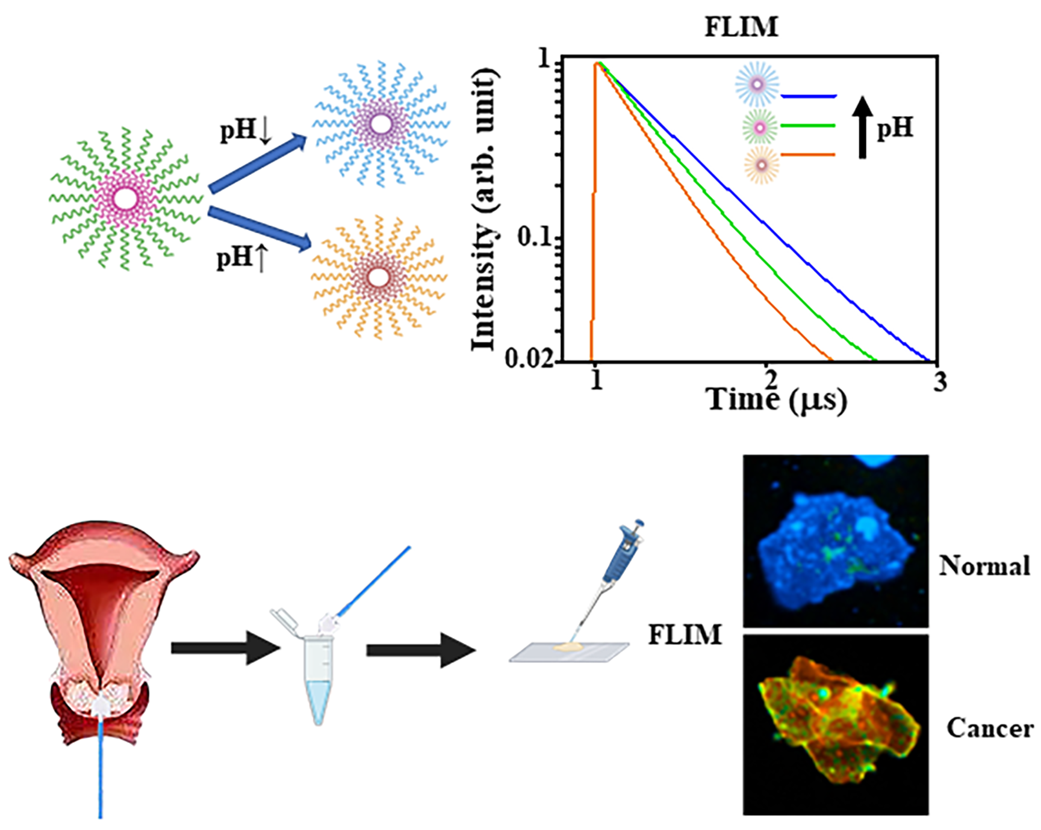
Figure 1. An intracellular pH sensor AIS/ZnS QDs combined with FLIM are used for noninvasive cervical cancer screening, and the method may be applied to other pH-related diseases in the future.

REFERENCES
[1] Wenhua Su, Dan Yang, Yulan Wang, Yawei Kong, Wanlu Zhang, Jing Wang, Yiyan Fei, Ruiqian Guo, Jiong Ma, Lan Mi, Nano Research, 15, 5193–5204 (2022)
[2] Mingmei Ji, Jiahui Zhong, Runzhe Xue, Wenhua Su, Yawei Kong, Yiyan Fei, Jiong Ma, Yulan Wang, Lan Mi, Int. J. Mol. Sci. 23, 11476 (2022)

