Measurement of the heading error of a free alignment precession magnetometer

Zoran D. Grujić¹, Marija Ćurčić¹, Aleksandra Milenkovic¹, Jonas Hinkel², Theo Scholtes²
¹Institute of Physics Belgrade,Serbia
¹Leibniz Institute of Photonic Technology, Jena, Germany
e-mail:zoran.grujic@ipb.ac.rs

Optically pumped magnetometers (OPMs) have proved competitive sensitivities, robustness, and low cost with respect to competition, but their performance for high accuracy applications is not well studied. Optimization of an all optical free spin precession (FSP) magnetometer [1] has shown possible high accuracy of a such device. But, in unpublished investigations that followed that work it emerged that FSP magnetometer suffers from a heading error two orders of magnitude larger than its sensitivity. Then an investigation on applicability of Free Alignment Precession (FAP) produced by linearly polarized light was started.

We studied Larmor frequency measured simultaneously by two linearly polarized beams, in a spherical cesium cell with antirelaxation coating. If frequencies measured by those beams are different and function of the angle between their polarizations a heading error is detected. The experimental setup allows arbitrary mutual orientations of magnetic field B₀ ≈ 1.58 μT and directions of polarizations of light beams.

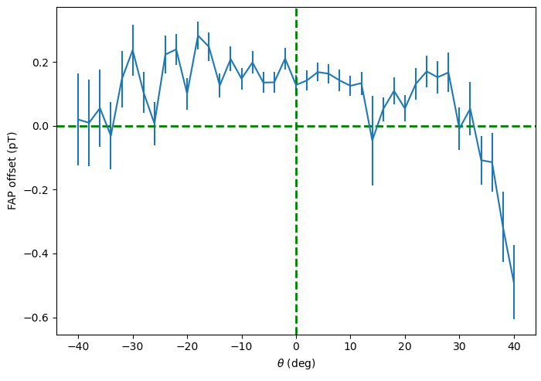
Figure 1. Measurement of the heading error of a FAP magnetometer. Direction of the B₀ and polarization direction of one of probe beams was fixed while we varied the polarization direction of the second probe beam.

In this particular case (see Fig. 1), the heading error is below 1 pT, thus at least six orders of magnitude below B₀. Further investigation is under way.

REFERENCES
[1] ZD Grujić, PA Koss, G Bison, A Weis, Eur. Phys. J. D 69 135 (2015)

