**Remote temperature sensing using upconverting phosphor and artificial neural networks**

M.S. Rabasovic, M.G. Nikolicand D. Sevic

*Institute of Physics, Belgrade, Serbia*

e-mail:majap@ipb.ac.rs

In this study we analyze possibilities of using artificial neural networks (ANN) for modeling the temperature sensing curve of a thermophosphor.

For machine learning analysis of data and ANN model we have used Solo+Mia software package (Version 9.1, Eigenvector Research Inc, USA). Experimental results were obtained using experimental setup presented in detail in [1,2]. Upconverting material was excited at 980 nm by using pulsed laser diode. Usual, conventional way is to use intensity ratios of spectral lines for determining the calibration curves for remote temperature sensing [3-5]. Based on thus obtained data we have trained the neural network to recognize temperature of sample based on its luminescence spectrum. For training we have used 69 measured spectral points between 525 nm and 560 nm, so the neural network has 69 input nodes.

Temperature sensing calibration curve of Y2O2S:Er3+,Yb3+ is shown in Figure 1 (a). Structure of ANN used to model the temperature sensing characteristics of nano phosphor is shown in Figure 1 (b). ANN predictions, shown in Figure 1 (c) imply reliable estimation of temperature using ANN shown in Figure 1 (b).

The artificial neural network provides quick and strait answer when questioned with data of samples heated to unknown temperatures. This kind of approach is very versatile, and, if needed, improved by other machine learning approaches and deep learning [6,7].

(a)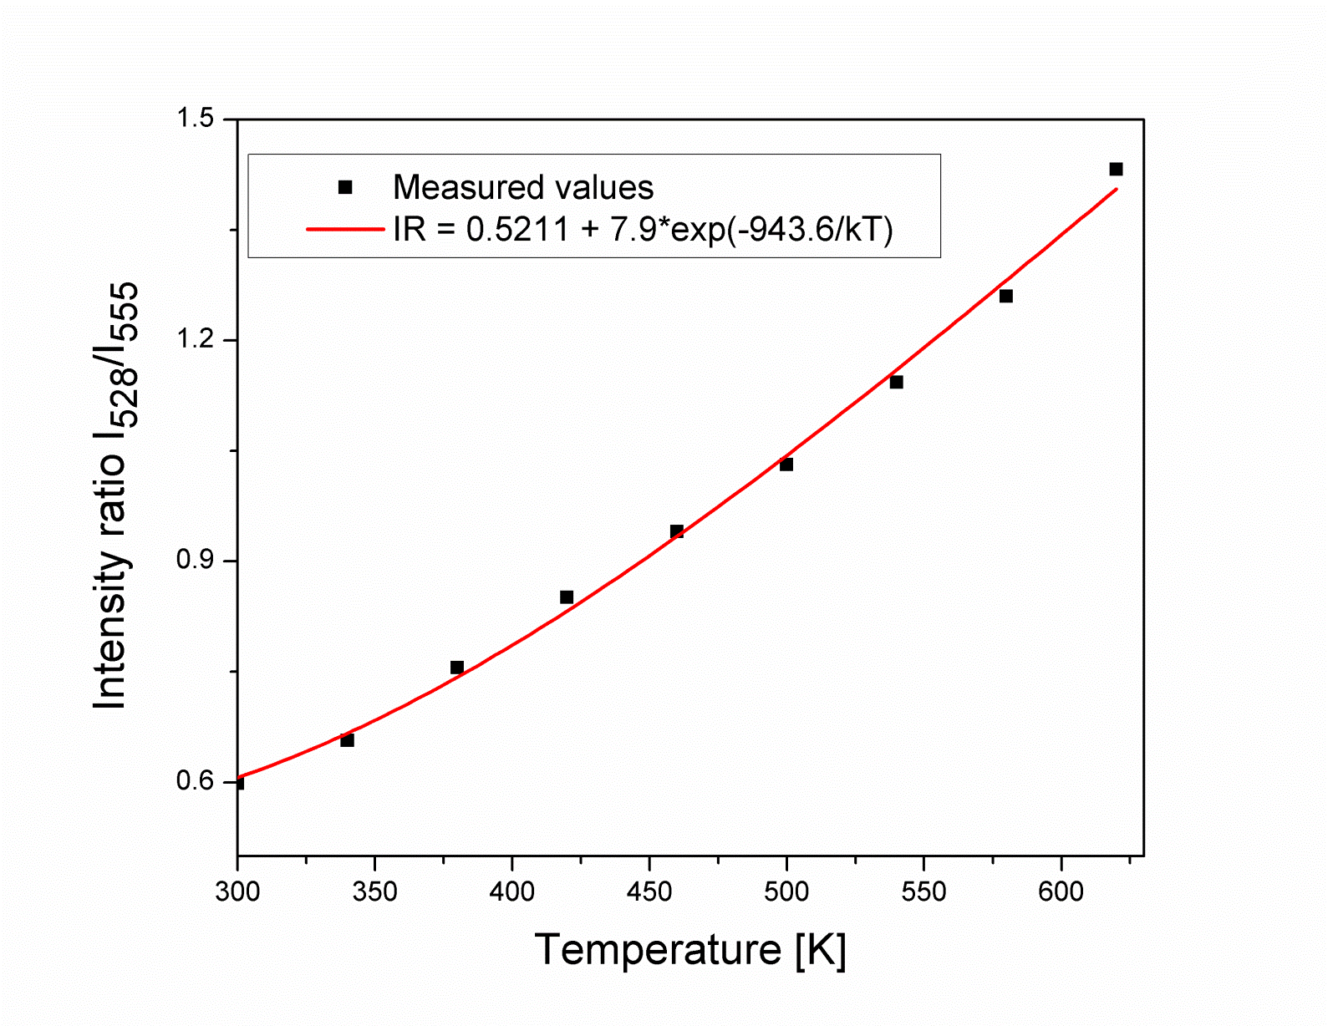 (b)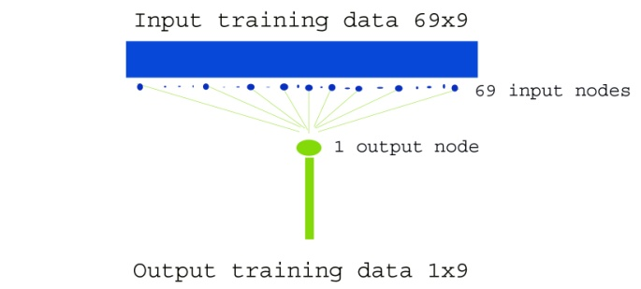(c) 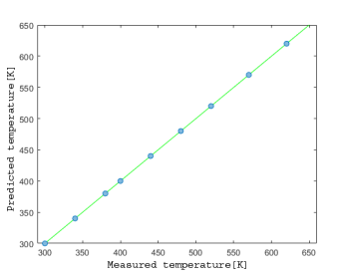

Figure 1. (a) Temperature sensing calibration curve of Y2O2S:Er3+,Yb3+. (b) Structure of ANN used to model the temperature sensing characteristics of nano phosphor. (c) Plot of predicted temperatures vs measured temperatures from training set.

REFERENCES

[1] D. Sevic, M.S. Rabasovic, J. Krizan, S. Savic-Sevic, M.D. Rabasovic, B.P. Marinkovic,

M.G. Nikolic, Optical and Quantum Electronics 52, 232 (2020).

[2] D. Sevic, M.S. Rabasovic, J. Krizan, S. Savic-Sevic, M.G. Nikolic, B.P. Marinkovic, M.D. Rabasovic, J. Phys. D: Appl. Phys. 53**,** 015106 (2020).

[3] D. Jaque and F. Vetrone, Nanoscale, 4**,** 4301-4326 (2012).

[4] C. D. S. Brites, P. P. Lima, N.J.O. Silva, A. Millan, V.S. Amaral, F. Palacio, L.D. Carlos, Nanoscale, 4,4799-4829 (2012).

[5] M. Aldén, A. Omrane, M. Richter, G. Sarner, Progress in Energy and Combustion Science, 37, 422-461 (2011).

[6] M.S. Rabasovic, B.P. Marinkovic, D. Sevic, Advances in Space Research 71 (2023).

[7] M.S Rabasovic, B.P. Marinkovic and D. Sevic, Contrib. Astron. Obs. Skalnate Pleso 50/3, 1-6, (2022).