Absorption coefficients and refractive index changes in a strongly prolate and strongly oblate ellipsoidal quantum dot

V. Pavlovic, Lj. Stevanovic
Faculty of Sciences and Mathematics, University of Nis, Serbia
e-mail: vladan.pavlovic@pmf.edu.rs

Quantum dots (QDs) are nanoscale semiconductor structures that exhibit unique optical and electronic properties due to their quantum confinement effects. These properties make them highly attractive for a wide range of applications, including optoelectronics, photovoltaic, and quantum information processing. Due to quantum confinement effects, the energy levels of electrons in quantum dots become discrete, leading to size-dependent absorption spectra. Moreover, the refractive index change exhibited by quantum dots is another critical characteristic that influences their optical behavior. The refractive index represents how light propagates through a material, and any changes in this property can significantly impact the interaction of light with quantum dots.

In this paper, Optical Absorption Coefficient (AC) and Refractive Index (RI) changes of a strongly prolate and strongly oblate Ellipsoidal Quantum Dot (EQD) are investigated.

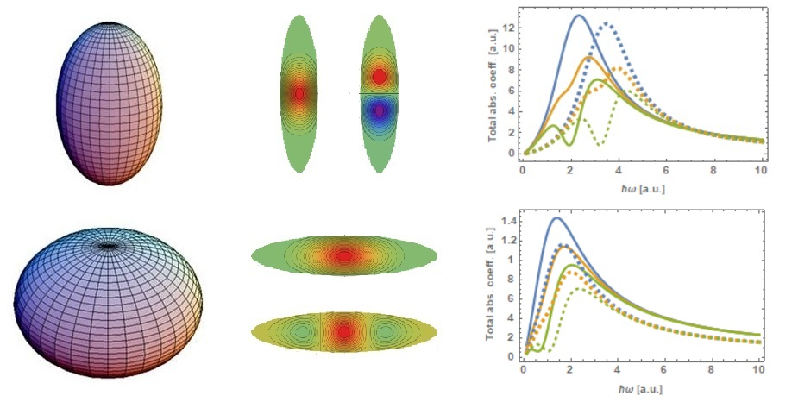
Figure 1. Strongly prolate (top) and strongly oblate (bottom) ellipsoidal quantum dot

For a strongly prolate and strongly oblate EQD, wave function can be approximated by a suitable analytical function [1, 2], where eigen energy shows good matching with numerical results. These wave functions are then used, together with density operator [3, 4], given by von Neumann equation, in order to investigate the linear and the third order nonlinear optical AC and RI changes.

It is shown that the total AC and RI are strongly size dependent, and their peaks exhibit a red shift as the size increases. It is also shown that total AC and RI are dependent on ellipticity parameter, and the peaks shift toward the lower energies as ellipticity increases.

REFERENCES
[1] D. B. Hayrapetyan, Phys. E Low-dimens. Syst. Nanostruct. 145, 115493 (2023).
[2] D. B. Hayrapetyan, et al., Phys. E Low-dimens. Syst. Nanostruct. 95, 27-31 (2018).
[3] E. Sadeghi, et al., Phys. B 406, 241-244 (2011)
[4] G. Rezai, et al., Curr. App. Phys. 11, 176-181 (2011)

