Synchrotron radiation photoemission spectroscopy study of the valence band electronic structure of Ag-Ag₂S Janus nanoparticles for the development of nanomotors propelled by NIR light

Danijela Danilović^{1,2}, Dušan K. Božanić^{1,2}, Jelena Pajović³, Gustavo A. Garcia⁴,
Laurent Nahon⁴, Tijana Marić⁵, Vladimir Djoković^{1,2}

¹Vinca Institute of Nuclear Sciences, University of Belgrade, P.O. Box 522, 11001 Belgrade, Serbia
²Center of Excellence for Photoconversion, "Vinča" Institute of Nuclear Sciences - National Institute of the Republic of Serbia, University of Belgrade, Serbia,
³Faculty of Physics, University of Belgrade, Studentski trg 12, 11001 Belgrade, Serbia
⁴Synchrotron SOLEIL, l’Orme des Merisiers, St.Aubin, BP48, 91192 Gif sur Yvette Cedex, France
⁵Department of Health Technology, Technical University of Denmark, Kgs Lyngby,2800 Denmark
e-mail: danijelad@vin.bg.ac.rs

Silver-silver sulfide (Ag-Ag₂S) hybrid nanosystem which consists of plasmonic metal Ag and narrow band gap semiconductor Ag₂S is typically studied as a photocatalyst under visible and NIR light¹⁻². Janus morphology of this system is especially interesting due to the possibility of initiating two different chemical reactions, that are spatially separated on two halves of the system. Here, we present the fabrication of Ag-Ag₂S Janus nanoparticles and the examination of their valence electronic structure. For the investigation of the electronic structure of isolated nanoparticles, we performed synchrotron radiation vacuum ultraviolet photoelectron spectroscopy using the velocity map imaging (VMI) technique. By using two different photon energies, hν=9.5 eV and hν=11 eV, we obtained angle-resolved photoelectron images. Photoemission spectra and the dependence of the asymmetry parameter α on the binding energy are derived from VMI images using modified p-Basex inversion method³. In addition, we coupled Ag-Ag₂S nanoparticles to the TiO₂ and studied the actuation of obtained hybrid nanosystem in a liquid medium under visible and NIR light.

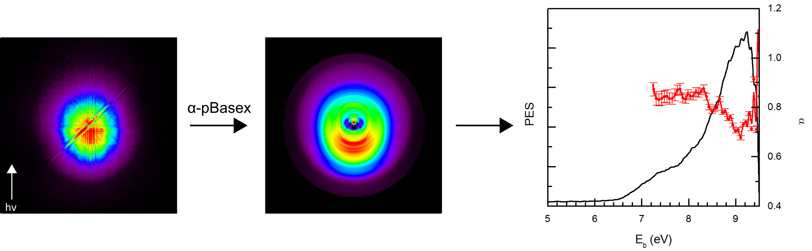
Fig 1. Raw and p-Basex reconstructed photoelectron image of Ag-Ag₂S nanoparticles, and photoemission spectrum and α parameter dependence on the binding energy (hν=9.5 eV).

REFERENCES
[1] Zhang, X., Wang, W., Su, L., Nano Lett, 21, 2625 (2021).
[2] Jiang, F., Tian, Q., Tang, M., CrystEngComm, 13(24), 7189 (2011).
[3] Božanić, D. K., Garcia, G. A., Sublemontier, O, J. Phys. Chem. C, 124, 24500 (2020).

