**Cutting edge technique for determination of spatial resolution limits of nonlinear laser scanning microscopy**

M. Bukumira1, J. Jelić1, A. Denčevski1, M.D.Rabasović1, N. Vujičić2, A. Senkić2, А. Supina2, А. Krmpot1

*1Institute of Physics Belgrade, University of Belgrade, Laboratory for Biophysics, Belgrade, Serbia*

*2Institute of Physics, Center of Exellence for advanced Materials and Sensing devices, Zagreb, Croatia*

e-mail: [marta@ipb.ac.rs](mailto:marta@ipb.ac.rs)

Microscope resolution is the shortest distance between two points on a sample that can be distinguished as separate entities. Due to the wave nature of light and the phenomenon of diffraction, it is fundamentally limited: even under theoretically ideal conditions and optical components, the microscope has a finite resolution.

In this paper, we determined the lateral and axial resolution of a nonlinear laser scanning microscope by measuring its Point Spread Function (PSF). The measurement was preformed in two ways: by imaging fluorescent beads using two-photon excited fluorescence (standard method), and by using transition metal dichalcogenide monolayers of molybdenum disulfide and tungsten disulfide (cutting edge method). The monolayers - obtained by chemical vapor deposition1, efficiently generate second harmonic (SHG) signal due to the lack of central symmetry. The monolayers were also used for determination of the lateral resolution of third harmonic generation (THG) microscopy.

Measurements were performed for different objectives and several standard excitation wavelengths, depending on the type of sample. As expected, the best resolution was obtained for the objective with the largest numerical aperture and the shortest excitation wavelength. In addition, the values ​​obtained by the non-standard cutting edge method are closer to the theoretical values ​​of the resolution, because the contributions of the out-of-focus signal are significantly reduced due to the two-dimensional nature of the layers. The measured PSF can be further used to deconvolve the images obtained on this microscope.

Due to its properties such as great depth of penetration of incident radiation and label-free imaging, as well as the possibility of making 3D models, our microscope is widely used in examining samples of biological origin, such as: erythrocytes2, chitin structures3, human colon4, collagen, dentin, ...

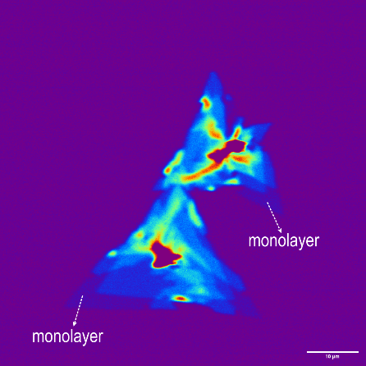 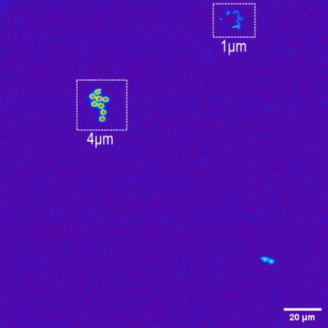

Figure 1. Left: WS2 (mono)layers; right: fluorescent beads of different diameters (4µm and 1µm)

20µm

REFERENCES

[1] A. Senkic *et al.*, Mater. Chem. Phys. **296**, 127185 (2023)

[2] K. Bukara *et al.*,J. Biomed. Opt. **22**(2), 026003 (2017)

[3] MD Rabasovic *et al.*, J. Biomed. Opt. **20**(1), 016010 (2015)

[4] SZ Despotovic *et al.*, Sci. Rep. **10**, 6359 (2020)