**Interband Cascade Lasers: advantages of bulk AlGaAsSb claddings**

**B. Petrović**1**, A.Bader** 1**, F. Hartmann** 1**, R. Weih** 2, **F. Jabeen** 1**and S. Höfling** 1

1 *Julius-Maximilians-Universität Würzburg, Physikalisches Institut, Lehrstuhl für Technische Physik, Am Hubland, 97074 Würzburg, Germany*

2nanoplus Nanosystems and Technologies GmbH, Oberer Kirschberg 4, D-97218 Gerbrunn, Germany

email: borislav.petrovic@physik.uni-wuerzburg.de

Interband cascade lasers (ICLs) are mid-infrared emitting devices used for gas-sensing applications in environmental protection, medicine, and military applications. In the 3-7 μm wavelength range, ICLs have the lowest threshold current densities and also have significantly higher characteristic temperatures compared to type-I laser diodes. This is crucial for portable devices operating in continuous wave (CW) regime. Cladding materials of low refractive index and high thermal conductivity are important for the optical confinement and heat disipation.

We have grown ICLs emitting at 4.9μm with AlGaAsSb bulk and AlSb/InAs superlattice claddings (Figure 1a) and we characterize and contrast the lasers' figures of merit. P-I-curves (Figure 1b) and temperature dependent measurements (Figure 1c) show improved device operation for ICLs with bulk claddings in comparison to the usually employed superlattice claddings. The improvement of threshold current density can be attributed to lower refractive index of AlGaAsSb cladding [1]. In support to the result, we have simulated optical mode confinement factor throughout both ICL structures and noted it’s increase of 10.3% in the active region of ICL with AlGaAsSb claddings.

Higher thermal conductivity of the bulk compared to superlattice (7 W/m·K to 1-3 W/m·K) claddings [2] and higher characteristic temperature contribute to enhancement in operation in CW.

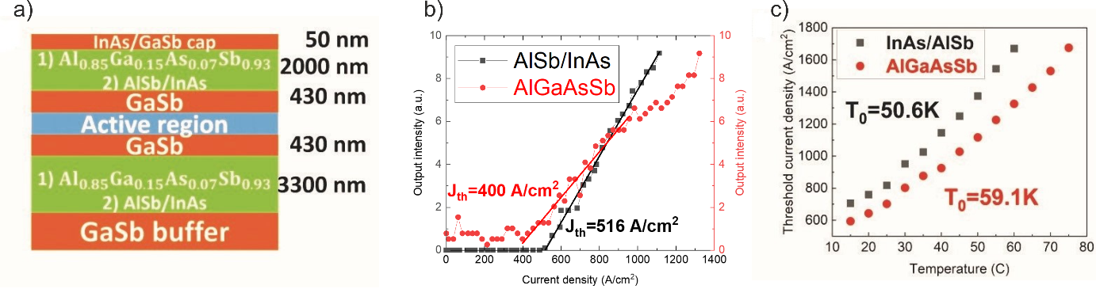

Figure 1: a) Layer structure with 1) bulk and 2) superlattice claddings b) P-I characteristics c) Characteristic temperatures

REFERENCES

[1] R. Weih, A. Bauer, M. Kamp, S. Höfling, *Optical Materials Express*, **3**, 10, (2013).

[2] T. Borca-Tasciuc et al. *IEEE Journal of Appl. Phys.*, 9, **92**, (2002).