In vivo multiphoton imaging of a filamentous fungus Phycomyces blakesleeanus: the effect of small ambient temperature increase on mitochondrial morphology and lipid droplets density

T. Pajic¹, S. Kozakijevic¹, A. J. Krmpot², M. Zivic¹, N. V. Todorovic³ and M. D. Rabasovic²
¹Faculty of Biology, University of Belgrade, Serbia
²Institute of Physics Belgrade, University of Belgrade, Serbia
³Institute for Biological Research “Siniša Stanković”, University of Belgrade, Serbia
e-mail:tpajic@bio.bg.ac.rs

Mitochondrial function, and consequently cellular metabolic status and fitness of a cell, is tightly linked to the dynamic changes of mitochondrial morphology, including mitochondrial fusion, fission and mitophagy [1]. Lipid droplets (LDs) can be in close contact with mitochondria, and accumulate autophagy or mitophagy generated material during the reparatory processes [2]. The effect of increased ambient temperature on mitochondrial morphology and LDs density in living cells of the filamentous fungus Phycomyces blakesleeanus was investigated. For in vivo imaging of mitochondria and LDs multiphoton microscopy was used. Multiphoton microscopy enables 3D imaging in high resolution and reduced photodamage and photobleaching of the sample using IR ultrafast pulsed lasers. Mitochondria were stained with the vital dye Rhodamine123 (Rh123) which enters these organelles based on their membrane potential - mitochondria must be healthy/active to stain. A wavelength of 800 nm from Ti:Sa laser (160 fs pulse duration, 76 MHz repetition rate) was used for two-photon excitation of Rh123. The laser beam was focused by the Zeiss Plan Neofluar 40x1.3 objective lens and the signal was detected through a bandpass interference filter MF530/43 (ThorLabs, USA). For LDs staining a Nile Red dye was used and excited by Yb: KGW laser at 1040 nm [3]. Six morphological types of mitochondria were observed in the hyphae of this fungus: intermediate type - normal, intermediate with small semicircular tubules, tubular, elongated tubular, fragmented (small ellipsoid tubule) and fragmented with exclusively spheroid-shaped mitochondria. Changes in mitochondrial morphology were induced by a small temperature change. A 3°C increase in ambient temperature, from 22°C, had a dramatic effect on mitochondrial morphology, inducing the appearance of a predominantly tubular mitochondrial morphology. The total area percentage of mitochondria showed an increasing trend when grown at 25°C. Increasing the ambient temperature to 25°C induced a statistically significant increase in the percentage of hyphal area occupied by LDs from 2.9 ± 1.6 to 4.7 ± 2.2 (mean value and SD in percentage of hyphal area). The observed response to the small temperature increase points to the physiological adaptation of hyphal metabolism.
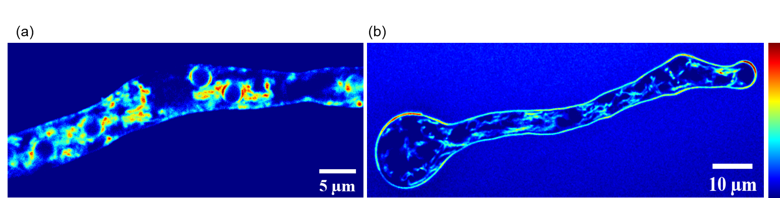
Figure 1. Two-photon images of mitochondrial morphology in Phycomyces blakesleeanus hyphae. (a) intermediate morphology at 22°C (b) tubular morphology at 25ºC. Both hyphae were stained with 5 μM Rh123. Intensity bar is geven on the righ, deep blue-lowest two photon excited fluorescence signal, deep red – highest TPEF signal

REFERENCES
[1] K. Ma, G. Chen, W. Li, O. Kepp, Y. Zhu, Q. Chen. Front Cell Dev Biol. 8:467. (2020)
[2] M. Long, T. G. McWilliams. Autophagy. 19:2, 724-725. (2023)
[3] T. Pajić, N. V. Todorović, M. Živić, S. N. Nikolić, M. D. Rabasović, A. H. A. Clayton, A. J. Krmpot. Sci. Rep. 12, 18760. (2022)

