**Shape-changing microstructures for multifunctional microfluidics**

S. Nocentini1,2, S. Donato2, D. Martella1,2, C. Credi2,3, C. Parmeggiani2,4 and D. S. Wiersma1,2,5

1 *Istituto Nazionale di Ricerca Metrologica INRiM, Turin, Italy*

2 *European Laboratory for Non-linear Spectroscopy, Sesto Fiorentino, Italy*

3 *National Institute of Optics, National Research Council, Sesto Fiorentino, Italy*

4 *Department of Chemistry Ugo Schiff, University of Florence, Sesto Fiorentino, Italy*

5 *Department of Physics and Astronomy, University of Florence, Sesto Fiorentino, Italy.*

e-mail: nocentini@lens.unifi.it

The miniaturization of functional components and actuators within active microfluidic circuits constitutes a fascinating technological challenge. The role of pumps, valves and mechanical filter is of paramount importance to dynamically operate with microfluidic devices, and their implementation can be tackled by the 3D micro patterning of smart materials with a shape changing behavior. To avoid the complex integration of batteries or electronic circuits, the activation of such active micro-components can be obtained by optically driven micro machines and actuators that exploit optical stimuli as fuel, converting light energy into mechanical work. Among photo-responsive materials, shape-changing polymers such as liquid crystalline networks (LCN) offer reversible deformations in the millisecond time range [1,2]. In this contribution, we will present the patterning of LCN with a laser-based printing technique based on two-photon polymerization that allows to micropattern functional polymers in 3D shapes even in microfluidic channels (Figure 1). By tailoring the material choice and the printing parameters, structures made by the same material capable of different deformations can be printed on the same chip in a single fabrication process. The design of the structure reversible deformation enlarges the reshaping and functional properties of integrated soft microstructures also determining the dynamics of the structure deformation both in dry and liquid environments.

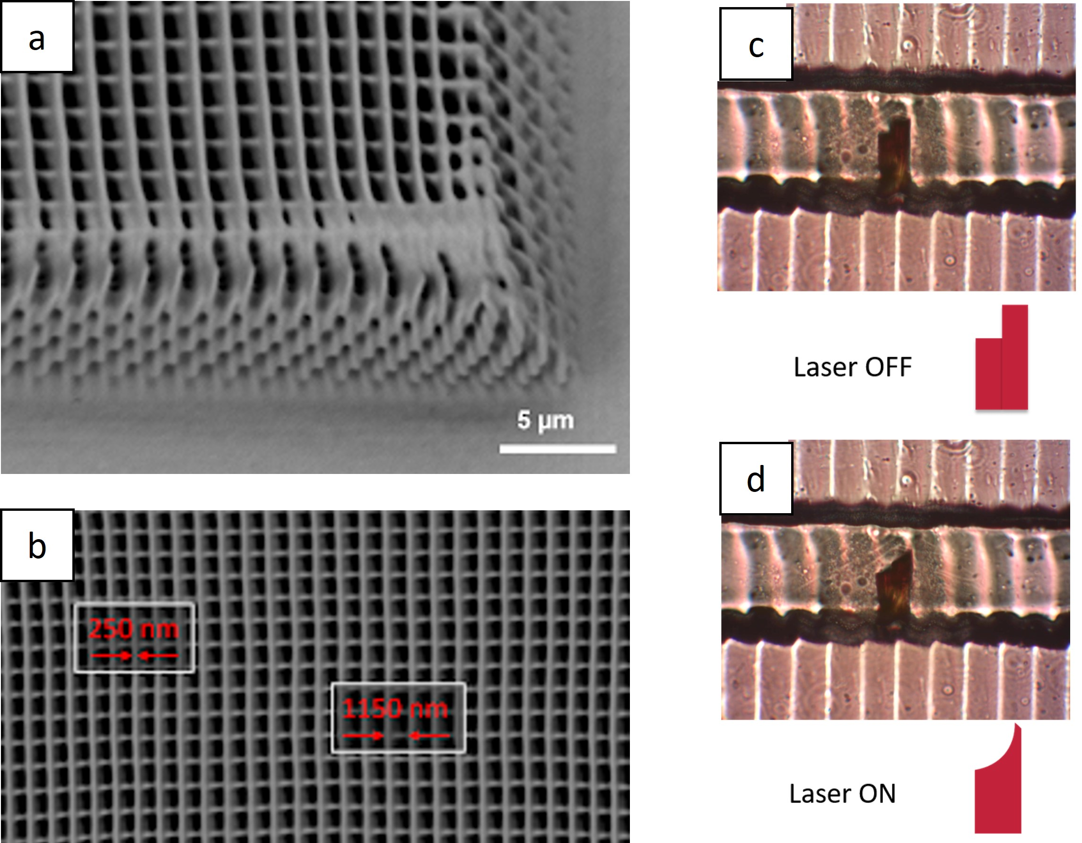

Figure 1. Soft elastic microstructures printed by two photon direct laser writing: on the left, a LCN woodpile (a-b); on the right, a LCN valve in a micro-fluidic channel (c) under light illumination (d).

REFERENCES

[1] De Bellis, et al., *Adv. Funct. Mater.,* 2213162 (2023).

[2] Nocentini, et al., *Adv. Opt. Mater.* **6**(15), 1800167 (2018).

The research leading to these results has received funding from HORIZON-WIDERA-2021-ACCESS-03-01 – Twinning, Grant agreement No 101079355.