Bioactive compounds of Carlina acanthifolia L. roots obtained by fractional extraction and their 3D fluorescence spectra

N. Petkova¹, I. Ivanov¹, E. Saralieva¹, D. Georgieva², K. Nikolova², T. Eftimov^{3,4} , G. Gentscheva⁵, L. Vladimirova - Mihaleva
¹University of Food Technologies, Department of Organic Chemistry and Inorganic Chemistry, Plovdiv, Bulgaria
²Medical University, Varna, Department of Physics and Biophysics Bulgaria
³Université du Québec en Outaouais, Gatineau, Québec, Canada
⁴Central Laboratory of Applied Physics, Bulgarian Academy of Sciences, Plovdiv, Bulgaria
⁵Medical University-Pleven, Department of Chemistry and Biochemistry, Pleven, Bulgaria
⁶Sofia University “St. Kliment Ohridski”, Faculty of Physics, Sofia, Bulgaria
e-mail:kr.nikolova@abv.bg
Carlina acanthifolia L. is widely used in traditional medicine due to the presence of essential oil (1-2%) in the outer part of the roots of the plant. It is mainly used for its choleretic and anti-inflammatory properties, as well as for the treatment of gastrointestinal problems [1].
We obtain the fractions by sequential extraction with different solvents (hexane, chloroform, ethyl acetate, ethanol, and water) from carline thistles (Carlina acanthifolia All.) roots, evaluate the phytochemical compounds and for the first time, we report here the 3D fluorescence excitation-emission spectra. The highest yield (11.02 %) was obtained by using 95% ethanol. The highest extractive content of total phenols, flavonoids, and derivatives of economic acids was found in the ethyl acetate fraction. Three phenolic acids were detected in the ethyl acetate fraction – chlorogenic, p-coumaric, and sinapic acids, as chlorogenic acid was dominating among the others (16.06 mg/g extract). These fractions demonstrated the highest antioxidant potential and the fluorescent properties of the roots are related to them. The topographic view of the excitation-emission matrix (EEM) presented in Figure 1 outlines a large strong first maximum (λ_{em,1} = 570 nm for λ_{exc,1} = 470 nm) and a weaker narrower second one (λ_{em,2} = 595 nm for λ_{exc,2} = 640 nm). The emission spectrum of the main maximum is rather large at 90% level (δλ_{em,1} = 60 nm) but is observed over a narrow excitation bandwidth (δλ_{exm,1} = 25 nm) (Table 1). The Stokes shift Δλ is around 100 nm over the excitation range from 430 nm to 560 nm. The energy diagram is shown in Figure 2, the darker areas representing the 90% level of the larger maximum.
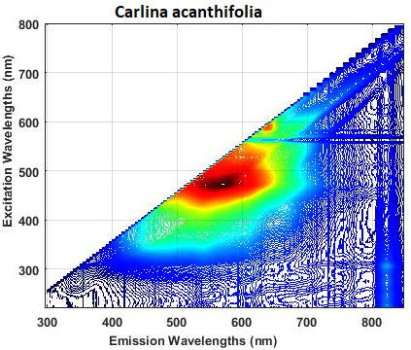
δλ_{em,max}
δλ_{exc,max}
λ_{exc}=λ_{em}
Δλ
2.21 eV
2.87 eV
2.64 eV
2.53 eV
1.94 eV
2.48 eV
2.32 eV
2.10 eV
430 nm – 560 nm
540 nm – 600 nm
595 nm
650 nm

1.94 eV
2.48 eV
2.32 eV
2.10 eV
2.21 eV
2.87 eV
2.64 eV
2.53 eV
Figure 2. Energy diagram as revealed from the EEM in Figure 1.
Figure 1. Topographic view of the fluorescence excitation emission matrix (EEM) from Carlina acanthifolia
TABLE 1
λ_{ex,1} (nm) | δλ_{ex,1} (nm) | λ_{em,1} (nm) | δλ_{em,1} (nm) | Δλ (nm) | λ_{ex,2} (nm) | λ_{em,2} (nm)
470 | 25 | 570 | 60 | 100 | 595 | 640
REFERENCES
1. M. Strzemskia, M. Wójciak-Kosiora, Ir. Sowa, M. Agacka-Mołdoc, P. Rączkowski, D. Matosiuk, Ł. Kurach, R. Kocjan, Sł. Dresler, Talanta, 174, 633-637 (2017),
This study is financed by the European Union-Next Generation EU, through the National Recovery and Resilience Plan of the Republic of Bulgaria, project № BG-RRP-2.004-0009-C02

