From French fries to Foie Gras, turning around a synchrotron

F. Jamme¹, J. Pajovic², F. Wien¹, and M. Réfrégiers³
¹DISCO Beamline, Synchrotron SOLEIL, Gif-sur-Yvette, France
²University of Belgrade, Faculty of Physics, Studentski trg 12, Belgrade, Serbia
²CBM CNRS UPR430, rue Charles Sadron, Orléans, France
matthieu.refregiers@cnrs.fr

Probably the best way to enter a synchrotron and to understand the usefulness of parasitic effects in accelerator physics is through its applications.
We will take a tour of the quasi-relativistic nature of accelerated particles - the ultimate for an electron in a synchrotron - and some original applications we've come across at the SOLEIL synchrotron in life sciences and cultural heritage.
Of particular interest, deep ultraviolet (DUV: from 180 to 380 nm), have enough energy to interact with a very broad range of biomolecules [1], pigments [2], semiconductors, …., and at the same time, not so energetic that they can continue to travel through air and water. It is therefore a perfect energy range for studying those molecules in their natural environment. Controlling the delivered power, it is even possible to work with living microorganisms [3].
Most applications will be based on natural luminescence observed in a diversity of samples, but time resolved circular dichroism using the natural polarization of the upper and lower parts of the synchrotron beam extracted from a bending magnet will also be illustrated [4].
We will discuss the diversity of applications in structural biology, food science, cultural heritage, pharmacological research and medical diagnostics developed in DUV at SOLEIL, a large-scale facility open to a broad range of research communities.

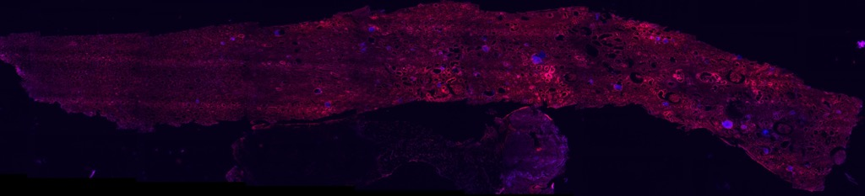

Figure 1. Direct observation of calcium oxalates precipitation (blue) in a kidney biopsy (tissue autofluorescence shown in red).

REFERENCES
[1] https://doi.org/10.1111/boc.201200075
[2] https://doi.org/10.1017/S1431927622000873
[3] https://doi.org/10.1038/s42003-020-0929-x
[4] https://doi.org/10.1063/1.5120346

