**PHOTONICA 2023**

**Exploiting the quantumness of coherent states: toward macroscopic quantum light**

Carla Hermann Avigliano (1,2)

1. *Departamento de Física, FCFM, Universidad de Chile, Santiago, Chile.*

*(2) ANID - Millenium Science Initiative Program - Millenium Institute for Research in Optics (MIRO)*

*Email: carla.hermann@uchile.cl*

Can we harvest useful quantum properties from coherent states? Can we engineer quantum states with them, creating useful nonclassical states from mostly classical light? Our last works attempt to answer both questions with a solid yes. We show how nonlinear light-matter interactions reveal the unambiguous quantum nature of coherent states, creating macroscopic and highly nonclassical light while preserving their coherent photon statistics [1]. Figure 1 shows examples of the generation of such states, where the uncertain region of an initial coherent state in the phase space representation (Wigner Function) nonlinearly evolves into negative values, an unmistakable quantum fingerprint. The emergent non-minimal uncertainty states have a significant metrological advantage, a fundamental resource for quantum metrology. Remarkably, we also show how to deterministically generate Fock states with large photon numbers and high fidelities within the well-known Jaynes–Cummings model, which is a particular case of such nonlinear interactions [2].

Our results highlight how useful quantum features can be extracted from the seemingly most classical states of light, a relevant phenomenon for quantum optics applications.

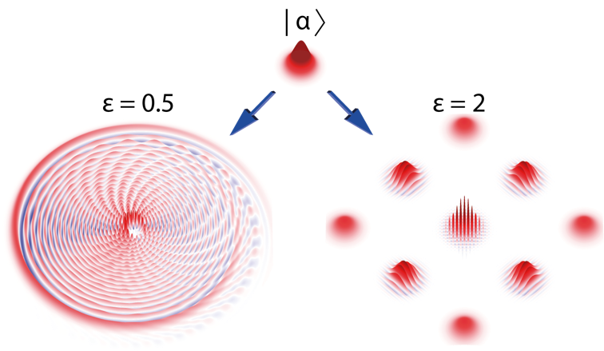

Figure 1: Nonlinear evolution of a coherent state into highly non-Gaussian states.

References

[1] Emergence of Non-Gaussian Coherent States Through Nonlinear Interactions. M. Uria, A. Maldonado-Trapp, C. Hermann-Avigliano, and P. Solano. Phys. Rev. Research 5, 013165 – 2023. <https://doi.org/10.1103/PhysRevResearch.5.013165>

[2] Deterministic Generation of Large Fock States. M. Uria, P. Solano, and C. Hermann-Avigliano. Phys. Rev. Lett. 125, 093603 – 2020. <https://doi.org/10.1103/PhysRevLett.125.093603>