A single ion meets a single Rydberg atom

R. Löw
University of Stuttgart
Stuttgart, Germany
e-mail: r.loew@physik.uni-stuttgart.de

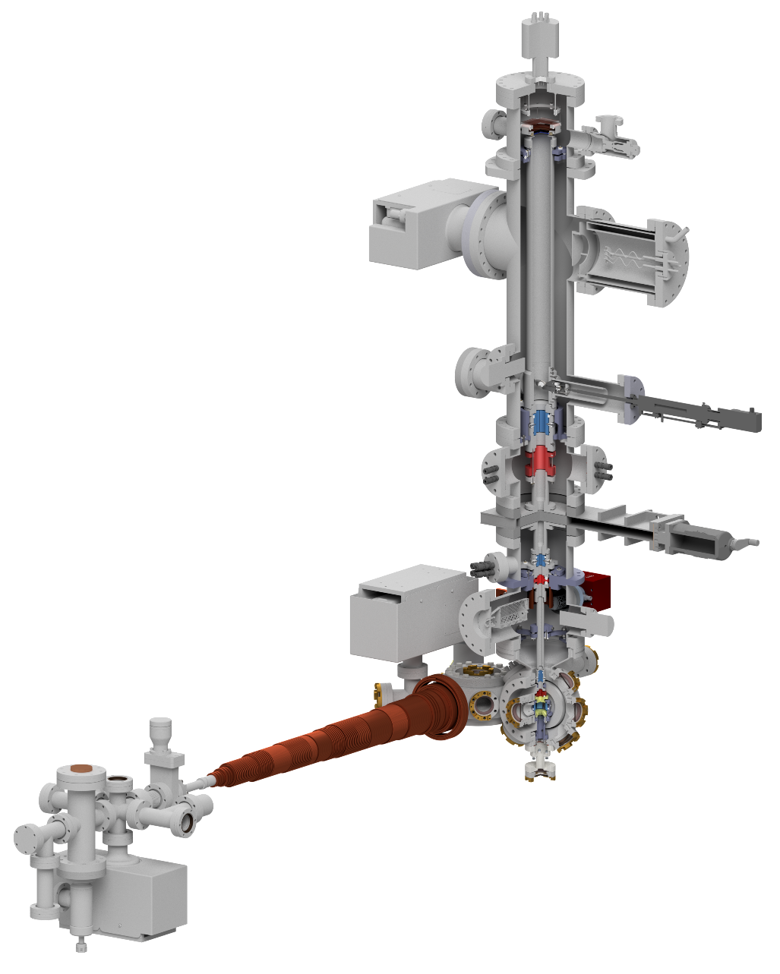
Highly excited Rydberg atoms can form quite unusual bonds,
which lead to long-range Rydberg molecules with exotic
properties, here we study a molecular ion that is formed due
to the interaction between an ionic charge and a flipping-induced
dipole of a highly excited Rydberg atom [1]. This molecule
feature an unusual large bond length, therefore dynamical
processes are slowed down drastically. This leads to a
vibrational dynamics in the microsecond regime [2] that
can be observed in real space by using a high-resolution
ion microscope [3]. By applying a weak external electric
field of a few mV/cm, it is possible to control the orientation
of the ionic ultralong-range Rydberg molecules directly during
the creation process. When the field is quenched off in a
subsequent step, the vibrational dynamics can be initialized and
observed under the ion microscope in real space. In the end we
will look at the unbound collision dynamics of a Rydberg atom
and an Ion.

Figure 1. Schematics of a new type of ion microscope for probing ultracold gases beyond the typical optical resolution. The setup consists of a traditional cooling chamber (Zeeman-slower, MOT, evaporation) and a science chamber connected to a spatially resolving detector including three magnifying ion lenses.

REFERENCES
[1] Nicolas Zuber, Viraatt SV Anasuri, Moritz Berngruber, Yi-Quan Zou, Florian Meinert, Robert Löw, Tilman Pfau, Nature, 605 453 (2022)
[2] Yi-Quan Zou, Moritz Berngruber, Viraatt SV Anasuri, Nicolas Zuber, Florian Meinert, Robert Löw, Tilman Pfau, PRL 130 023002 (2023)
[3] Christian Veit, Nicolas Zuber, Oscar Herrera-Sancho, Viraatt SV Anasuri, Thomas Schmid, Florian Meinert, Robert Löw, Tilman Pfau, PRX 11 011036 (2021)

