Scanning quantum microscopy

Frank Setzpfandt^{1,2}
¹Institute of Applied Physics, Abbe Center of Photonics, Friedrich Schiller University Jena, Jena, Germany
²Fraunhofer Institute of Applied Optics and Precision Engineering IOF, Jena, Germany
e-mail:f.setzpfandt@uni-jena.de

Quantum correlations of photon pairs in time and space have been widely employed for quantum-enhanced measurements and specially in the field of quantum imaging [1]. Imaging approaches based on such correlations fundamentally enable to image below the shot-noise limit, thus allowing to extract more information from a sample than classically possible with the same number of photons. Wide-field imaging schemes using correlations, however, are often limited by the properties of the needed sources for correlated photon pairs. In particular, for reaching a high spatial resolution, very short photon-pair sources would be necessary [2], which in turn limits the generation rate and thus increases the measurement time.
One approach that overcomes these limitations is based on scanning imaging. In my talk, I will discuss our implementation of a scanning microscope exploiting the correlations of photon pairs to enable infrared imaging [3]. This approach greatly reduces the demands on the photon-pair source while still allowing to access the advantages enabled by using correlations. I will show that the spatial resolution of our system is now only limited by the used optics. Furthermore, I will discuss first experiments towards hyperspectral imaging of biological specimen.
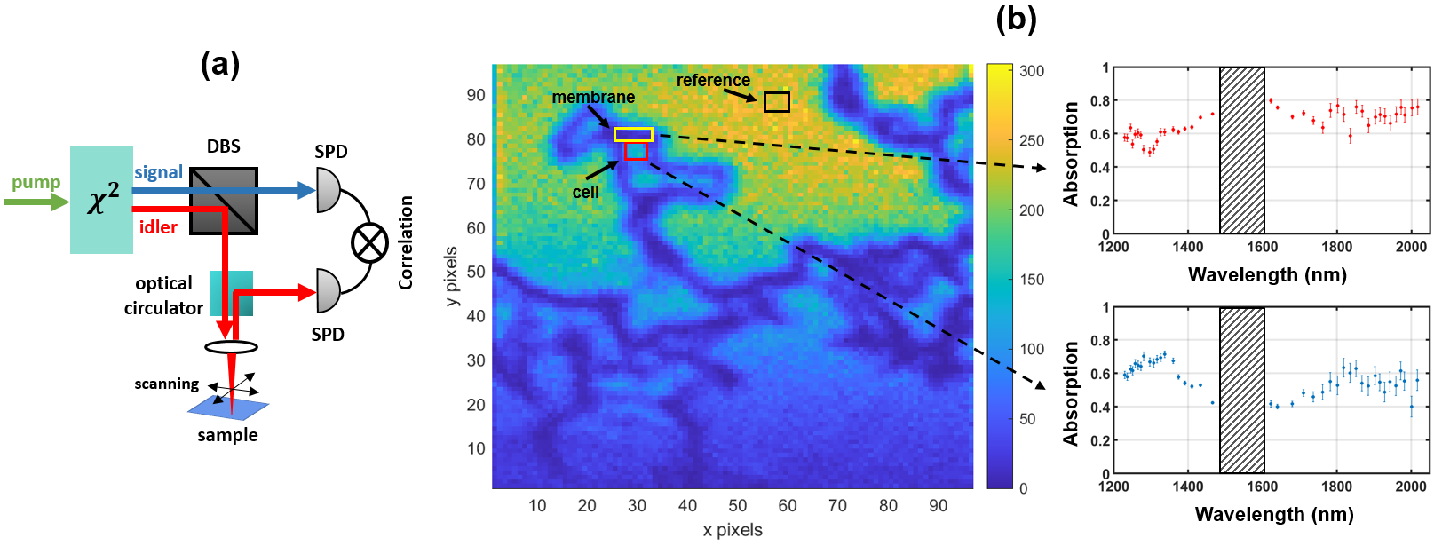

Figure 1. (a) Scheme of the implementation of the scanning quantum microscope and (b) measurement results for HEK 293T cells, where the image is taken at 1465 nm wavelength, while the two insets show spectra obtained with the microscope at the membrane and core regions of one cell in the sample.

REFERENCES
[1] I. Ruo-Berchera, and I. P. Degiovanni, "Quantum imaging with sub-Poissonian light: challenges and perspectives in optical metrology," Metrologia 56, 024001 (2019).
[2] A. Vega, E. A. Santos, J. Fuenzalida, M. Gilaberte Basset, T. Pertsch, M. Gräfe, S. Saravi, and F. Setzpfandt, „Fundamental resolution limit of quantum imaging with undetected photons,” Phys. Rev. Research 4, 033252 (2022)
[3] V. F. Gili, C. Piccinini, M. Safari Arabi, P. Kumar, V. Besaga, E. C. Brambila-Tamayo, M. Gräfe, T. Pertsch, and F. Setzpfandt, „Experimental realization of Scanning Quantum Microscopy,“ Appl. Phys. Lett. 121, 104002 (2022)

