Structured laser beams: generation and applications

D. Porfirev^{1,2}, A. Porfirev^{1,2}, S. Khonina^{1,2}, and S. Karpeev^{1,2}
¹Samara National Research University, Samara, Russia
²Image Processing Systems Institute of RAS—Branch of the FSRC “Crystallography and Photonics” RAS, Samara, Russia
e-mail:dporfirev@gmail.com

In recent years, structured laser beams with a complex distribution of intensity, phase, and polarization are increasingly used in different fields of modern science – optical manipulation, communication, microscopy, laser material processing, etc. In the field of optical manipulation, structured laser beams are effectively used for the realization holographic optical tweezers - modifications of the conventional optical tweezers, for the invention of which Arthur Ashkin was awarded the Nobel Prize in Physics in 2018. The use of structured laser beams made it possible to shape complex optical traps for the rotation of micro-objects [1], moving them along predetermined complex three-dimensional trajectories [2], and also for the realization of the so-called tractor beams [3]. In the field of laser material processing, structured laser beams are widely used for direct one-step fabrication of various unique one-, two, and even three-dimensional microstructures.
In this work, we demonstrate the use of diffractive optical elements and their combinations with polarizing elements, such as q-plates and depolarizers for generation of structured laser beams with the desired amplitude, phase and/or polarization. The generation of multi “bottle” optical beams, multi-spiral laser beams, hybrid cylindrical vector beams, and arrays of non-uniformly polarized laser beams are demonstrated. The proposed approaches made it possible to realize advanced optical manipulation - trapping and guiding of multiple particles in space (see Fig. 1). In addition, we used the generated laser beams for realization of precision laser processing of polarization-sensitive materials (such as azopolymer thin films and nano-multilayer structures based on chalcogenide glasses) and demonstration of spiral-shaped mass transfer, polarization-sensitive multi-beams patterning, and direct fabrication of different types of surface relief gratings (see Fig. 2). This work was supported by the Russian Science Foundation grant No. 22-12-00041.

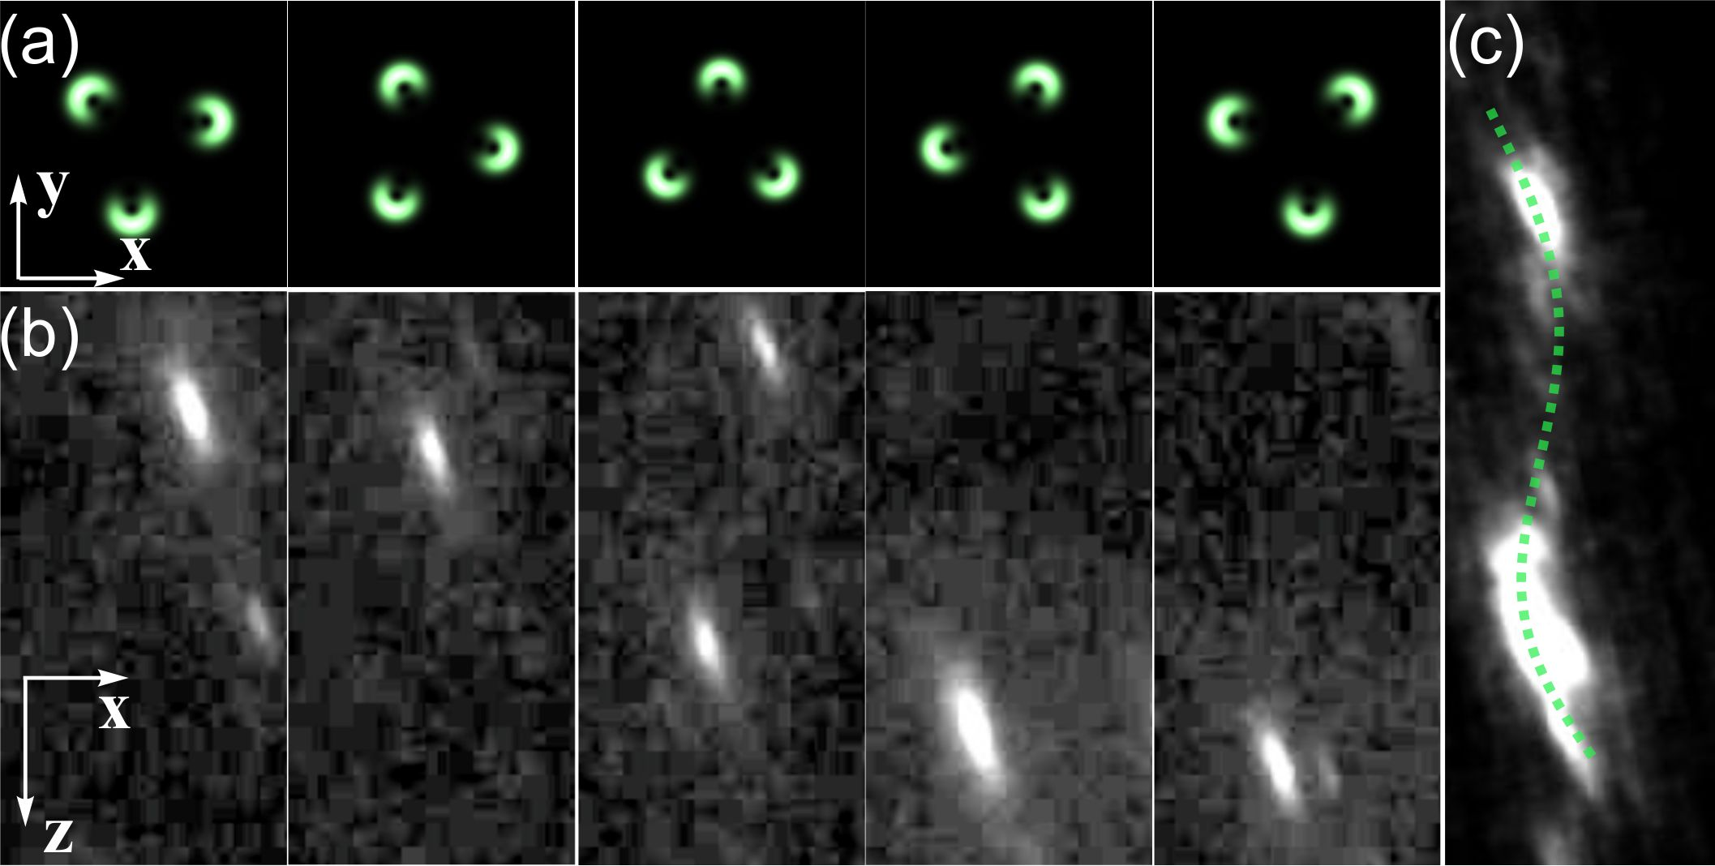
Figure 1. Laser guiding of a light-absorbing particle in air with a rotating laser beam: (a) transverse intensity distributions of the beam, (b) motion stages of the guided particle, (c) particle trajectory.
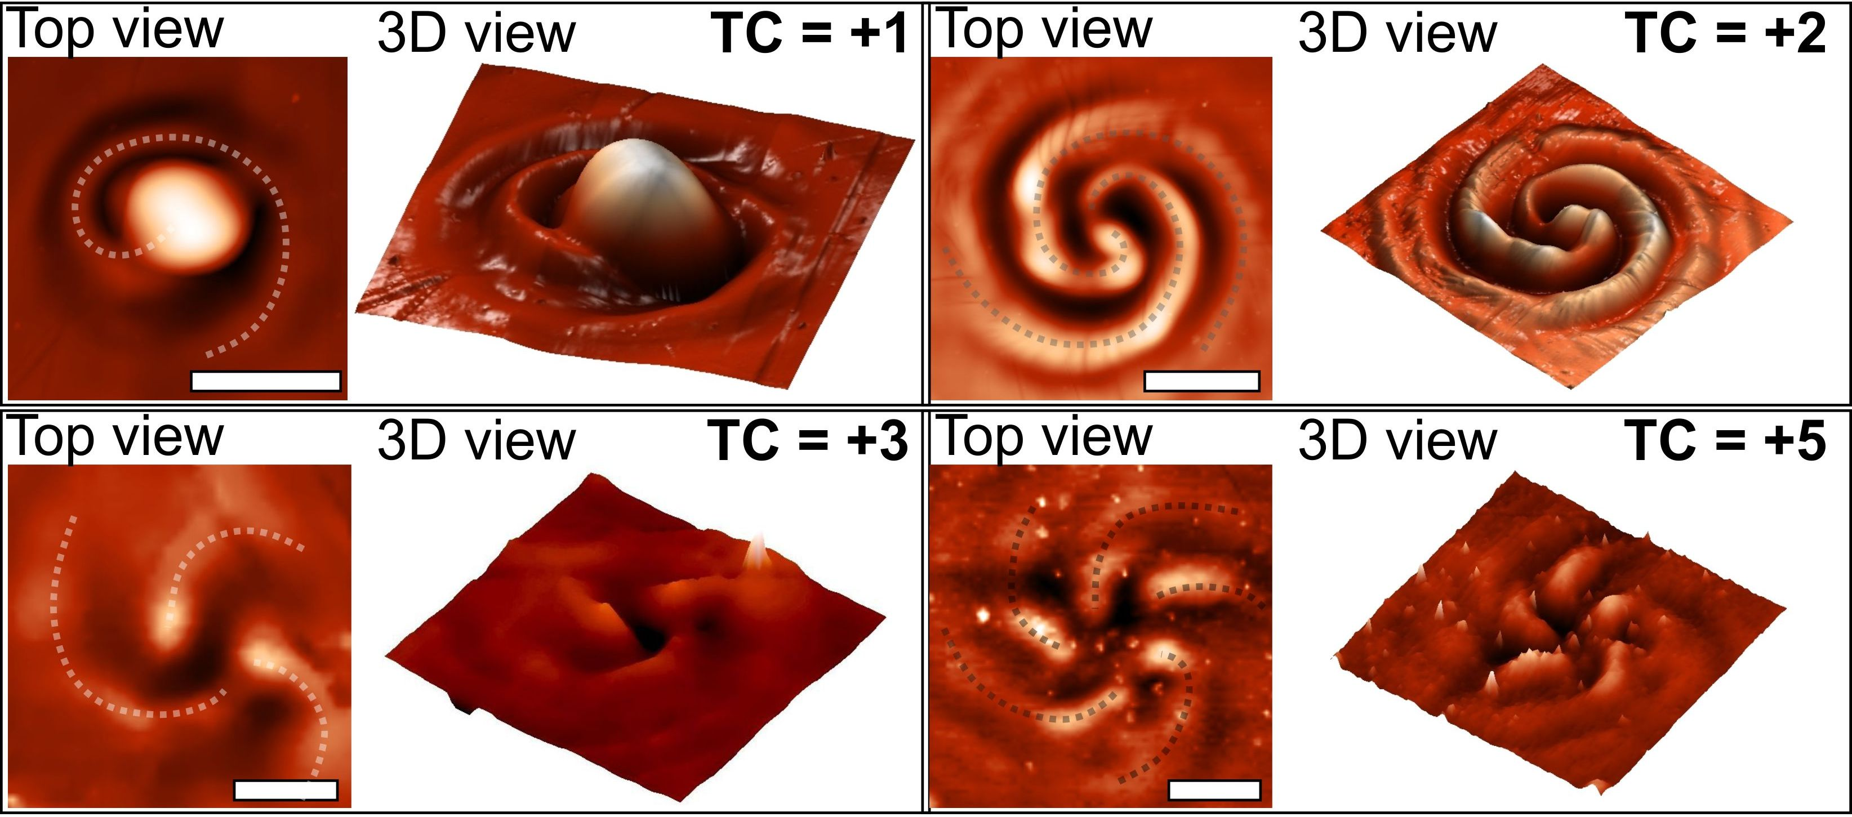
Figure 2. Multi-spiral laser patterning of azopolymer thin films: profiles of the microstructures fabricated with circularly polarized multi-spiral light fields.

REFERENCES
[1] M. Padgett, R. Bowman, Nat. Photonics 5, 343 (2011).
[2] J. A. Rodrigo, T. Alieva, Optica 2, 812 (2015).
[3] S. Sukhov, A. Dogariu, Phys. Rev. Lett. 107, 203602 (2011).

