Spontaneous emission of three-level ladder-type atom coupled to one-dimensional rectangular waveguide

Lj. Stevanović and M. Perić
Department of Physic, Faculty of Sciences and Mathematics, University of Niš, Serbia
e-mail:milica.peric1@pmf.edu.rs

Coupling the quantum emitter, like an atom, to a one-dimensional waveguide provides the way of the photon propagation control in possible quantum channels [1], [2]. This kind of waveguide-quantum electrodynamic system is a candidate for the application in quantum network [3] as a local quantum node playing the role of quantum switch [4] or one-photon transistor [5].

We study the spontaneous emission dynamics of the excited three-level atom in ladder configuration placed in a hollow rectangular waveguide with perfectly conducting walls. The model is based on solving time-dependent Schrödinger equation with the Hamiltonian obtained in the formalism of second quantization under the dipole and rotating-wave approximations [6]. The assumption is made that both dipole-allowed atomic transitions are coupled with transverse waveguide modes.

The effects of the atom position in the waveguide, atomic energy level separations and the orientation of atomic dipoles are discussed regarding the possible waveguide modes for the photon emission. The two cases are considered: when the two emerging photons belong to different modes and when they can be emitted in the same mode.

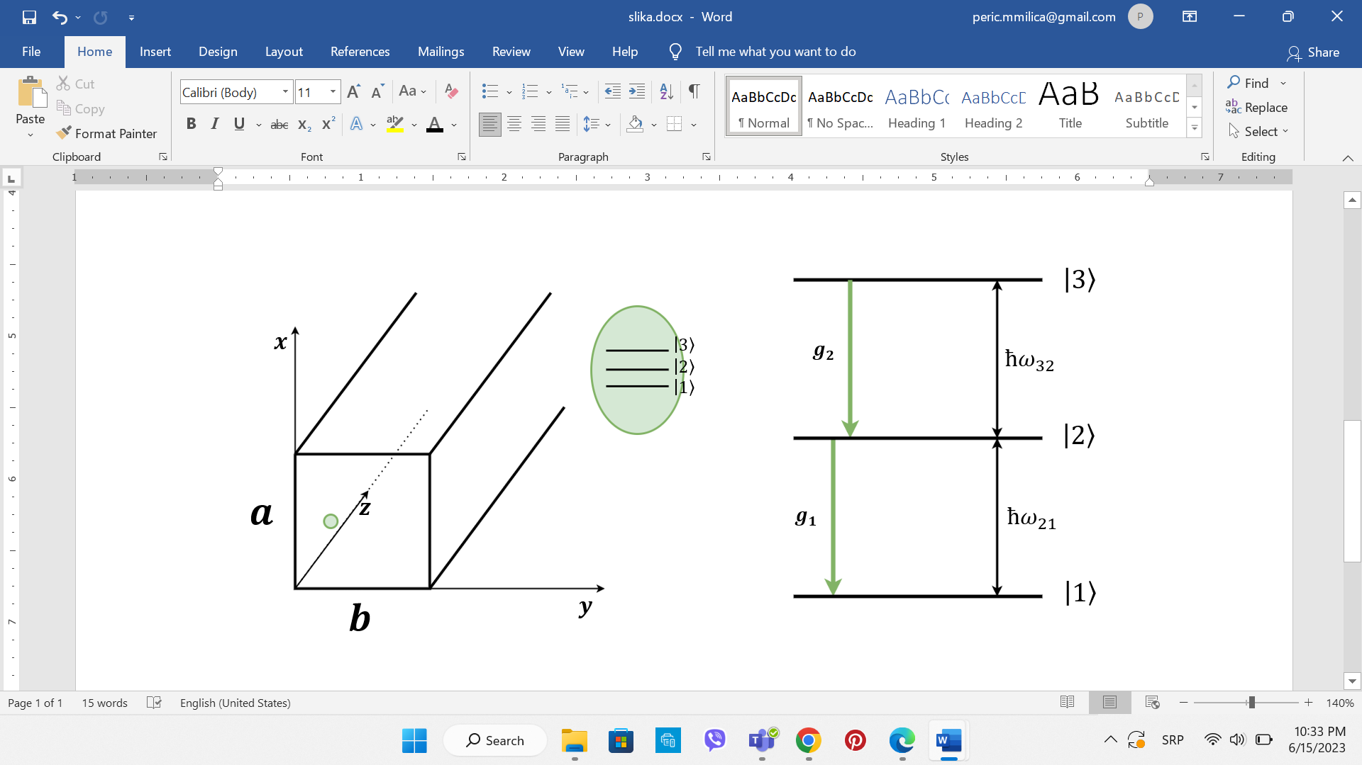

Figure 1. Three-level atom coupled to rectangular waveguide

REFERENCES
[1] J. T. Shen and S. Fan, Opt. Lett. 30, 2001 (2005).
[2] Q. Li, L. Zhou and C. P. Sun, Phys. Rev. A 89, 063810 (2014).
[3] H. J. Kimble, Nature 453, 1023 (2008).
[4] L. Zhou, L. P. Yang, Y. Li and C. P. Sun, Phys. Rev. Lett. 111, 103604 (2013).
[5] D. E. Chang, A. S. Sørensen, E. A. Demler and M. D. Lukin, Nat. Phys. 3, 807 (2007).
[6] H. Song, X. Sun, J. Lu and L. Zhou, Commun. Theor. Phys. 69, 59 (2018).

