Nonlinear optics in atomically thin materials

G. Soavi¹
¹Institute of Solid State Physics, Friedrich Schiller University Jena, Germany
e-mail: giancarlo.soavi@uni-jena.de

Two-dimensional materials, such as graphene and transition metal dichalcogenides (TMDs), have attracted enormous interest in recent years as a viable platform for nonlinear optics [1]. On one hand, their atomically thin nature allows for frequency conversion without phase matching constraints, leading to ultra broadband parametric amplification and down-conversion of photons. On the other hand, 2D materials are easy to integrate on photonic platforms, and thus they are ideal candidates for in-fiber and on-chip nonlinear operations with platforms that would otherwise display negligible nonlinear effects. In this talk I will discuss some of our recent results and activities in this growing field of research, with a focus on the following aspects: (1) electrical and all-optical modulation of nonlinearities in graphene [2] and TMDs [3]; (2) nonlinear photonic integrated devices based on graphene for gas sensing [4] and logic operations [5] and (3) ultrafast nonlinear valleytronics in TMDs [6].

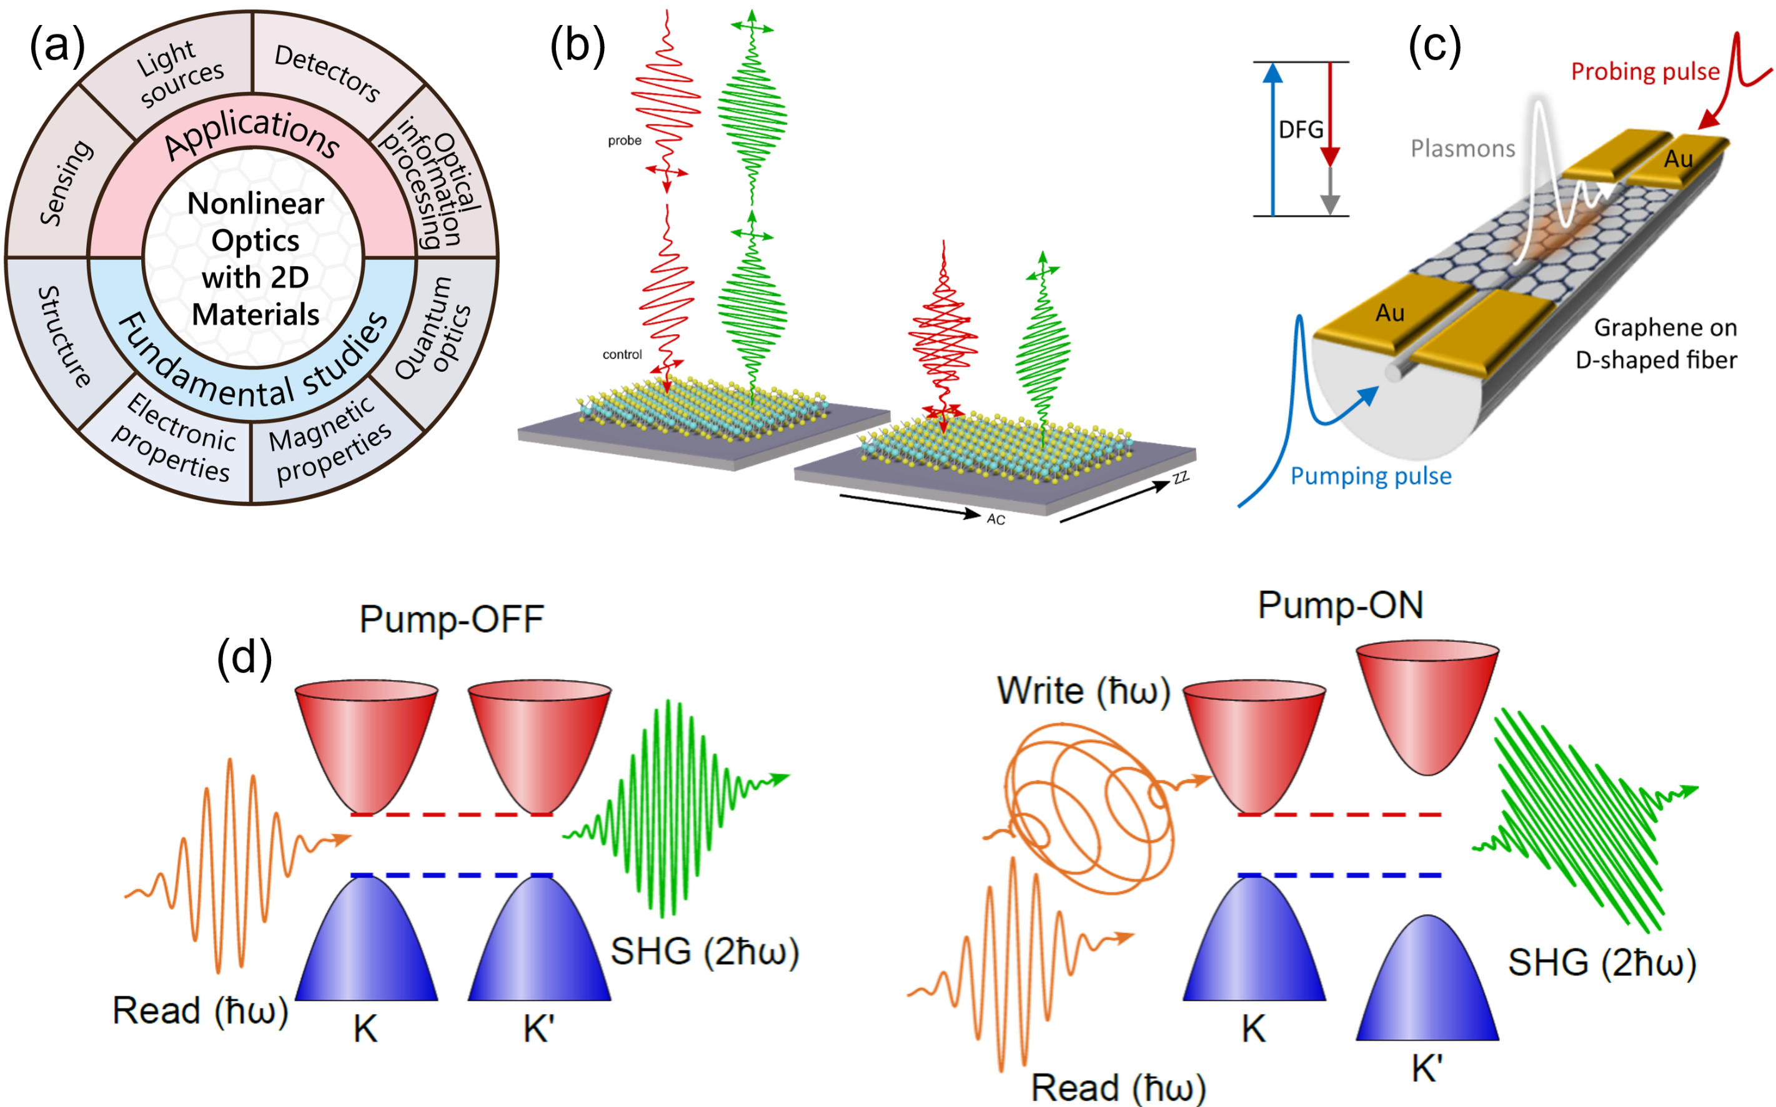

Figure 1. (a) Overview of applications and fundamental studies enabled by nonlinear optics in 2D materials, from Ref. [1]; (b) schematic of all-optical modulation of SHG in TMDs, from Ref. [3]; (c) graphene on a D-shaped fiber for logic operations enabled by difference frequency generation, from Ref. [5]; (d) operating principle of valley SHG for all-optical generation and detection of a valley imbalance in TMDs, from Ref. [6].

REFERENCES
[1] O. Dogadov et al., Laser & Photonics Reviews 16, 2100726 (2022)
[2] G. Soavi et al., Nat. Nanotechnol. 13, 583 (2018)
[3] S. Klimmer at al., Nat. Photon. 15, 837 (2021)
[4] N. An et al., Nano Lett. 20, 6473 (2020)
[5] Y. Li et al., Nat. Comms. 13, 3138 (2022)
[6] P. Herrmann et al., Small https://doi.org/10.1002/smll.202301126

